In THE

**Supreme Court of the State of Arizona**

**Brush & Nib Studio, LC, et al.**,

*Plaintiffs/Appellants/Cross-Appellees*,

*v.*

**City of Phoenix**,

*Defendant/Appellee/Cross-Appellant*.

No. CV-18-0176-PR

Filed September 16, 2019

Appeal from the Superior Court in Maricopa County

The Honorable Karen A. Mullins, Judge

No. CV2016-052251

rEVERSED IN PART

Opinion of the Court of Appeals, Division One

244 Ariz. 59 (App. 2018)

VaCATed IN PART

COUNSEL:

Jeremy D. Tedesco, Jonathan A. Scruggs (argued), Samuel D. Green, Kristen K. Waggoner, John J. Bursch, Alliance Defending Freedom, Scottsdale, Attorneys for Brush & Nib Studio, LC, Breanna Koski and Joanna Duka

Colin F. Campbell, Eric M. Fraser (argued), Joshua D. Bendor, Osborn Maledon, P.A., Phoenix; Cris Meyer, Phoenix City Attorney, Heidi E. Gilbert, Assistant Chief Counsel, Phoenix, Attorneys for City of Phoenix

Nathan W. Kellum, Center for Religious Expression, Memphis, TN and Samuel J. Doncaster, Doncaster Law, PLLC, Phoenix, Attorneys for Amicus Curiae Center for Religious Expression

Joshua Carden, Joshua Carden Law Firm, PC, Scottsdale Attorney for Amicus Curiae Jewish Coalition for Religious Liberty

David L. Rose, Rose Law Office PLLC, Phoenix, Attorneys for Amicus Curiae Arizona Legislators

Stewart Salwin, Statecraft PLLC, Phoenix, Attorneys for Amicus Curiae Tyndale House Publishers, et al.

Kevin L. Beckwith, Kevin L. Beckwith, PC, Phoenix, Attorneys for Amicus Curiae Law and Economics Scholars

Michael L. Kitchen, Margrave Celmins, P.C., Scottsdale, Attorneys for Amicus Curiae Cato Institute, et al.

Kathleen E. Brody, American Civil Liberties Union Foundation of Arizona, Phoenix and Lindsey Kaley, American Civil Liberties Union Foundation, New York, NY, Attorneys for Amicus Curiae the American Civil Liberties Union, et al.

Mark Brnovich, Arizona Attorney General, Rusty D. Crandell, Assistant Solicitor General, Angelina B. Nguyen, Unit Chief Counsel, Phoenix, Attorneys for Amicus Curiae State of Arizona, et al.

Bert E. Moll, The Law Firm of Bert E. Moll, P.C., Chandler, Attorneys for Amicus Curiae Tyndale House Publishers, et al.

Robert J. Bozelli, The Bozelli Law Firm, PC, Chandler, Attorneys for Amicus Curiae Professor Adam J. Macleod

Roopali H. Desai, D. Andrew Gaona, Coppersmith Brockelman PLC, Phoenix, Attorneys for Amicus Curiae Bloom & Blueprint Event Co., LLC, et al.

Roopali H. Desai, Coppersmith Brockelman PLC, Phoenix and Alex J. Luchenitser, Americans United for Separation of Church and State, Washington, DC, Attorneys for Amicus Curiae Americans United for Separation of Church and State, et al.

Joshua Carden, Joshua Carden Law Firm, P.C., Scottsdale and Michael K. Whitehead, Whitehead Law Firm, LLC, Lee’s Summit, MO, Attorneys for Amicus Curiae Ethics & Religious Liberty Commission of the Southern Baptist Convention, et al.

Stewart Salwin, Statecraft PLLC, Phoenix, Attorney for Amicus Curiae National Center for Law and Policy

Daniel C. Barr, Barry G. Stratford, Randal B. McDonald, Katherine E. May, Lindsey M. Huang, Perkins Coie LLP, Phoenix, Attorneys for Amicus Curiae First Amendment Scholars

Jessica M. Hernandez, MayesTelles PLLC, Phoenix and Jennifer C. Pizer, Lambda Legal Defense and Education Fund, Inc., Los Angeles, CA, Attorneys for Amicus Curiae Lambda Legal Defense and Education Fund, Inc.

Kenneth W. Schutt, Jr., Schutt Law Firm, P.L.C., Scottsdale, Attorneys for Amicus Curiae The C12 Group, LLC

Amanda Salvione, Greenspoon Marder LLP, Phoenix, Attorney for Amicus Curiae ONE Community Media, LLC d/b/a ONE Community

JUSTICE GOULD authored the opinion of the Court, in which JUSTICES BOLICK, LOPEZ, and PELANDER (Retired) joined. JUSTICE BOLICK filed a concurring opinion. JUSTICE BALES (Retired), joined by VICE CHIEF JUSTICE TIMMER and JUDGE STARING,[1]* dissented. VICE CHIEF JUSTICE TIMMER filed a dissenting opinion. JUDGE STARING filed a dissenting opinion.

JUSTICE GOULD, opinion of the Court:

1. The rights of free speech and free exercise, so precious to this nation since its founding, are not limited to soft murmurings behind the doors of a person’s home or church, or private conversations with like–minded friends and family. These guarantees protect the right of every American to express their beliefs in public. This includes the right to create and sell words, paintings, and art that express a person’s sincere religious beliefs.
2. With these fundamental principles in mind, today we hold that the City of Phoenix (the “City”) cannot apply its Human Relations Ordinance (the “Ordinance”) to force Joanna Duka and Breanna Koski, owners of Brush & Nib Studios, LC (“Brush & Nib”), to create custom wedding invitations celebrating same-sex wedding ceremonies in violation of their sincerely held religious beliefs. Duka, Koski, and Brush & Nib (“Plaintiffs”) have the right to refuse to express such messages under article 2, section 6 of the Arizona Constitution, as well as Arizona’s Free Exercise of Religion Act (“FERA”), A.R.S. § 41-1493.01.
3. Our holding is limited to Plaintiffs’ creation of custom wedding invitations that are materially similar to those contained in the record. *See* Appendix 1. We do not recognize a blanket exemption from the Ordinance for all of Plaintiffs’ business operations. Likewise, we do not, on jurisprudential grounds, reach the issue of whether Plaintiffs’ creation of other wedding products may be exempt from the Ordinance. *See* Appendix 2.
4. Duka and Koski’s beliefs about same-sex marriage may seem old-fashioned, or even offensive to some. But the guarantees of free speech and freedom of religion are not only for those who are deemed sufficiently enlightened, advanced, or progressive. They are for everyone. After all, while our own ideas may be popular today, they may not be tomorrow. Indeed, “[w]e can have intellectual individualism” and “rich cultural diversities . . . only at the price” of allowing others to express beliefs that we may find offensive or irrational. *West Virginia State Board of Education v. Barnette*, 319 U.S. 624, 641–42 (1943). This “freedom to differ is not limited to things that do not matter much . . . [t]he test of its substance is the right to differ as to things that touch the heart of the existing order.” *Id.* at 642.
5. Given this reality, the government “must not be allowed to force persons to express a message contrary to their deepest convictions.” *Nat’l Inst. of Family & Life Advocates v. Becerra* (*NIFLA*), 138 S. Ct. 2361, 2379 (2018) (Kennedy, J., concurring). Rather, Plaintiffs are entitled to

continue to advocate with utmost, sincere conviction that, by divine precepts, same-sex marriage should not be condoned. The First Amendment ensures that religious organizations and persons are given proper protection as they seek to teach the principles that are so fulfilling and so central to their lives and faiths, and to their own deep aspirations to continue the family structure they have long revered.

*Obergefell v. Hodges*, 135 S. Ct. 2584, 2607 (2015).

1. Although this case is about freedom of speech and religion, it suits the preferred analysis of our dissenting colleagues to reframe it as one involving discriminatory conduct based on a customer’s sexual orientation. This mischaracterization reflects neither Plaintiffs’ position nor our holding. Literally none of the examples of invidious, status-based discrimination the dissent invokes, *see infra* ¶ 217-18, would even be remotely permitted under our holding today. Plaintiffs must, and they do, serve all customers regardless of their sexual orientation. However, by focusing solely on the anti-discrimination purpose of the Ordinance, the dissent engages in a one–sided analysis that effectively deprives Plaintiffs of their fundamental right to express their beliefs. But no law, including a public accommodations law, is immune from the protections of free speech and free exercise. Rather, “[i]f there is any fixed star in our constitutional constellation, it is that no official, high or petty, can prescribe what shall be orthodox in politics, nationalism, religion, or other matters of opinion or force citizens to confess by word or act their faith therein.” *Barnette*, 319 U.S. at 642.
2. The enduring strength of the First Amendment is that it allows people to speak their minds and express their beliefs without government interference. But here, the City effectively cuts off Plaintiffs’ right to express their beliefs about same–sex marriage by telling them what they can and cannot say. And to justify this action, both the City and the primary dissent claim that if we dare to allow Plaintiffs to express their beliefs, we, in essence, run the risk of resurrecting the Jim Crow laws of the Old South.
3. But casting Plaintiffs’ free speech and exercise rights in such a cynical light does grave harm to a society. As Justice Jackson observed in *Barnette*, “[s]truggles to coerce uniformity of sentiment in support of some end thought essential to their time and country have been waged by many good as well as by evil men,” but, inevitably “those bent on its accomplishment must resort to an ever-increasing severity.” *Barnette*, 319 U.S. at 640. We would be wise to heed his warning about government efforts to compel uniformity of beliefs and ideas:

[a]s governmental pressure toward unity becomes greater, so strife becomes more bitter as to whose unity it shall be.  . . . . Ultimate futility of such attempts to compel coherence is the lesson of every such effort from the Roman drive to stamp out Christianity as a disturber of its pagan unity, the Inquisition, as a means to religious and dynastic unity, the Siberian exiles as a means to Russian unity, down to the fast failing efforts of our present totalitarian enemies. Those who begin coercive elimination of dissent soon find themselves exterminating dissenters. Compulsory unification of opinion achieves only the unanimity of the graveyard.

*Id*. at 641.

1. Duka and Koski are the sole member-owners of Brush & Nib, a for-profit limited liability company. Duka and Koski operate Brush & Nib as an “art studio” specializing in creating custom artwork for weddings, events, special occasions, home décor, and businesses. Duka and Koski work out of Koski’s home and personally design and create their products. In addition to custom-designed products, Brush & Nib sells some pre-made products. Duka and Koski do not maintain Brush & Nib as a brick-and-mortar store but instead sell their products online through various media platforms.
2. Apart from Plaintiffs’ custom wedding invitations, the record contains only a few examples of their products. In contrast, there are numerous examples of Plaintiffs’ custom wedding invitations. *See* Appendix 1. All these custom invitations feature Plaintiffs’ hand-drawn images and paintings, custom lettering and calligraphy, as well as their original artwork. Additionally, the names of a female bride and a male groom are prominently displayed in every custom invitation.
3. The City concedes that “[a]ll the custom wedding invitations Brush & Nib creates include language that is celebratory of the wedding.” Specifically, Plaintiffs create and write celebratory statements in every custom invitation, including such statements as “[the couple or their parents] request the pleasure of your company at the *celebration* of their marriage,” “request the *honor* of your presence,” “invite you to the *celebration* of their marriage,” or “invite you to share in the *joy* of their marriage.” (Emphasis added.)
4. Plaintiffs closely collaborate with each client in creating their custom wedding invitations. The client provides the names of the bride and groom, as well as the location and date of the wedding. A client may also share preferences regarding the colors and style of the invitation. Plaintiffs, in turn, propose their artistic ideas for the invitation, including colors, artwork, text, and phrasing. As part of this process, Plaintiffs “frequently suggest the particular words to use” in the invitation.
5. Once a client signs a contract for their services, Plaintiffs design and create the invitations. Although a client may ultimately reject Plaintiffs’ work, the contract states that Brush & Nib “retains complete artistic freedom with respect to every aspect of the design’s and artwork’s creation.” The contract provides that the client’s requested design and artwork must “express[] messages that promote [Brush & Nib’s] religious or artistic beliefs, or at least are not inconsistent with these beliefs.” Further, Brush & Nib “reserves the right to terminate” the contract if it subsequently determines, in its “sole discretion, that the requested design or artwork communicates ideas or messages . . . that are inconsistent with [Brush & Nib’s] religious or artistic beliefs.”
6. Duka and Koski are Christians. Based on their faith, they do not believe they can do anything, either in their business or personal lives, that “violates their religious beliefs or dishonors God.” Thus, in addition to making a profit, Duka and Koski seek to operate Brush & Nib consistent with their religious beliefs. For example, Brush & Nib’s Operating Agreement (the “Agreement”) states that Brush & Nib is a “for-profit limited liability company” that “is owned solely by Christian artists who operate [Brush & Nib] as an extension of and in accordance with their artistic and religious beliefs.” The Agreement sets forth Brush & Nib’s “Core Beliefs” and provides that “Brush & Nib is unwilling to use its artistic process” or “create art” that contradicts its religious “beliefs and message.” The Agreement further provides that Brush & Nib “reserves the right to deny any request for action or artwork that violates its artistic and religious beliefs.” As examples of such objectionable artwork, the Agreement states that Brush & Nib will refuse to create “custom artwork that communicates ideas or messages . . . that contradict biblical truth, demean others, endorse racism, incite violence, or promote any marriage besides marriage between one man and one woman, such as same-sex marriage.”
7. Duka and Koski hold traditional Christian beliefs about marriage. They believe that “God created two distinct genders in His image,” and that only a man and a woman can be joined in marriage. This belief is based on the Bible; thus, for example, Plaintiffs cite Matthew 19:4–5, which states that God “made them male and female, and said, [f]or this reason a man shall leave his father and mother and be joined to his wife, and the two shall become one.” (Internal quotation marks omitted.) Duka testified that she believes that marriage reflects God’s glory and presents a picture of “Christ and his love for the church.”
8. As a tenet of their faith, Duka and Koski do not believe that two people of the same sex can be married. Plaintiffs stress that they will create custom artwork for, and sell pre-made artwork to, any customers regardless of their sexual orientation. However, they believe that creating a custom wedding invitation that conveys a message celebrating same-sex marriage, for any customer regardless of sexual orientation, violates their sincerely held religious convictions.

**A. The Ordinance**

1. The City of Phoenix’s Ordinance, as amended in 2013, prohibits public accommodations from discriminating against persons based on their status in a “protected” group, which includes a person’s sexual orientation. Phx., Ariz., City Code (“PCC”) § 18-4(B). In contrast, neither Arizona’s public accommodations law nor the federal civil rights public accommodations statute lists sexual orientation as a legally protected status. *See* A.R.S. § 41-1442(A); 42 U.S.C. § 2000a(a).
2. Under the Ordinance, public accommodations include “all establishments offering their services, facilities or goods to or soliciting patronage from the members of the general public.” PCC § 18-3. Section 18-4(B)(2) makes it unlawful for any business operating as a public accommodation to “directly or indirectly[] refuse, withhold from, or deny to any person . . . accommodations, advantages, facilities or privileges . . . because of” a person’s status in a protected group. Additionally, the Ordinance forbids such businesses from making any “distinction . . . with respect to any person based on” status with respect to “the price or quality of any item, goods or services offered.” PCC § 18-4(B)(2).
3. Section 18-4(B)(3) also makes it unlawful for a public accommodation “to directly or indirectly display, circulate, publicize or mail any advertisement, notice or communication which states or implies that any facility or service shall be refused or restricted because of” a person’s status. This subsection also prohibits displays or publications that state or imply that based on a person’s status they “would be unwelcome, objectionable, unacceptable, undesirable or not solicited.” *Id.*
4. Complaints regarding violations of the Ordinance are initially handled by the City’s Equal Opportunity Department (the “Department”). PCC § 18-5(A). If the Department determines that there is reasonable cause to believe that a violation has occurred, it must first attempt to resolve the violation though “informal methods,” such as conciliation and mediation. *Id.* § 18-5(D)(2), (E), (G). However, if the Department finds no reasonable cause, the complainant may “request that the City Attorney file a criminal complaint.” *Id.* § 18-5(D)(1). Further, if the business owner refuses to correct the violation through informal means, the Department may refer the matter to the City Attorney for criminal prosecution. *Id.* § 18-6.
5. Pursuant to § 18-7(A), any person convicted of violating the Ordinance is guilty of a class 1 misdemeanor. As punishment, a violator may be ordered to serve up to six months in jail or three years’ probation, or pay a maximum fine of $2,500, or any combination of jail, fines, and probation. *Id.* § 1-5. Section 1-5 also provides that “[e]ach day any violation” continues “shall constitute a separate offense.” Continuing violations may also “be deemed a public nuisance” and “abated as provided by law.” *Id.*

**B. Procedural Background**

1. To date, the City has not cited Plaintiffs for violating the Ordinance. Plaintiffs filed this action to enjoin the City from enforcing the Ordinance against them in the future, as well as to obtain a declaration that the Ordinance violates their right to free speech under article 2, section 6 of the Arizona Constitution, and their free exercise right under FERA, § 41-1493.01. As part of their requested declaratory relief, Plaintiffs request an order allowing them to post a proposed statement (the “Statement”) on Brush & Nib’s website announcing their intention to refuse requests to create custom artwork for same-sex weddings. The Statement explains that Brush & Nib will not “create any artwork that violates our vision as defined by our religious and artistic beliefs and identity.” It lists several examples of objectionable artwork, including artwork promoting businesses that “exploit women or sexually objectify the female body,” exploits the environment, or “any custom artwork that demeans others, endorses racism, incites violence, contradicts our Christian faith, or promotes any marriage except marriage between one man and one woman,” such as “wedding invitations[] for same-sex wedding ceremonies.”
2. The City filed a motion to dismiss, arguing that Plaintiffs lacked standing to bring this action. Specifically, the City asserted that Plaintiffs had not yet refused to create any products for a same-sex wedding and therefore had not violated the Ordinance. The trial court denied the motion.
3. After an evidentiary hearing, the court denied Plaintiffs’ motion for a preliminary injunction. Following the hearing, each party moved for summary judgment. The trial court denied Plaintiffs’ motion but granted the City’s motion. In its ruling, the court concluded that the Ordinance did not violate Plaintiffs’ rights to free speech or free exercise of religion under FERA.
4. The court of appeals affirmed both the trial court’s denial of the City’s motion to dismiss and its grant of summary judgment in favor of the City. *Brush & Nib Studio, LC v. City of Phoenix*, 244 Ariz. 59, 68–69 ¶ 16, 78 ¶ 55 (App. 2018). The court held that the Ordinance did not violate Plaintiffs’ freedom of speech or substantially burden their free exercise rights under FERA. *Id.* at 72 ¶ 29, 73 ¶ 32, 77 ¶ 49. However, the court struck down as unconstitutionally vague the provision in § 18-4(B)(3) prohibiting displays or publications stating or implying that a person in a protected group “would be unwelcome, objectionable, unacceptable, undesirable or not solicited.” *Id.* at 75–76 ¶¶ 43–45 & n.12. The court severed this provision from the Ordinance, concluding that the remainder of § 18-4(B)(3) “operates independently and is enforceable.” *Id.* at 76 ¶ 44.
5. We granted review because this case involves constitutional and statutory issues of statewide importance. We have jurisdiction pursuant to article 6, section 5(3) of the Arizona Constitution.

**II.**

1. Plaintiffs contest the trial court’s denial of their motion for a preliminary injunction, as well as the court’s denial of their motion for summary judgment and grant of summary judgment in favor of the City. However, we need not review the trial court’s denial of Plaintiffs’ motion for a preliminary injunction because its rulings on the parties’ summary judgment motions are dispositive here.
2. We review the trial court’s rulings on the motions for summary judgment de novo. *Jackson v. Eagle KMC L.L.C.*, 245 Ariz. 544, 545 ¶ 7 (2019). We review statutory, constitutional, and mixed questions of law and fact de novo. *City of Surprise v. Ariz. Corp. Comm’n*, 246 Ariz. 206, 210 ¶ 10 (2019) (statutes); *Gallardo v. State*, 236 Ariz. 84, 87 ¶ 8 (2014) (constitutional questions); *Valley Med. Specialists v. Farber*, 194 Ariz. 363, 366 ¶ 10 (1999) (mixed questions of law and fact).
3. Plaintiffs concede Brush & Nib is a public accommodation as defined by PCC § 18-3. However, they argue that the Ordinance, as applied by the City, compels them to use their artistic talents and personal expression to create custom invitations celebrating same-sex weddings in violation of their free speech rights under article 2, section 6 of the Arizona Constitution and their free exercise rights under FERA. Plaintiffs assert they will serve all customers, regardless of their sexual orientation. However, they refuse to create or express certain messages, regardless of *who* makes the request. This includes creating custom invitations that celebrate a same-sex marriage ceremony.
4. The City concedes that the Ordinance does not require Duka and Koski to express any messages condoning or celebrating same-sex marriage. Thus, for example, the City agrees that the Ordinance does not require Duka and Koski to create a custom invitation containing the statement, “support gay marriage,” or symbols, such as the equal sign of the Human Rights Campaign, that would be recognized by a third-party observer as expressly endorsing same-sex marriage. The City argues, however, that the Ordinance, as applied to Plaintiffs’ custom wedding invitations, regulates conduct, not speech. Thus, by refusing to create or sell such invitations for use in same-sex weddings, the City contends that Plaintiffs are engaging in discriminatory conduct prohibited by the Ordinance.
5. For their remedy, Plaintiffs generally seek relief permitting them to (1) refuse requests to create custom-made wedding products for same-sex weddings, and (2) post their Statement regarding their intention to refuse such services. Alternatively, Plaintiffs seek partial relief limited to their creation of custom wedding invitations that are “materially similar” to the invitations contained in the record.
6. Plaintiffs originally raised both facial and as-applied challenges to the constitutionality of the Ordinance. However, because Plaintiffs’ facial challenge was limited to the provision struck down by the court of appeals (a ruling neither party challenges here), only Plaintiffs’ as-applied challenge remains. *See* *Brush & Nib*, 244 Ariz. at 75–76 ¶¶ 43–45 & n.12. Thus, we need not consider the general validity of the Ordinance or the Ordinance’s application to other individuals or businesses that are not before this Court. *See Boddie v. Connecticut*, 401 U.S. 371, 379 (1971) (stating that “a statute or a rule may be held constitutionally invalid as applied when it operates to deprive an individual of a protected right although its general validity . . . is beyond question,” and that “in cases involving religious freedom, free speech or assembly, this Court has often held that a valid statute was unconstitutionally applied in particular circumstances because it interfered with an individual’s exercise of those rights”).

**III.**

1. The City argues the trial court erred in denying its motion to dismiss based on Plaintiffs’ lack of standing. Specifically, the City asserts that because Plaintiffs filed this action “before any same-sex couple had requested custom wedding products,” their lawsuit is based on speculative claims about how the Ordinance might apply to hypothetical customer requests involving Plaintiffs’ entire range of custom products. Because none of these abstract legal claims may ever arise, the City contends that Plaintiffs’ action challenging PCC § 18-4(B)(2) is not ripe and should be dismissed.
2. We ordinarily review a trial court’s ruling on a motion to dismiss for an abuse of discretion, *Legacy Foundation Action Fund v. Citizens Clean Elections Commission*, 243 Ariz. 404, 405 ¶ 6 (2018), but questions of standing and ripeness are reviewed de novo, *In re Estate of Stewart*, 230 Ariz. 480, 483–84 ¶ 11 (App. 2012) (ripeness); *Aegis of Ariz., L.L.C. v. Town of Marana*, 206 Ariz. 557, 562 ¶ 16 (App. 2003) (standing).
3. Although the Arizona Constitution does not have a case or controversy requirement like the Federal Constitution, we do apply the doctrines of standing and ripeness “as a matter of sound judicial policy.” *Bennett v. Napolitano*, 206 Ariz. 520, 524 ¶ 16 (2003). Because in this case the underlying concerns for standing and ripeness are the same, we simply use the term “ripeness” to apply to both doctrines here. *See Thomas v. Anchorage Equal Rights Comm’n*, 220 F.3d 1134, 1138 (9th Cir. 2000) (“The constitutional component of the ripeness inquiry is often treated under the rubric of standing and, in many cases, ripeness coincides squarely with standing’s injury in fact prong.”); *Town of Gilbert v. Maricopa Cty.*, 213 Ariz. 241, 244 ¶ 8 (App. 2006) (stating that “[r]ipeness is analogous to standing”).
4. Ripeness is a prudential doctrine that prevents a court from rendering a premature decision on an issue that may never arise. *Winkle v. City of Tucson*, 190 Ariz. 413, 415 (1997). Though federal justiciability jurisprudence is not binding on Arizona courts, the factors federal courts use to determine whether a case is justiciable are instructive. *See Bennett*, 206 Ariz. at 525 ¶ 22. Thus, as a general matter, if the plaintiff has incurred an injury, the case is ripe. *See Brewer v. Burns*, 222 Ariz. 234, 238 ¶ 15 (2009). A case is also ripe if there is an actual controversy between the parties. *Estate of Stewart*, 230 Ariz. at 484 ¶ 12; *see Planned Parenthood Ctr. of Tucson, Inc. v. Marks*, 17 Ariz. App. 308, 312–13 (1972) (stating that challengers of statute forbidding abortions under certain circumstances were not required to wait for criminal prosecution because that statute allegedly chilled their constitutional rights and therefore constituted an actual controversy).
5. Here, we need not speculate about how the Ordinance might apply to customer requests for Plaintiffs’ custom wedding invitations. While it is true that, for most of Plaintiffs’ products, the factual record is not sufficiently developed, that is not the case with respect to the custom invitations. The record, as reflected by the exhibits contained in Appendix 1, contains numerous examples of Plaintiffs’ custom wedding invitations. All of these invitations contain detailed examples of Plaintiffs’ words, drawings, paintings, and original artwork, and Duka and Koski have testified about their process of designing and creating these custom invitations. *Supra* ¶¶ 9–14*.* Additionally, in their briefs, the parties have analyzed, in detail, the legal claims and arguments based on these custom invitations.
6. Finally, because Plaintiffs have specifically asked this Court, as an alternative form of relief, to limit our decision to custom wedding invitations that are materially similar to the invitations contained in the record, *supra* ¶ 31, we may limit our analysis and holding to Plaintiffs’ creation of this specific product. *See* A.R.S. § 41-1493.01(D) (permitting FERA claimants to “obtain *appropriate relief* against a government” (emphasis added)); *Califano v. Yamasaki*, 442 U.S. 682, 702 (1979) (stating that “the scope of injunctive relief is dictated by the extent of the violation established”).
7. Thus, we conclude there is an actual case and controversy that exists regarding Plaintiffs’ creation of custom wedding invitations that are materially similar to those in the record. Duka and Koski face a real threat of being prosecuted for violating the Ordinance by refusing to create such invitations for a same-sex wedding. *See Babbitt v. United Farm Workers Nat’l Union*, 442 U.S. 289, 298, 300–01 (1979) (finding standing despite the lack of a concrete factual situation or criminal enforcement of the statute against the challenger because the threshold issue, whether the challengers’ activity was protected as free speech, was justiciable); *see also* A.R.S. § 12-1832 (authorizing any person “whose rights . . . are affected by a . . . municipal ordinance” to seek declaratory relief on the validity of the ordinance and “obtain a declaration of rights, status or other legal relations thereunder”). In contrast, Plaintiffs’ sweeping challenge to the Ordinance as applied to all of Brush & Nib’s remaining custom wedding products (as reflected in Appendix 2) implicates a multitude of possible factual scenarios too “imaginary” or “speculative” to be ripe. *Thomas*, 220 F.3d at 1139 (quoting *Babbitt*, 442 U.S. at 298).
8. Additionally, given the City’s assertion that it can apply the Ordinance to Plaintiffs’ custom wedding invitations, which includes the threat of criminal prosecution and significant penalties, Plaintiffs have suffered an injury through the chilling of their free speech and free exercise rights. *Virginia v. Am. Booksellers Ass’n*, 484 U.S. 383, 392–93 (1988) (holding there was an injury to challenger’s speech rights prior to a challenged criminal statute becoming effective, where the state never stated it would not enforce the statute).
9. Accordingly, we agree with the trial court and the court of appeals that, to the extent Plaintiffs’ action is based on their custom wedding invitations, it is justiciable. We therefore affirm the trial court and the court of appeals’ denial of the City’s motion to dismiss as to Plaintiffs’ custom wedding invitations. *Brush & Nib*, 244 Ariz. at 68–69 ¶ 16. However, Plaintiffs’ claims based on their remaining custom products are not ripe, and we therefore reverse and grant the City’s motion to dismiss as to these products.

**IV.**

1. Plaintiffs allege that the Ordinance, as applied by the City, compels them to create custom wedding invitations celebrating same-sex marriage in violation of Arizona’s free speech clause. *See* Ariz. Const. art. 2, § 6 (stating that “[e]very person may freely speak, write, and publish on all subjects, being responsible for the abuse of that right”).
2. Generally, “[w]e will not reach a constitutional question if a case can be fairly decided on non[-]constitutional grounds.” *R.L. Augustine Constr. Co., Inc. v. Peoria Unified Sch. Dist. No. 11*, 188 Ariz. 368, 370 (1997). However, when constitutional and non-constitutional issues are intertwined in a case, we must address the constitutional issue. *See State v. Church*, 109 Ariz. 39, 41 (1973); *Katherine S. v. Foreman*, 197 Ariz. 371, 378 ¶ 16 (App. 1999) (deciding constitutional issue because the issue was “intertwined” with non-constitutional issue and citing *Church* for the proposition that the “fact that constitutional and non-constitutional issues are interwoven justifies addressing all issues”).
3. Here, because Plaintiffs’ FERA claim is closely intertwined with their free speech claim, we find it necessary to address the constitutional issue in this case. *Katherine S.*, 197 Ariz. at 378 ¶ 16; *see also Watchtower Bible & Tract Soc’y of N.Y., Inc. v. Village of Stratton,* 536 U.S. 150, 160-69 (2002) (discussing both freedom of speech and free exercise as the plaintiff’s exercise of both rights were affected by challenged law); *cf. Employment Div. v. Smith,* 494 U.S. 872, 881-82 (1990) (collecting cases analyzing both freedom of speech and free exercise); *Masterpiece Cakeshop, Ltd. v. Colo. Civil Rights Comm’n*, 138 S. Ct. 1719, 1740–48 (2018) (Thomas, J., concurring) (analyzing free speech issue despite concluding that challengers’ free exercise rights were violated). The legal and factual questions underlying Plaintiffs’ free speech and FERA claims require us to address the same basic issues: (1) whether the Ordinance, as applied by the City, compels Plaintiffs to express a message that violates their religious convictions, and (2) if so, whether Plaintiffs have a protected right to refuse to express that message in the operation of their business.
4. In examining the text of Arizona’s free speech clause, we first observe that whereas the First Amendment is phrased as a constraint on government, U.S. Const. amend. I (“Congress shall make no law . . . abridging the freedom of speech.”), our state’s provision, by contrast, is a guarantee of the individual right to “freely speak, write, and publish,” subject only to constraint for the abuse of that right. *See State v. Stummer*, 219 Ariz. 137, 142 ¶ 14 (2008); *see also id.* ¶ 15 (“The encompassing text of [a]rticle 2, [s]ection 6 indicates the Arizona framers’ intent to rigorously protect freedom of speech.”). Thus, by its terms, the Arizona Constitution provides broader protections for free speech than the First Amendment. *See, e.g.*, *Coleman v. City of Mesa*, 230 Ariz. 352, 361 ¶ 36 n.5 (2012) (stating that article 2, section 6 “is in some respects more protective of free speech rights than the First Amendment”); *Stummer*, 219 Ariz. at 143 ¶ 17 (“We have also stated that [a]rticle 2, [s]ection 6 has ‘greater scope than the [F]irst [A]mendment.’” (citation omitted)); *Mountain States Tel. & Tel, Co. v. Ariz. Corp. Comm’n*, 160 Ariz. 350, 356 (1989) (“[W]e apply here the broader freedom of speech clause of the Arizona Constitution.”).
5. However, although article 2, section 6 does, by its terms, provide greater speech protection than the First Amendment, we have rarely explored the contours of that right. Rather, we have often relied on federal case law in addressing free speech claims under the Arizona Constitution*. Stummer*, 219 Ariz. at 142 ¶ 16 (stating that “Arizona courts have had few opportunities to develop Arizona’s free speech jurisprudence,” and in “construing [a]rticle 2, [s]ection 6 have followed federal interpretations of the United States Constitution”); *Mountain States*, 160 Ariz. at 358 (looking to First Amendment precedent in determining that a government regulation violated Arizona’s free speech clause)*.* Here, while Plaintiffs generally assert that their compelled speech claim, *see infra* Section IV(A)–(D), is based on the Arizona Constitution, in arguing that claim they rely almost exclusively on federal cases construing the First Amendment.
6. This, however, presents no difficulty for us in resolving Plaintiffs’ compelled speech claim. Specifically, because federal precedent conclusively resolves Plaintiffs’ claim, we can adequately address it under First Amendment jurisprudence. And, because a violation of First Amendment principles “necessarily implies” a violation of the broader protections of article 2, section 6 of the Arizona Constitution, by applying First Amendment jurisprudence, we therefore address Plaintiffs’ state claim. *Coleman*, 230 Ariz. at 361 ¶ 36 n.5 (noting that because plaintiffs had adequately stated a claim under the First Amendment, this “necessarily implie[d] that they ha[d] also stated claims under [a]rticle 2, [s]ection 6 of Arizona’s Constitution,” and thus there was no need to address whether Arizona’s free speech clause “might afford greater protection . . . than applies under the First Amendment”); *see also Mountain States*, 160 Ariz. at 358 (“As we have already determined that ‘narrow specificity’ is a requirement of a time, place, and manner regulation under the [F]irst [A]mendment, we must hold the same under the more stringent protections of the Arizona Constitution.”).

**A. Compelled Speech**

1. The compelled speech doctrine is grounded on the principle that freedom of speech “includes both the right to speak freely and the right to refrain from speaking at all.” *Wooley v. Maynard*, 430 U.S. 705, 714 (1977); *see also Hurley v. Irish-Am. Gay, Lesbian & Bisexual Grp. of Bos.*, 515 U.S. 557, 573 (1995) (“[O]ne important manifestation of the principle of free speech is that one who chooses to speak may also decide what not to say.” (citation and internal quotation marks omitted)); *Riley v. Nat’l Fed’n of the Blind of N.C.*, 487 U.S. 781, 796–97 (1988) (stating that the First Amendment guarantee of free speech necessarily includes the freedom of deciding “both what to say and what *not* to say”).
2. The compelled speech doctrine was first articulated in *Barnette*. There, the Supreme Court addressed a state law requiring a child who was a Jehovah’s Witness to salute the American flag. 319 U.S. at 626–29. For both the child and his parents, saluting the flag violated their religious beliefs. *Id.* at 629. The Court struck down the law as violating the First Amendment, stating that the government cannot compel any individual “to utter what is not in his mind,” *id.* at 634, and that all citizens have autonomy over their “opinion[s] and personal attitude[s],” *id.* at 631, 636; *see also Turner Broad. Sys., Inc. v. FCC*, 512 U.S. 622, 641 (1994) (stating that “[a]t the heart of the First Amendment lies the principle that each person should decide for himself or herself the ideas and beliefs deserving of expression, consideration, and adherence,” and that any “[g]overnment action that . . . requires the utterance of a particular message favored by the Government[] contravenes this essential right”).
3. There are, generally speaking, two lines of cases addressing compelled speech. The first involves regulations requiring an individual to express a prescribed government message. For example, in *Wooley*, the Court held that a law was unconstitutional because it forced a Jehovah’s Witness, in violation of his religious beliefs, to display the state motto “Live Free or Die” on his license plate. 430 U.S. at 707–08, 717; *see also NIFLA*, 138 S. Ct. at 2368–69, 2378 (holding that plaintiffs were likely to succeed in their claim that a state law unconstitutionally compelled speech by requiring crisis pregnancy centers, which were established to prevent abortions, to disseminate prescribed government notices about public funding for abortion services).
4. A second line of compelled speech cases involves a government regulation that compels a person to host or accommodate another’s message. *See, e*.*g*., *Hurley*, 515 U.S. at 572–73, 581 (holding that a state public accommodations law could not be used to compel a parade sponsor to host or accommodate messages from parade participants the sponsor found to be objectionable). This line of cases includes government regulations compelling a person to engage in self-censorship to avoid hosting another’s message, as well as regulations forcing a person to respond to another’s speech when they would prefer to remain silent. *See Pac. Gas & Elec. Co. v. Pub. Util. Comm’n*, 475 U.S. 1, 5–7, 16–17, 21 (1986) (plurality opinion) (holding that a regulation requiring a privately-owned utility to include, along with its monthly bills, an editorial newsletter published by a consumer group that was critical of its ratemaking practices violated the utility’s free speech rights because the utility might “feel compelled to respond to arguments and allegations made by [the consumer group]”); *Miami Herald Publ’g Co. v. Tornillo*, 418 U.S. 241, 244, 256–58 (1974) (holding that a statute granting political candidates the right to reply to unfavorable newspaper articles violated the First Amendment because it forced newspapers to either respond to the candidates’ replies or engage in compelled self-censorship by forgoing printing any articles criticizing a candidate).
5. The fundamental principle underlying both lines of compelled speech cases is that an individual has autonomy over his or her speech and thus may not be forced to speak a message he or she does not wish to say. *Hurley* is instructive on this point. There, a private group of veterans (the “Council”) was granted a permit by the City of Boston to sponsor a St. Patrick’s Day parade. *Hurley*, 515 U.S. at 560. However, the Council refused to allow a group of gay, lesbian, and bisexual descendants of Irish immigrants (“GLIB”) to march “behind a shamrock-strewn banner” stating, “Irish American Gay, Lesbian and Bisexual Group of Boston.” *Id.* at 561, 570. The Supreme Judicial Court of Massachusetts subsequently determined that the Council’s refusal violated the state public accommodations law. *Id.* at 563–64.
6. The United States Supreme Court reversed, holding that because the parade was a form of protected speech under the First Amendment, the public accommodations law could not be used to compel the Council to host GLIB’s message. *Id.* at 568–69, 573. The Court stated that “whatever the [Council’s] reason” for keeping GLIB’s message out of the parade, “it boils down to the choice of a speaker not to propound a particular point of view, and that choice is presumed to lie beyond the government’s power to control.” *Id.* at 575. The Court held that compelling the Council to host GLIB’s message “violate[d] the fundamental rule of protection under the First Amendment, that a speaker has the autonomy to choose the content of his own message.” *Id.* at 573. *Hurley* further emphasized that “when dissemination of a view contrary to one’s own is forced upon a speaker intimately connected with the communication advanced, the speaker’s right to autonomy over the message is compromised.” *Id.* at 576; *see also Wooley*, 430 U.S. at 715 (“Here, as in *Barnette*, we are faced with a state measure which forces an individual . . . to be an instrument for fostering public adherence to an ideological point of view he finds unacceptable. In doing so, the State ‘invades the sphere of intellect and spirit which it is the purpose of the First Amendment to our Constitution to reserve from all official control.’” (quoting *Barnette*, 319 U.S. at 642)).
7. The importance of protecting an individual’s autonomy over his or her speech was most recently addressed in *Janus v. American Federation of State, County, & Municipal Employees, Council 31*, 138 S. Ct. 2448 (2018). There, Janus, a nonunion employee, objected to paying “agency fees” to a union. *Id.* at 2461–62. The union claimed the agency fees were based on collective bargaining activities benefiting both union and nonunion employees. *See id.* at 2461. However, Janus objected to paying any fees to the union because he disagreed with its collective bargaining position, which he believed was having a negative effect on the state’s “fiscal crises.” *Id.* at 2461–62.
8. The Supreme Court concluded that requiring Janus to pay the agency fees violated his free speech rights because it compelled him to subsidize the union’s speech. *Id.* at 2466, 2486. The Court stated that “[c]ompelling individuals to mouth support for views they find objectionable violates” the “cardinal constitutional command” that individuals have autonomy over their speech. *Id.* at 2463. The Court explained that “[f]ree speech serves many ends,” and “[w]henever the Federal Government or a State prevents individuals from saying what they think on important matters or compels them to voice ideas with which they disagree, it undermines these ends.” *Id.* at 2464. The Court further explained that “[w]hen speech is compelled . . . additional damage is done” because it “forc[es] free and independent individuals to endorse ideas they find objectionable[, which] is always demeaning,” and coerces individuals “into betraying their convictions.” *Id.*

**B. Protected Speech**

1. To prevail on their compelled speech claim, Plaintiffs first must show that their custom wedding invitations are protected speech under the First Amendment. *See Hurley*, 515 U.S. at 568–70 (examining whether, as a threshold matter, a parade involves protected speech); *see also Rumsfeld v. Forum for Acad. & Inst. Rights, Inc.* (*FAIR*), 547 U.S. 47, 64 (2006) (determining, as an initial matter, that access to law school interview rooms did not involve protected speech); *Coleman*, 230 Ariz. at 357 ¶ 18 (“To determine if the Colemans have stated a claim for a violation of their free speech rights, we must determine whether tattooing is constitutionally protected expression.”).
2. Plaintiffs assert that their custom invitations are “pure speech,” and therefore fully protected. The City, however, contends that Plaintiffs’ invitations contain no constitutionally relevant speech component. Rather, according to the City, applying the Ordinance to require Duka and Koski to create custom invitations for same-sex weddings purely involves conduct, without implicating speech.

**1. Pure Speech**

1. Pure speech is protected under both the Arizona Constitution and the First Amendment. *Coleman*, 230 Ariz. at 357–58 ¶¶ 18–19, 361 ¶ 36 n.5; *see also* *Anderson v. City of Hermosa Beach*, 621 F.3d 1051, 1058 (9th Cir. 2010). Pure speech includes written and spoken words, as well as other media such as paintings, music, and film “that predominantly serve to express thoughts, emotions, or ideas.” *Coleman*, 230 Ariz. at 358 ¶ 18; *see also Brown v. Entm’t Merchs. Ass’n*, 564 U.S. 786, 790 (2011) (stating that books, plays, films, and video games are protected pure speech); *Hurley*, 515 U.S. at 569 (stating that music, painting, and poetry are examples of speech that are “unquestionably shielded” under the First Amendment); *Kaplan v. California*, 413 U.S. 115, 119–20 (1973) (stating that “pictures, films, paintings, drawings, and engravings” enjoy First Amendment protection). Additionally, this Court has concluded that tattoos are pure speech. *Coleman*, 230 Ariz. at 358–59 ¶ 23 (citing *Anderson*, 621 F.3d at 1059–60 (holding that tattoos are pure speech and thus “entitled to full First Amendment protection”)).
2. Pure speech also includes original artwork. *See Cressman v. Thompson*, 798 F.3d 938, 952 (10th Cir. 2015) (holding that paintings, drawings, and original artwork are protected pure speech); *White v. City of Sparks*, 500 F.3d 953, 955–56 (9th Cir. 2007) (stating that original artwork is protected speech); *ETW Corp. v. Jireh Publ’g, Inc.*, 332 F.3d 915, 924 (6th Cir. 2003) (same); *Bery v. City of New York*, 97 F.3d 689, 694–96 (2d Cir. 1996) (same). As one court has stated, the First Amendment protects “art for art’s sake.” *Piarowski v. Ill. Cmty. Coll. Dist. 515*, 759 F.2d 625, 628 (7th Cir. 1985); *see also Jucha v. City of North Chicago*, 63 F. Supp. 3d 820, 825 (N.D. Ill. 2014) (“There is no doubt that the First Amendment protects artistic expression.”).
3. Protection for pure speech is not solely based on the medium itself. *See Coleman*, 230 Ariz. at 359 ¶ 24 (stating that “whether or not something is ‘speech’ protected by the First Amendment cannot focus upon the medium chosen for its expression” (citation and internal quotation marks omitted)). Rather, words, pictures, paintings, and films qualify as pure speech when they are used by a person as a means of self-expression. *See Hurley*, 515 U.S. at 576 (stating that self-expression exists where the speaker is “intimately connected with the communication advanced”); *Cressman*, 798 F.3d at 954 (“Pure-speech treatment is only warranted for those images whose creation is itself an act of self-expression.”); *Jucha*, 63 F. Supp. 3d at 827 (stating that pure speech involves self-expression through art and other forms of “expressive media”). Thus, for example, a painting is pure speech when an artist paints it to express his personal “vision of movement and color.” *White*, 500 F.3d at 956.
4. In addition to pure speech, the First Amendment also protects conduct that is “sufficiently imbued with elements of communication.” *Texas v. Johnson*, 491 U.S. 397, 404 (1989) (quoting *Spence v. Washington*, 418 U.S. 405, 409 (1974)); *see Coleman*, 230 Ariz. at 358 ¶ 19. However, because “an apparently limitless variety of conduct can be labeled ‘speech,’” *United States v. O’Brien*, 391 U.S. 367, 376 (1968), an “interpretive step” is necessary to determine whether conduct contains an expressive element. *Anderson*, 621 F.3d at 1061. To make this determination, the Supreme Court has formulated a two-part test (referred to as the “*Spence-Johnson* test”): (1) whether the speaker intends for the conduct to convey a “particularized message,” and (2) the “likelihood [is] great” that a reasonable third-party observer would understand the message. *Spence*, 418 U.S. at 410–11; *see Johnson*, 491 U.S. at 404; *Coleman*, 230 Ariz. at 358 ¶ 19 (discussing the *Spence-Johnson* test).
5. Courts do not apply the *Spence-Johnson* test to pure speech. For example, in *Hurley*, the Court stated that “a narrow, succinctly articulable message is not a condition of constitutional protection” for expression such as the “painting of Jackson Pollock, music of Arnold Schöenberg, or Jabberwocky verse of Lewis Carroll.” 515 U.S. at 569; *see also Anderson*, 621 F.3d at 1060 (citing *Hurley* for the proposition that the *Spence-Johnson* test does not apply to pure speech); *Coleman*, 230 Ariz. at 359 ¶ 27 (citing *Hurley* for the proposition that the *Spence-Johnson* test “does not apply to paintings and music”); *Klein v. Or. Bureau of Labor & Indus.*, 410 P.3d 1051, 1069–70 (Or. Ct. App. 2017) (citing *Hurley* for the proposition that “a particularized, discernible message is not a prerequisite for First Amendment protection” for various forms of pure speech, such as art, music, and video games), *vacated and remanded* *for further consideration*, 139 S. Ct. 2713 (2019) (mem.).
6. Likewise, in *Coleman*,we stated that “purely expressive activity,” or pure speech, “is entitled to full First Amendment protection,” but “conduct with an expressive component” is only protected if it satisfies the *Spence-Johnson* test. 230 Ariz. at 358 ¶ 19 (quoting *Anderson*, 621 F.3d at 1059); *see also Anderson*, 621 F.3d at 1060 (holding that pure speech is protected “without relying on the *Spence*[*-Johnson*] test”); *Jucha*, 63 F. Supp. 3d at 827 (holding that “where the case involves purely expressive works of art or other expressive media, it is not appropriate to apply *Spence*”); *cf. Klein*, 410 P.3d at 1070 n.8 (stating that “as we understand the Supreme Court to have held[], because the creation of artwork and other inherently expressive acts are unquestionably undertaken for an expressive purpose, they need not express an articulable message to enjoy First Amendment protection”).

**2. Business Activity**

1. Generally, there is no free speech protection for non-expressive business activities. *See Coleman*, 230 Ariz. at 360 ¶ 31 (stating that “generally applicable laws, such as taxes, health regulations, or nuisance ordinances, may apply to” expressive businesses); *see also* *Citizen Publ’g Co. v. United States*, 394 U.S. 131, 139–40 (1969) (holding that there is no First Amendment protection for newspaper publishing companies that engage in specific monopolistic commercial practices that violate antitrust laws); *Okla. Press Publ’g Co. v. Walling*, 327 U.S. 186, 192–93 (1946) (holding that the Fair Labor Standards Act applies to all business and that there is no First Amendment exemption from the Act for newspaper publishing and distribution companies).
2. However, some businesses, like tattoo studios and video game companies, do create and sell products that are protected free speech. *Brown*, 564 U.S. at 790 (video games); *Coleman*, 230 Ariz. at 355 ¶ 2 (tattoos). For such products, both the finished product and the process of creating that product are protected speech. *Coleman*,230 Ariz. at 360 ¶ 26 (holding that “the process of tattooing is expressive activity”).
3. A business does not forfeit the protections of the First Amendment because it sells its speech for profit. As we stated in *Coleman*, the “degree of First Amendment protection is not diminished merely because the [protected expression] is sold rather than given away.” 230 Ariz. at 360 ¶ 31 (alteration in original) (quoting *City of Lakewood v. Plain Dealer Publ’g Co.*, 486 U.S. 750, 756 n.5 (1988)). Likewise, the Supreme Court stressed in *Riley* that“a speaker’s rights are not lost merely because compensation is received; a speaker is no less a speaker because he or she is paid to speak.” 487 U.S. at 801; *see also Hurley*, 515 U.S. at 573–74 (stating the right to autonomy of speech and freedom from compelled speech is “enjoyed by business corporations generally,” including “professional publishers”); *Joseph Burstyn, Inc. v. Wilson*, 343 U.S. 495, 501 (1952) (holding that motion picture companies that operate for profit are “a form of expression whose liberty is safeguarded by the First Amendment”).
4. However, simply because a business creates or sells speech does not mean that it is entitled to a blanket exemption for all its business activities. Like other organizations and associations, no business “is likely ever to be exclusively engaged in expressive activities,” and even the most expressive business will be engaged in non-expressive business activities. *Roberts v. U.S. Jaycees*, 468 U.S. 609, 635 (1984) (O’Connor, J., concurring in part and in the judgment). Thus, for example, in *Pittsburgh Press Co. v. Pittsburgh Commission on Human Relations*, 413 U.S. 376, 385–88, 390–91 (1973), the Supreme Court held that while the First Amendment protected the content of articles published by a newspaper, it did not protect the newspaper’s facilitation of illegal hiring practices by publishing gender-specific employment advertisements. *See also Arcara v. Cloud Books, Inc.*, 478 U.S. 697, 698–99, 705–06 & n.3 (1986) (holding that adult bookstore owner, who allowed prostitution to be solicited on his business premises, was engaged in “‘nonspeech’ conduct” that “manifest[ed] absolutely no element of protected expression,” and stating that “First Amendment values may not be invoked by merely linking the words ’sex’ and ‘books’”); *Hishon v. King & Spalding*, 467 U.S. 69, 78 (1984) (stating that while law firms may engage in free speech and freedom of association, there is no free speech protection to engage in discriminatory employment practices).

**3. Plaintiffs’ Custom Wedding Invitations**

1. Here, the First Amendment does not protect all of Plaintiffs’ business activities or products simply because they operate Brush & Nib as an “art studio.” However, Plaintiffs’ custom wedding invitations, and the process of creating them, are protected by the First Amendment because they are pure speech. Each custom invitation created by Duka and Koski contains their hand-drawn words, images, and calligraphy, as well as their hand-painted images and original artwork. Additionally, Duka and Koski are intimately connected with the words and artwork contained in their invitations. *See Hurley*, 515 U.S. at 576 (stating that protected speech involves communications that are “intimately connected” with the speaker). For each invitation, Duka and Koski spend many hours designing and painting custom paintings, writing words and phrases, and drawing images and calligraphy. Moreover, they insist on retaining artistic control over the ideas and messages contained in the invitations to ensure they are consistent with their religious beliefs.
2. In short, here, like tattoos and the process of tattooing in *Coleman*, Plaintiffs’ custom wedding invitations, and the creation of those invitations, constitute pure speech entitled to full First Amendment protection. 230 Ariz. at 359 ¶¶ 23, 26.
3. The City argues, however, that Plaintiffs’ custom invitations do not implicate pure speech protection because they often only convey “logistical” information (such as date, time, and location) about a wedding. Thus, like the scheduling emails in *FAIR*, the City contends that Plaintiffs’ custom invitations do not implicate speech in a constitutionally relevant way.
4. We disagree. The City concedes that every custom invitation contains “language that is celebratory of the wedding.” Moreover, viewing the invitations as a whole, it is clear that Plaintiffs’ artwork, calligraphy, and hand-lettering is designed to express a celebratory message about each wedding. *See Riley*, 487 U.S. at 795–96 (stating that courts view the expressive content of speech as a whole, and do not separately analyze each word and phrase); *cf. Hurley*, 515 U.S. at 568 (stating that a parade, as a form of expression, must be viewed as a whole, and cannot be reduced to “just motion” or simply the observable fact that it involves a group of people marching from one destination to another). Moreover, Plaintiffs’ inclusion of original artwork and celebratory words and phrases has an emotive impact on the overall message of the invitations. *See Cohen v. California*,403 U.S. 15, 26 (1971) (stating that in analyzing speech, words “are often chosen as much for their emotive as their cognitive force,” and the emotional force “may often be the more important element of the overall message sought to be communicated”).
5. The City’s comparison of this case to *FAIR* is inapt. In *FAIR*, an association of law schools and law faculties challenged the constitutionality of the Solomon Amendment. 547 U.S. at 52–53. That law required the Department of Defense to deny federal funding to any institution of higher education, including law schools, that prohibited military recruiters from gaining access to campuses. *Id.* at 51–53. Because Congress had adopted a “Don’t Ask, Don’t Tell” policy excluding gays and lesbians from serving in the military, FAIR objected, on free speech grounds, to providing the military access to their campuses for recruiting purposes. *See id.* at 52–53 & n.1.
6. The Court rejected FAIR’s free speech claim. Specifically, it concluded that FAIR’s actions in denying or granting access to their campuses involved conduct, not speech. *Id.* at 62. Additionally, the Court stated that the emails and notices FAIR sent to students advising them about the dates, times, and locations the military was on campus were “plainly incidental to the Solomon Amendment’s regulation of conduct.” *Id.* Simply because FAIR used words “either spoken, written, or printed” as a means to grant access to their campuses did not transform FAIR’s conduct into personal expression. *See id.* (citation omitted).
7. At bottom, the Court recognized that FAIR could not identify any personal expression or speech intimately connected with permitting access to a room on a law school campus. *See id.* at 63–65; *see also* *Hurley*, 515 U.S. at 576 (holding that protected speech exists when the speaker is “intimately connected with the communication advanced”). The Court concluded that “the schools are not speaking when they host interviews and recruiting receptions” and that “a law school’s decision to allow recruiters on campus is not inherently expressive.” *FAIR*, 547 U.S. at 64; *see Telescope Media Group v. Lucero*, 2019 WL 3979621 at *9 (8th Cir. Aug. 23, 2019) (stating that *FAIR* “was [ ] about the availability of a forum,” and that the “Supreme Court upheld the law because it did not interfere with the law schools’ expression or coopt their speech” because “[s]imply hosting recruiters was not speech”); *see also PruneYard Shopping Ctr. v. Robins*, 447 U.S. 74, 76–78, 87–88 (1980) (rejecting compelled speech claim where the owner of a shopping center failed to identify any personal expression intimately connected with the shopping center and the challenged law merely required him to open his property to speakers without forcing him to speak).
8. This case bears no resemblance to *FAIR*. Here, Plaintiffs’ custom wedding invitations, and the creation of those invitations, constitute pure speech; Plaintiffs use their original artwork, paintings, hand-drawn images, words, and calligraphy as a means of personal expression. In contrast, FAIR was not “intimately connected” with the empty interview rooms on their campuses, nor was it compelled to create emails containing words, phrases, and artwork celebrating the military’s presence on campus.
9. The City claims, however, that Plaintiffs’ refusal is not really based on speech, but rather discriminatory conduct directed at a customer’s sexual orientation. The dissent similarly, but incorrectly, asserts that Plaintiffs seek to decline products or services based merely on Plaintiffs disfavoring or disapproving of certain customers. But these arguments misstate Plaintiffs’ position and are not supported by the record. Duka and Koski neither testified nor argue that their faith prohibits them from serving a customer based on their sexual orientation. Rather, Duka and Koski have testified that they are willing to serve any customer, regardless of status, and no contrary evidence has been presented. Additionally, the record contains no complaints against Plaintiffs for discriminating against customers based on their sexual orientation.
10. Nonetheless, the City argues that Plaintiffs’ discriminatory intent is shown by the fact that, apart from one name, a custom invitation for a same-sex couple is identical to one for a heterosexual couple. We reject this rather myopic view of the invitations, which defies the very nature of speech and art. Speech must be viewed as a whole, and even one word or brush stroke can change its entire meaning. *See Cohen*, 403 U.S. at 26; *see also Telescope Media Group*, 2019 WL 3979621 at *4 (stating that owners of wedding videography business did not create “simple recordings, the product of planting a video camera at the end of the aisle and pressing record. Rather, they intend to shoot, assemble, and edit the videos with the goal of expressing their own views about the sanctity of marriage”). For example, in *Hurley*, the Supreme Court determined that one banner in a parade of 20,000 participants changed the expressive content of the entire parade. 515 U.S. at 560–61, 572–75. Thus, for Duka and Koski, writing the names of two men or two women (even when the names could refer to either a male or female) clearly *does* alter the overall expressive content of their wedding invitations. *Cf. Kaahumanu v. Hawaii*, 682 F.3d 789, 799 (9th Cir. 2012) (stating that, in the context of expressive conduct, “[w]edding ceremonies convey important messages about the couple, their beliefs, and their relationship to each other and to their community”).
11. Ultimately, the City’s analysis is based on the flawed assumption that Plaintiffs’ custom wedding invitations are fungible products, like a hamburger or a pair of shoes. They are not. Plaintiffs do not sell “identical” invitations to anyone; every custom invitation is different and unique. For each invitation, Duka and Koski create different celebratory messages, paintings and drawings; they also personally write, in calligraphy or custom hand-lettering, the names of the specific bride and groom who are getting married. In short, Plaintiffs do not create the same wedding invitation for *any* couple, regardless of whether the wedding involves a man and a woman *or* a same-sex couple.
12. Next, both the City and the dissent contend that while the custom invitations themselves may contain protected speech, Plaintiffs’ refusal to create them for, and sell them to, a customer for a same-sex wedding does not implicate speech. We disagree. The process of creating and selling pure speech, which undeniably involves decisions about what to create and what not to create, is protected by the First Amendment. *Coleman*, 230 Ariz. at 359 ¶ 26, 360 ¶ 31 (holding that “the process of tattooing is expressive activity” and expressly rejecting a distinction between a business and the speech it creates); *see Brown*, 564 U.S. at 792 n.1 (stating that with respect to protection of free speech, “[w]hether government regulation applies to creating, distributing, or consuming speech makes no difference.”); *Telescope Media*, 2019 WL 3979621 at *5, 8 (rejecting the state’s argument that a public accommodation law only regulated wedding videography owners’ conduct, not their speech, and concluding that although “producing a video requires several actions, that, individually, might be mere conduct,” what was relevant for its free speech analysis “is that these activities come together to produce finished videos that are medi[a] for the communication of ideas.”) (internal quotations omitted); *Anderson*, 621 F.3d at 1060, 1062–63 (holding that like the tattoo itself, both the process and business of tattooing are protected under the First Amendment); *White*, 500 F.3d at 954 (holding that “an artist’s *sale* of his original artwork constitutes speech protected under the First Amendment” (emphasis added)); *see also Riley*, 487 U.S. at 795–96 (holding that both the contributions subsidizing free speech and the professional fundraiser’s solicitation efforts in raising those contributions must be examined “as a whole,” and, as a result, the test for “fully protected expression” must be applied to both); *cf. Simon & Schuster, Inc. v. Members of the N.Y. State Crime Victims Bd.*, 502 U.S. 105, 108, 123 (1991) (holding that a statute regulating the income generated from books and other media by those accused or convicted of a crime constituted an impermissible regulation of speech).
13. The City also argues that because Plaintiffs’ refusal affects only same-sex couples, their refusal is essentially a proxy for discrimination based on sexual orientation. We disagree. The fact that Plaintiffs’ message-based refusal primarily impacts customers with certain sexual orientations does not deprive Plaintiffs of First Amendment protection. For example, in *Hurley*, the Council’s decision to exclude GLIB’s banner effectively excluded any other parade participants who may have wanted to express their pride in their sexual orientation by marching behind similar banners. But because the impact was based on *message*, not *status*, it was protected. *See Hurley*, 515 U.S. at 572–76, 580–81; *see also Boy Scouts of Am. v. Dale*, 530 U.S. 640, 653–54 (2000) (discussing *Hurley* and stating “that the parade organizers did not wish to exclude the GLIB members because of their sexual orientations, but because they wanted to march behind a GLIB banner”); *cf. Masterpiece Cakeshop*, 138 S. Ct. at 1723 (stating that if a wedding cake baker “refused to design a special cake with words or images celebrating the marriage . . . that might be different from a refusal to sell any cake at all” and that “these details might make a difference”).
14. The City’s reliance on *Christian Legal Society v. Martinez,* 561 U.S. 661 (2010), and *Lawrence v. Texas*, 539 U.S. 558 (2003), is misplaced. Those cases stand for the proposition that a governmental regulation targeting a person’s sexual conduct is, in effect, a law that discriminates based on a person’s sexual orientation. *See* *Christian Legal Soc’y*, 561 U.S. at 672, 675, 689 (relying on *Lawrence* and concluding that there was no difference between an organization’s exclusion of individuals who engage in “unrepentant homosexual conduct” and exclusion of persons based on their sexual orientation); *Lawrence*, 539 U.S. at 583 (O’Connor, J., concurring in the judgment) (reasoning that “there can hardly be more palpable discrimination against a class than making the conduct that defines the class criminal” (citation omitted)).
15. Here, Plaintiffs’ objection is based on neither a customer’s sexual orientation nor the sexual conduct that defines certain customers as a class. Plaintiffs will make custom artwork for any customers, regardless of their sexual orientation, but will not, regardless of the customer, make custom wedding invitations celebrating a same-sex marriage ceremony. Thus, although Plaintiffs’ refusal may, like *Hurley*, primarily impact same-sex couples, their decision is protected because it is not based on a customer’s sexual orientation.
16. The City also claims that the invitations are the customer’s speech, not Plaintiffs’ speech. According to the City, because Plaintiffs include the information requested by the customer, they merely serve as a scribe, or conduit, for the customer’s speech.
17. This argument is not supported by the record. Duka and Koski are involved in every aspect of designing and creating the invitations, and they retain substantial (if not complete) artistic control over the messages that are expressed in the invitations. *See supra* ¶¶ 9–14. Clearly, Duka and Koski are more than a “scribe” for the customer.
18. But more importantly, the fact that the invitations may contain the speech of both Plaintiffs and their customers does not mean that Plaintiffs’ speech is unprotected. In *Hurley*, the Court rejected the government’s argument that the parade did not include the personal expression of the Council because it incorporated speech originally created by others. *See* 515 U.S. at 569–70*.* The Court stated that “First Amendment protection [does not] require a speaker to generate, as an original matter, each item featured in the communication.” *Id.* at 570; *see also* *Riley*, 487 U.S. at 794 n.8 (stating that even though “the fund-raiser, not the charity, [was] the object of the regulation[, f]ining the fund-raiser” for its solicitation efforts to subsidize “speech for the charity has an obvious and direct relation to [not only] the charity’s speech,” but also the fundraiser, who “has an independent First Amendment interest in the speech”).
19. Likewise, in *Coleman*, we recognized that “a tattoo reflects not only the work of the tattoo artist but also the self-expression of the person displaying the tattoo’s relatively permanent image.” 230 Ariz. at 359 ¶ 25. Thus, we concluded that a tattoo is the protected speech of both the customer and the artist, even when the artist uses a standard message or design to create the tattoo. *Id.* at 358 ¶ 23, 360 ¶ 30; *see also Buehrle v. City of Key West*, 813 F.3d 973, 977 (11th Cir. 2015) (holding that tattoos display the message of both the artists and the customer); *Anderson*, 621 F.3d at 1062 (holding that “[a]s with all collaborative creative processes, both the tattooist and the person receiving the tattoo are engaged in expressive activity”).
20. The City and the dissent make several other arguments, none of which is persuasive. For example, both the City and the dissent claim that, to an objective observer, the custom invitations do not necessarily convey a message which they describe as “endorsing” same-sex marriage. This argument, however, erroneously applies the *Spence-Johnson* test for expressive conduct to pure speech. *See supra* ¶¶ 61–63. Whether a third party is able to discern any articulable “message” in pure speech, especially artwork, is simply irrelevant in terms of whether it is protected under the First Amendment. Nothing illustrates this principle more clearly than *Coleman.* There, we held that tattoos are protected pure speech, even though, as a practical matter, the message or meaning of many tattoos may well be indecipherable to an objective observer. But, because the tattoos contained the personal expression of the *artist*,we held the tattoos were protected pure speech. 230 Ariz. at 358–59, 360 ¶¶18, 23–26, 30; *see supra* ¶¶ 63, 85–86.
21. In a related argument, the City and the dissent claim that if Plaintiffs have any protected speech rights in their invitations, it is limited to statements expressly “endorsing” or “supporting” same-sex marriage. This argument simply ignores Plaintiffs’ right to refuse to create messages that “celebrate” a same-sex wedding. Possibly the dissent ignores this right because, as the City concedes, *every* custom invitation Plaintiffs create contains “language that is celebratory of the wedding.” *Supra* ¶ 11. And, of course, there is no legal justification for holding that free speech only protects messages that “endorse” or “support” same-sex weddings but not messages celebrating such weddings. Indeed, as the Supreme Court has stated, the right to free speech includes any “medium for the communication of ideas” that “may affect public attitudes and behavior in a variety of ways, ranging from direct espousal of a political or social doctrine to the subtle shaping of thought which characterizes all artistic expression.” *Burstyn*, 343 U.S. at 501.
22. The City also argues that because the invitations are sold for profit, they are a form of commercial activity, not speech. But the fact that Plaintiffs sell the custom invitations for profit has no bearing on their First Amendment protection.
23. In a similar vein, the dissent claims that because Plaintiffs operate Brush & Nib as a public accommodation, their free speech rights must give way to the Ordinance. However, as we explain, *infra* ¶¶ 107, 153– 54, public accommodation laws are not immune to the First Amendment.
24. The remaining arguments raised by the dissent are equally unavailing. For example, the dissent claims that there is no compelled speech because “nothing requires Brush & Nib to identify itself as the supplier of an invitation or precludes it from disclaiming that its sales constitute an endorsement of the beliefs of its customers.” *Infra* ¶ 201. However, the essence of free speech protection is a person’s autonomy over what to say and when to say it. *See Hurley*, 515 U.S. at 576 (stating that “protection of a speaker’s freedom would be empty” if “the government could require speakers to affirm in one breath that which they deny in the next.”) (brackets and citation omitted); *Telescope Media*, 2019 WL 3979621 at *9 (same). We fail to see how Plaintiffs’ autonomy over their speech is protected by requiring them to conceal their identity as artists and to disclaim any responsibility for creating artwork that contradicts their religious beliefs.
25. Additionally, by claiming that we “implausibly characterize[] [Plaintiffs’] commercially prepared wedding invitation as ‘pure speech,’” *infra* ¶ 183, the dissent creates a confusing and arbitrary line. For example, if, as we concluded in *Coleman*, a business tattooing images such as skulls, snakes, and barbed wire fences on a person’s skin is creating pure speech (even if these images are based on standard designs and patterns), how is Plaintiffs’ creation of original paintings, artwork, and celebratory messages for their custom invitations not pure speech? *See* 230 Ariz. at 360 ¶ 30.
26. Accordingly, we conclude that Plaintiffs’ custom wedding invitations, and the creation of those invitations, constitute protected pure speech.

**C. Level of Scrutiny**

1. Because the custom invitations are protected pure speech, we must determine whether the Ordinance violates Plaintiffs’ free speech rights. To make this determination, we must first decide what level of scrutiny applies to the Ordinance. This requires us to examine whether the Ordinance is a content-neutral or content-based regulation of speech, or merely a regulation of conduct. *Turner Broad.*, 512 U.S. at 637, 642 (stating that, after concluding cable programmers and operators were engaged in protected speech activities, a court must then decide whether the law regulates speech in a content-neutral or content-based way, which determines the appropriate level of scrutiny).
2. Plaintiffs assert that the Ordinance, as applied by the City, is content-based because it compels them to create custom invitations expressing messages that celebrate same-sex marriage. As a result, Plaintiffs contend the Ordinance is subject to strict scrutiny. In contrast, the City argues the Ordinance purely regulates discriminatory conduct, not speech, and therefore is subject to the rational basis test.
3. First, “laws that by their terms distinguish favored speech from disfavored speech on the basis of the ideas or views expressed are content based.” *Turner Broad.*, 512 U.S. at 643; *see also Reed v. Town of Gilbert*, 135 S. Ct. 2218, 2227 (2015). A law may also be content-based “if its manifest purpose is to regulate speech because of the message it conveys.” *Turner Broad.*, 512 U.S. at 645. Content-based laws must satisfy strict scrutiny. *Reed*, 135 S. Ct. at 2227. Thus, such laws “are presumptively unconstitutional and may be justified only if the government proves that they are narrowly tailored to serve compelling state interests.” *Id.* at 2226.
4. Second, content-neutral laws that regulate non-expressive conduct, and not speech, are subject to the rational basis test. *See Coleman*, 230 Ariz. at 358 ¶ 19 (stating that “if the conduct is not ‘sufficiently imbued with elements of communication,’ then the regulation need only be rationally related to a legitimate governmental interest” (quoting *Anderson*, 621 F. 3d at 1059)).
5. Third, content-neutral regulations “that impose an incidental burden on speech” are subject to intermediate scrutiny. *Turner Broad.*, 512 U.S. at 662. Under intermediate scrutiny, a law is justified if: (1) “it furthers an important or substantial governmental interest,” (2) “the governmental interest is unrelated to the suppression of free expression,” and (3) any restriction on speech is incidental and “no greater than is essential” to further the government interest. *Id.* (quoting *O’Brien*, 391 U.S. at 377).
6. Finally, a facially content-neutral law may, as applied to a particular plaintiff, operate as a content-based law. For example, in *Holder v. Humanitarian Law Project*, 561 U.S. 1, 26–28 (2010), a facially content-neutral statute that “*generally* function[ed] as a regulation of conduct” was, as applied to plaintiffs, a content-based statute because “the conduct triggering coverage under the statute consist[ed] of communicating a message.” *See also Masterpiece Cakeshop*, 138 S. Ct. at 1741 (Thomas, J., concurring) (stating that “[a]lthough public-accommodations laws generally regulate conduct, particular applications of them can burden protected speech”); *cf. Dale*, 530 U.S. at 644 (holding that a public accommodations law that was applied to force the Boy Scouts, in violation of their organizational values, to admit a gay man, who was a gay and lesbian rights advocate, violated their freedom of association under the First Amendment).
7. When a facially content-neutral law is applied by the government to compel speech, it operates as a content-based law. Thus, laws that “[m]andat[e] speech that a speaker would not otherwise make necessarily alters the content of the speech” and are therefore considered “content-based regulation[s] of speech.” *Riley*, 487 U.S. at 795; *see* *Telescope Media*, 2019 WL 3979621 at *6 (stating that “[l]aws that compel speech or regulate it based on its content are subject to strict scrutiny”).
8. *Hurley* is instructive on this issue. In *Hurley*, the Court addressed a public accommodations law that did “not, on its face, target speech or discriminate on the basis of its content,” but focused on prohibiting “the act of discriminating against individuals in the provision of publicly available goods, privileges, and services.” 515 U.S. at 572. However, the Court observed that the public accommodations law had been applied “in a peculiar way.” *Id.* Specifically, the law was not being applied to “address any dispute about the participation of openly gay, lesbian, or bisexual individuals” in the parade. *Id.* Indeed, like Plaintiffs here, the Council “disclaim[ed] any intent to exclude homosexuals as such, and no individual member of GLIB claim[ed] to have been excluded from parading as a member of any group that the Council ha[d] approved to march.” *Id.* Rather, because GLIB’s banner affected the expressive content of their parade, *Hurley* concluded that the “application of the statute produced an order essentially requiring [the Council] to alter the expressive content of their parade,” and therefore “had the effect of declaring the sponsors’ speech itself to be the public accommodation.” *Id.* at 572–73. As a result, the Court held that the public accommodations law, as applied to the Council’s parade, was unconstitutional because it compelled the Council “to modify the content of their expression.” *Id.* at 578; *see also Riley*, 487 U.S. at 795 (holding that law was content-based because it “[m]andat[ed] speech that a speaker would not otherwise make”); *City of Cleveland v. Nation of Islam*, 922 F. Supp. 56, 59 (N.D. Ohio 1995) (holding that city’s public accommodations law as applied to plaintiffs compelled speech in violation of the First Amendment); *cf.* *Klein*, 410 P.3d at 1069 (recognizing public accommodation law may be “subject to strict scrutiny” if it was applied “to require the creation of pure speech or art”).
9. Here, the Ordinance, like other public accommodations laws, prohibits businesses from denying access to equal goods and services to certain protected groups. Thus, by its terms, the Ordinance is a facially content-neutral law that generally targets discriminatory conduct, not speech. *See Hurley*, 515 U.S. at 572; *see also* *Masterpiece Cakeshop*, 138 S. Ct. at 1741 (Thomas, J., concurring) (stating that “public-accommodations laws generally regulate conduct”). Additionally, there is no evidence that the purpose of the Ordinance is to regulate speech.
10. However, the Ordinance, as applied to Plaintiffs’ custom wedding invitations, operates as a content-based law. Under the City’s application of the Ordinance, Duka and Koski face the threat of criminal prosecution, jail, fines, or closure of their business if they refuse to create custom invitations celebrating same-sex weddings. Thus, based on its onerous penalties, the Ordinance coerces Plaintiffs into abandoning their convictions, and compels them to write celebratory messages with which they disagree, such as “come celebrate the wedding of Jim and Jim,” or “share in the joy of the wedding of Sarah and Jane.” *See Telescope Media*, 2019 WL 3979621 at *6 (holding that state public accommodations law operated as a content-based regulation of owners’ wedding video business “[b]y treating the [owners’] choice to talk about one topic—opposite-sex marriages—as a trigger for compelling them to talk about a topic they would rather avoid—same-sex marriages”). In short, like *Hurley*, the City’s application of the Ordinance in this case essentially declares Plaintiffs’ “speech itself to be the public accommodation.” *Hurley*, 515 U.S. at 572–73.
11. Accordingly, because the Ordinance “necessarily alters the content” of Plaintiffs’ speech by forcing them to engage in speech they “would not otherwise make,” it must survive strict scrutiny. *Riley*, 487 U.S. at 795.

**D. Applying Strict Scrutiny**

1. Under the strict scrutiny test, the City has the burden of showing that the Ordinance (1) furthers a compelling government interest and (2) is narrowly tailored to achieve that interest. *NIFLA*, 138 S. Ct. at 2371.
2. The Ordinance generally serves the compelling interest of ensuring equal access to publicly available goods and services for all citizens, regardless of their status. *See Jaycees*, 468 U.S. at 624 (holding that the state’s “strong historical commitment to eliminating discrimination and assuring its citizens equal access to publicly available goods and services . . . plainly serves compelling state interests of the highest order”). However, that interest is not sufficiently overriding as to justify compelling Plaintiffs’ speech by commandeering their creation of custom wedding invitations, each of which expresses a celebratory message, as the means of eradicating society of biases.
3. In *Hurley*, the Supreme Court rejected any suggestion that a public accommodations law could justify compelling speech. The Court explained that although the government may prohibit “the act of discriminating against individuals in the provision of publicly available goods, privileges, and services,” it may not “declar[e] [another’s] speech itself to be [a] public accommodation” or grant “protected individuals . . . the right to participate in [another’s] speech.” 515 U.S. at 572–73. The Court observed that it may be argued “that the ultimate point of forbidding acts of discrimination toward certain classes is to produce a society free of the corresponding biases,” and therefore “[r]equiring access to a speaker’s message would thus be not an end in itself, but a means to produce speakers free of the biases.” *Id.* at 578–79. The Court concluded, however, that “if this indeed is the point of applying the [public accommodations] law to expressive conduct, it is a decidedly fatal objective, ” because “[w]hile the law is free to promote all sorts of conduct in place of harmful behavior, it is not free to interfere with speech for no better reason than promoting an approved message or discouraging a disfavored one, however enlightened either purpose may strike the government.” *Id.* at 579; *see Telescope Media*, 2019 WL 3979621 at *7 (stating that “[e]ven antidiscrimination laws, as critically important as they are, must yield to the Constitution. And as compelling as the interest in preventing discriminatory conduct may be, speech is treated differently under the First Amendment”).
4. Accordingly, like *Hurley*, the City has failed to demonstrate that the Ordinance, as applied to Plaintiffs’ creation of custom wedding invitations, furthers a compelling governmental interest.
5. The dissent claims, however, that *Hurley* is “inapposite” because the compelled speech violation there involved the application of a public accommodations law to a privately organized parade, not a for-profit public accommodation like Brush & Nib. But *Hurley* made no such distinction. To the contrary, the Court stated that the right to autonomy of speech and freedom from compelled speech is “enjoyed by business corporations generally,” including “professional publishers.” *Hurley*, 515 U.S. at 573–74.Indeed, as noted above, *supra* ¶ 101, what the Court considered “peculiar” was not the application of the public accommodations law to a privately organized parade, but application of the law to compel speech. 515 U.S. at 572–73. Consistent with *Hurley*, the Supreme Court has never limited the compelled speech doctrine to non-profit organizations and has, on many occasions, applied that doctrine to for-profit businesses. *See Pac. Gas & Elec. Co.*, 475 U.S. at 6–7, 16–17 (applying the compelled speech doctrine to a for-profit, privately-owned utility); *Miami Herald Publ’g Co.*, 418 U.S. at 244, 256–58 (applying the compelled speech doctrine to a newspaper company); *see also* *Coleman*, 230 Ariz. at 360 ¶ 31 (“[T]he degree of First Amendment protection is not diminished merely because the [protected expression] is sold rather than given away.” (alterations in original) (quoting *Plain Dealer Publ’g*, 486 U.S. at 756 n.5)); *Telescope Media*, 2019 WL 3979621 at *5–9 (applying the compelled speech doctrine to a for-profit, privately owned wedding video business operating as a public accommodation).
6. Additionally, because the purpose of the Ordinance is to regulate conduct, not speech, regulating Plaintiffs’ speech is not narrowly tailored to accomplish this goal. As the Court stated in *Riley*, “government regulation of speech must be measured in minimums, not maximums,” and that in seeking to promote a valid government interest, it should avoid adopting “a prophylactic rule of compelled speech” that is “unduly burdensome and not narrowly tailored.” 487 U.S. at 790, 798; *see also Pac. Gas & Elec. Co.*, 475 U.S. at 19 (holding that a regulation was not “a narrowly tailored means of serving a compelling state interest” because, although “[t]he State’s interest in fair and effective utility regulation may be compelling[,] . . . the State can serve that interest through means that would not violate appellant’s First Amendment rights”); *NAACP v. Button*, 371 U.S. 415, 433, 438 (1963) (“Because First Amendment freedoms need breathing space to survive, . . . [b]road prophylactic rules in the area of free expression are suspect. Precision of regulation must be the touchstone in an area so closely touching our most precious freedoms.” (citations omitted)).
7. We therefore conclude that because the Ordinance as applied to Plaintiffs’ creation of custom wedding invitations cannot survive strict scrutiny, the Ordinance runs afoul of the First Amendment, which “necessarily implies” a violation of Plaintiffs’ broader free speech right under article 2, section 6 of the Arizona Constitution. *Coleman*, 230 Ariz. at 361 ¶ 36 n.5; *see also* *Mountain States*, 160 Ariz. at 358.
8. The City’s concern that our decision will undermine the anti-discrimination purpose of the Ordinance, or that it will encourage other businesses to use free speech as a pretext to discriminate against protected groups, is unwarranted. Our holding today is limited to Plaintiffs’ creation of one product: custom wedding invitations that are materially similar to the invitations contained in the record. *Supra* ¶ 3. These invitations, unlike most commercial products and services sold by public accommodations, are unique because they consist of protected pure speech.
9. Nothing in our holding today allows a business to deny access to goods or services to customers based on their sexual orientation or other protected status. *See Telescope Media*, 2019 WL 3979621 at *10 (holding that, although the state public accommodations law must give way to the owners’ free speech rights to refuse to create videos celebrating same-sex marriage, this holding “leaves intact other applications of the [law] that do not regulate speech based on its content or otherwise compel an individual to speak.”).Additionally, the dissent’s claim that our holding conflicts with cases such as *Heart of Atlanta Motel, Inc. v. United States*, 379 U.S. 241 (1964), and *Newman v. Piggie Park Enterprises, Inc.*, 256 F. Supp. 941 (D. S.C. 1966), *aff’d in part and rev’d in part on other grounds*, 377 F.2d 433 (4th Cir. 1967), *aff’d as modified on other grounds*, 390 U.S. 400 (1968) (per curiam), is incorrect. Those cases did not involve compelled speech, but rather business owners who refused to serve African-Americans based solely on their race, a practice Plaintiffs expressly condemn, and that our holding clearly neither permits nor condones. *See Heart of Atlanta*, 379 U.S. at 244, 261–62 (upholding constitutionality of Title II of the Civil Rights Act as applied to hotels and motels, against challenges under the commerce, due process, and takings clauses and the Thirteenth Amendment); *Newman*, 256 F. Supp. at 944 (holding that Title II of the Civil Rights Act prohibited an owner of a restaurant from refusing to serve African-Americans).

**E. Other Jurisdictions**

1. Finally, the City claims that several decisions from other jurisdictions support its application of the Ordinance. These decisions, however, are either distinguishable or not persuasive.
2. For example, in *Elane Photography, LLC v. Willock*, 309 P.3d 53, 59–60 ¶ 7 (N.M. 2013), the owners of a commercial photography business refused, on religious grounds, to provide photography services for a same-sex wedding. But there, the court determined that the public accommodations law was not being applied to speech, but solely to the owners’ conduct in operating their photography business. *Id.* at 66 ¶¶ 34–35, 68 ¶¶ 41–43. However, we have—as has the United States Supreme Court—expressly rejected this distinction between a business and the speech that it creates. *Coleman*, 230 Ariz. at 360 ¶ 31; *supra* ¶ 65.
3. *Elane Photography* also held that the compelled speech doctrine did not apply to the owners because they operated their business as a public accommodation that sold their photographs for profit*.* 309 P.3d at 65–66 ¶ 33. Specifically, the court stated that “[t]he United States Supreme Court has never found a compelled-speech violation arising from the application of antidiscrimination laws to a for-profit public accommodation,” and that the Court has limited the doctrine cases where the “states have applied their public accommodation laws to free-speech events such as privately organized parades, and private membership organizations.” *Id.* at 65–66. However, as noted above, the Supreme Court has never limited the compelled speech doctrine to non-profit organizations, nor has it held that public accommodation laws are immune from the First Amendment. *See supra* ¶ 107.
4. The City’s reliance on *Gifford v. McCarthy*, 23 N.Y.S.3d 422 (App. Div. 2016), is also misplaced. There, the owners of a wedding venue (a farm) refused to rent it to a same-sex couple for their wedding ceremony. *Id.* at 426. Thus, unlike this case, *Gifford* did not address compelled pure speech, but rather conduct in denying access to a location. And, like *FAIR*, the owners could not identify any personal expression intimately connected with permitting access to the buildings and open fields on their farm. *Id.* at 431–32.
5. *State v. Arlene’s Flowers, Inc.*, 389 P.3d 543 (Wash. 2017), *vacated and remanded*, *Arlene’s Flowers, Inc. v. Washington*, 138 S. Ct. 2671 (2018) (mem.)[2], and *Klein*, 410 P.3d 1051, are distinguishable. In those cases, the owners’ activities arguably implicated the expressive conduct doctrine, not pure speech. *Klein*, 410 P.3d at 1065, 1074 (cakes); *Arlene’s Flowers*, 389 P.3d at 557–59 ¶¶ 41–47 & n.13 (floral arrangements). And, consistent with our conclusion, both cases acknowledged, at least impliedly, that words and paintings are forms of pure speech that cannot be compelled. *Klein*, 410 P.3d at 1069–70 (stating that the public accommodations law may have been subject to strict scrutiny if the owners had been creating pure speech, such as music, poetry, sculpture, and art); *Arlene’s Flowers*, 389 P.3d at 559 ¶ 47 n.13 (stating that plaintiff’s floral arrangements do not implicate free expression rights associated with other “forms of pure expression” like tattoos).
6. Finally, another case cited by the City, *Telescope Media Group v. Lindsey*, 271 F. Supp. 3d 1090 (D. Minn. 2017), was, with respect to the issues relevant here, recently reversed in part by the Eighth Circuit Court of Appeals. *Telescope Media Group*, 2019 WL 3979621.
7. In sum, these decisions from other jurisdictions regarding wedding vendors are either distinguishable or unpersuasive. We therefore hold that the Ordinance’s application to Plaintiffs’ custom wedding invitations violates article 2, section 6 of the Arizona Constitution. Accordingly, as to Plaintiffs’ creation of that particular product, the trial court erred in granting summary judgment in favor of the City and denying Plaintiffs’ motion for summary judgment on that claim.

**IV.**

1. In conjunction with their free speech claim, Plaintiffs also allege a free exercise claim under FERA, A.R.S. § 41-1493.01. Like their free speech claim, Plaintiffs’ FERA claim is based on compelling a message with which they disagree. As Christians, Plaintiffs seek to freely exercise their religion by expressing messages that are consistent with their faith, as well as refusing to express messages that are inconsistent with their faith. However, according to Plaintiffs, the Ordinance violates their free exercise protection under FERA because it forces them to create custom wedding invitations celebrating same-sex marriages, in contradiction of their religious belief that marriage can only be between one man and one woman.
2. In analyzing Plaintiffs’ free exercise claim, it is important to understand the history of FERA. Prior to the United States Supreme Court’s decision in *Employment Division v. Smith*, 494 U.S. 872 (1990), the Supreme Court assessed, on a case-by-case basis, the burdens that generally applicable laws placed on a person’s free exercise of religion in cases such as *Wisconsin v. Yoder*, 406 U.S. 205 (1972), and *Sherbert v. Verner*, 374 U.S. 398 (1963). *See Smith*, 494 U.S. at 881–82, 884–85; *see also Burwell v. Hobby Lobby Stores, Inc.*, 573 U.S. 682, 693 (2014); *Gonzales v. O Centro Espirita Beneficente Uniao do Vegetal*, 546 U.S. 418, 424 (2006). *Smith*, however, changed the Court’s free exercise framework by holding that “the Free Exercise Clause of the First Amendment does not prohibit governments from burdening religious practices through generally applicable laws.” *O Centro*, 546 U.S. at 424.
3. In response to *Smith*, Congress enacted the Religious Freedom Restoration Act of 1993 (“RFRA”), Pub. L. No. 103-141, 107 Stat. 1488 (codified as amended at 42 U.S.C. §§ 2000bb to 2000bb-4). *See* *O Centro*, 546 U.S. at 424. Congress found that “laws ‘neutral’ toward religion may burden religious exercise as surely as laws intended to interfere with religious exercise.” *Id*. at 439 (quoting § 2000bb(a)(2)). As a result, RFRA provides that the government may not substantially burden a person’s exercise of religion, “even if the burden results from a rule of general applicability.” *Id.* at 424 (quoting § 2000bb-1(a)).
4. Although RFRA remains operative as to the federal government, *see Guam v. Guerrero*, 290 F.3d 1210, 1220–22 (9th Cir. 2002), it was declared unconstitutional as to state laws; as a result, no state law claim is available under RFRA. *See City of Boerne v. Flores*, 521 U.S. 507, 534–36 (1997); *see also State v. Hardesty*, 222 Ariz. 363, 365 ¶ 7 n.6 (2009)*.*  Thus, following the Supreme Court’s decision in *Boerne*, in 1999, the Arizona Legislature passed FERA “to protect Arizona citizens’ right to exercise their religious beliefs free from undue governmental interference.” *Hardesty*, 222 Ariz. at 365 ¶ 8; *see* 1999 Ariz. Sess. Laws, ch. 332, § 2 (1st Reg. Sess.) [hereinafter FERA Sess. Law].
5. Like RFRA, FERA created a rule based on the Supreme Court’s pre-*Smith* framework. *See* FERA Sess. Law § 2(A)(6) (stating the test “as set forth in the federal cases of *Wisconsin v. Yoder*, 406 U.S. 205(1972) and *Sherbert v. Verner*, 374 U.S. 398 (1963), is a workable test for striking sensible balances between religious liberty and competing government interests”). Consistent with this pre-*Smith* framework, FERA provides that the “government shall not substantially burden a person’s exercise of religion even if the burden results from a rule of general applicability.” §  41-1493.01(B); *see also Hardesty*, 222 Ariz. at 366 ¶ 10; *cf. Yoder*, 406 U.S. at 220 (“A regulation neutral on its face may, in its application, nonetheless offend the constitutional requirement for governmental neutrality if it unduly burdens the free exercise of religion.”).
6. Here, Plaintiffs concede the Ordinance is a facially neutral law of general applicability. *See Hardesty*, 222 Ariz. at 365 ¶ 7 n.6; *see also Smith*, 494 U.S. at 881–82. As a result, their free exercise claim is based solely on FERA.

**A. FERA Analysis**

1. FERA establishes a two-step process. First, the party raising a free exercise claim must prove that: (1) their action or refusal to act is motivated by a religious belief, (2) the religious belief is sincerely held, and (3) the government’s regulation substantially burdens the free exercise of their religious beliefs. *Hardesty*, 222 Ariz. at 366 ¶ 10; *see also* A.R.S. § 41-1493(2); § 41‑1493.01(B). If the claimant proves these elements, then the burden shifts to the government to show that the law (1) furthers a compelling governmental interest and (2) is the “least restrictive means of furthering that compelling governmental interest.” § 41-1493.01(C)(1)–(2); *see also Hardesty*, 222 Ariz. at 366 ¶ 10. Because the text and requirements of FERA and RFRA are nearly identical, we rely on cases interpreting RFRA as persuasive authority in construing the requirements of FERA. *Hardesty*, 222 Ariz. at 367 ¶ 13 n.7.

**1. Religious Belief**

1. A free exercise claim under FERA must be based on a religious belief. A.R.S. § 41-1493(2) (defining the “[e]xercise of religion” as “the ability to act or refusal to act in a manner substantially motivated by a religious belief”); *Hardesty*, 222 Ariz. at 366 ¶ 10; *cf. Yoder*, 406 U.S. at 215 (“A way of life, however virtuous and admirable, may not be interposed as a barrier to reasonable state regulation . . . if it is based on purely secular considerations; to have the protection of the Religion Clauses, the claims must be rooted in religious belief.”). To satisfy this element, a claimant need not prove that a belief is a central tenet of her faith. § 41-1493(2) (stating that under FERA, a claimant is not required to show that one’s religious exercise “is compulsory or central to a larger system of religious belief”).
2. Here, it is undisputed that Plaintiffs’ “refusal to act,” that is, declining to express messages in their custom invitations celebrating same-sex weddings, is substantially motivated by Duka and Koski’s religious belief that marriage is only between a man and a woman.

**2. Sincerity of Belief**

1. The City also concedes that Duka and Koski’s religious beliefs about same-sex marriage are sincere. Duka and Koski base their beliefs on the Bible and the shared traditions and practices of Christians.  *Cf. Yoder*, 406 U.S. at 216 (“[T]he traditional way of life of the Amish is not merely a matter of personal preference, but one of deep religious conviction, shared by an organized group, and intimately related to daily living. That the Old Order Amish daily life and religious practice stem from their faith is shown by the fact that it is in response to their literal interpretation of the Biblical injunction from the Epistle of Paul to the Romans, ‘be not conformed to this world.’”).

**3. Substantial Burden**

1. Once a court determines that a party has a sincere religious belief, it must examine whether the government’s regulation imposes a substantial burden on the party’s free exercise of that belief. *Hardesty*, 222 Ariz. at 366 ¶ 10; *see also* A.R.S. §§ 41-1493(2),-1493.01(B). Not every burden is substantial; FERA provides that “trivial, technical or de minimis infractions” do not substantially burden a person’s free exercise of religion. § 41-1493.01(E); *see Navajo Nation v. United States Forest Service*, 535 F.3d 1058, 1070 (9th Cir. 2008) (stating that under RFRA, a government regulation that merely offends a person’s “religious sensibilities” is not a substantial burden of free exercise of religion). Thus, under the pre-*Smith* framework adopted by FERA, a substantial burden exists only when government action “forces” individuals “to choose between following the precepts of [their] religion” and receiving a government benefit, *Sherbert*, 374 U.S. at 404, or it “compels them, under threat of criminal sanction, to perform acts undeniably at odds with fundamental tenets of their religious beliefs,” *Yoder*, 406 U.S. at 218; *see also* *Navajo Nation*, 535 F.3d at 1069–70 (applying the substantial burden framework set forth in *Yoder* and *Sherbert* to RFRA, and observing that a threat of civil sanctions may also constitute a substantial burden).
2. *Yoder* is instructive on this issue. In *Yoder*, members of the Old Order Amish were convicted of violating Wisconsin’s compulsory school attendance law because they refused to send their children to high school after completing eighth grade. 406 U.S. at 207–08. The Amish parents believed that sending their children to a public high school “was contrary to the Amish religion and way of life.” *Id.* at 209. The Supreme Court concluded that the statute placed a substantial burden on the parents’ free exercise of religion. *Id.* at 218. The Court reasoned that the statute “affirmatively compel[led] [Amish parents], under threat of criminal sanction, to perform acts undeniably at odds with fundamental tenets of their religious beliefs.” *Id.*; *see also id.* at 237 (Stewart, J., concurring) (“This case involves the constitutionality of imposing criminal punishment upon Amish parents for their religiously based refusal to compel their children to attend public high schools. Wisconsin has sought to brand these parents as criminals for following their religious beliefs, and the Court today rightly holds that Wisconsin cannot constitutionally do so.”); *cf. Smith*, 494 U.S. at 898 (O’Connor, J., concurring in the judgment) (“A State that makes criminal an individual’s religiously motivated conduct burdens that individual’s free exercise of religion in the severest manner possible, for it ‘results in the choice to the individual of either abandoning his religious principle or facing criminal prosecution.’” (quoting *Braunfeld v. Brown*, 366 U.S. 599, 605 (1961))).
3. Similarly, in *Hobby Lobby*, the Supreme Court addressed whether a Health and Human Services (“HHS”) regulation substantially burdened the free exercise of religion under RFRA for the owners of three for-profit corporations. 573 U.S. at 688–91. The owners, who opposed abortion on religious grounds, objected to the regulation because it required them to provide employee health care coverage for certain methods of birth control. *Id.* at 691. Because the owners viewed these birth control procedures as a form of abortion, they refused to comply with the regulation. *Id.* at 691, 701, 703. However, by violating the regulation, the owners faced severe financial penalties and assessments which, in some instances, totaled hundreds of millions of dollars. *Id.* at 720.
4. The Court concluded that these financial sanctions and penalties clearly imposed a substantial burden on the owners’ exercise of their religious beliefs. *Id.* at 726. Indeed, although the owners were not required to actively participate in the objectionable procedures (all of those decisions were made independently by a female employee upon consulting with her physician), the Court held that “[b]ecause the contraceptive mandate forces them to pay an enormous sum of money . . . if they insist on providing insurance coverage in accordance with their religious beliefs, the mandate clearly imposes a substantial burden on those beliefs.” *Id*.; *cf. Holt v. Hobbs*, 135 S. Ct. 853, 860, 862–63 (2015) (holding that under the Religious Land Use and Institutionalized Persons Act (“RLUIPA”), which “mirrors” RFRA in the context of free exercise claims made by prisoners, the Department of Corrections’ grooming policy, which threatened a prisoner with disciplinary action if he grew a beard as dictated by his Muslim faith, substantially burdened the prisoner’s free exercise of religion).
5. Here, the coercion the Ordinance places on Plaintiffs to abandon their religious belief is unmistakable. The Ordinance, as applied by the City, presents Plaintiffs with a stark choice. On one hand, they can choose to forsake their religious convictions and create wedding invitations celebrating same-sex marriage. But, on the other hand, if they choose to remain faithful to their beliefs and violate the Ordinance by refusing to make such invitations, they face severe civil and criminal sanctions. Indeed, for every *day* Duka and Koski are in violation of the Ordinance, they may be ordered to serve up to six months in jail. *See* §§ 1-5; 18-4(B); 18-7(A). Thus, for example, if Plaintiffs post their proposed Statement on their website for a month, Duka and Koski could face up to *fifteen years* in jail. *See id.* Even if placed on probation, Plaintiffs face a possible fine of $2,500; for a continuing violation, the fine could be tens of thousands of dollars. *Id.* §§ 1-5, 18-4(B). Alternatively, the City has the authority under the Ordinance’s nuisance provision to simply shut down Duka and Koski’s business altogether. *See* *id.* § 1-5.
6. Despite the clear coercive effect of the Ordinance, the City claims that requiring Duka and Koski to create custom invitations for same-sex weddings does not place any burden on their exercise of their religious beliefs. Specifically, the City argues that Duka and Koski’s “religion says nothing about making wedding invitations,” and the act of creating a wedding invitation is too attenuated from their beliefs about marriage to place any burden, much less a substantial burden, on their free exercise of religion.
7. This argument is neither novel nor new. The United States Supreme Court rejected precisely the same argument in *Hobby Lobby*. There, in addressing the owners’ RFRA claim, the Court stated that the government’s main argument was “that the connection between what the [owners] must do (provide health-insurance coverage for four methods of contraception that may operate after the fertilization of an egg) and the end that they find to be morally wrong (destruction of an embryo) is simply too attenuated.” 573 U.S. at 723. The Court stated, however, that “[t]his argument dodges the question” of whether the regulation imposed “a substantial burden on the ability of the [owners] to conduct business in accordance with *their religious beliefs*.” *Id.* at 724. Rather, the Court observed that the government’s argument raised “a very different question that the federal courts have no business addressing”: “whether the religious belief asserted in a RFRA case is reasonable.” *Id.*
8. In rejecting this “reasonableness” argument, the Court focused on the fact that the owners “believe that providing the coverage demanded by the HHS regulations is connected to the destruction of an embryo in a way that is sufficient to make it immoral for them to provide the coverage.” *Id.* The Court stressed that in addressing whether the regulation posed a substantial burden on the owners’ religious beliefs, its “narrow function” was not to determine whether the owners’ beliefs were “flawed,” but whether “the line drawn [by the owners] reflects ‘an honest conviction.’” *Id.* at 724–25 (alteration in original) (citation omitted). Thus, with this framework in mind, the Court concluded that the regulation imposed a substantial burden on the owners’ free exercise of religion because they “sincerely believe that providing the insurance coverage demanded by the HHS regulations lies on the forbidden side of the line, and it is not for us to say that their religious beliefs are mistaken or insubstantial.” *Id.* at 725; *cf. Masterpiece Cakeshop*, 138 S. Ct. at 1731 (stating that the government is “obliged under the Free Exercise Clause to proceed in a manner neutral toward and tolerant of” a person’s religious beliefs, and “[i]t hardly requires restating that government has no role in deciding or even suggesting whether the religious ground for [a person’s] conscience-based objection is legitimate or illegitimate”); *cf. Dale*, 530 U.S. at 651, 653 (stating that “it is not the role of the courts to reject a group’s expressed values because they disagree with those values or find them internally inconsistent,” and therefore, “[a]s we give deference to an association’s assertions regarding the nature of its expression, we must also give deference to an association’s view of what would impair its expression”).
9. Thus, based on *Hobby Lobby*, we reject the City’s invitation to assess the reasonableness of Duka and Koski’s sincerely held religious beliefs. This is not a proper consideration in determining whether the Ordinance places a substantial burden on their right to free exercise of religion.
10. By adhering to *Hobby Lobby*, we do not, as the dissent claims, eliminate the substantial burden element from the FERA analysis. Rather, we follow the well-established rule that courts may not, under the guise of conducting a substantial burden analysis, examine the reasonableness of a person’s belief. 573 U.S.at 724.This deference does not, of course, dispose of the court’s legal duty under FERA to determine whether a law places a substantial burden on a person’s religious belief. As we note above, that element is satisfied here because the Ordinance coerces Plaintiffs into violating their belief. *Supra* ¶¶ 131–35.
11. However, the dissent seeks to evade the coercive effect of the Ordinance by attempting to refocus the substantial burden analysis on whether Plaintiffs’ *belief* is substantial. This argument, however, is nothing more than a repackaging of the City’s reasonableness argument. For example, the dissent contends that Plaintiffs’ adherence to their belief is flawed and inconsistent. *Infra* ¶¶ 208-09. However, by making this argument the dissent crosses the line drawn by *Hobby Lobby*,which prohibits a court from examining the alleged flaws or inconsistencies of a person’s beliefs while engaging in a substantial burden analysis. 573 U.S. at 724–25.
12. The dissent also asserts that Plaintiffs have failed to identify any “fundamental tenet” of their faith prohibiting them from creating the subject invitations. Of course, under FERA, Plaintiffs are not required to show that their belief is a “fundamental” tenet of their faith. A.R.S. § 41-1493(2). Moreover, this argument ignores the record, which clearly shows that Plaintiffs *do* have a fundamental, sincere belief that they cannot, consistent with their faith, create custom wedding invitations celebrating a same-sex marriage. *See supra* ¶¶ 15–16.
13. Next, citing *Hobby Lobby* as authority, the dissent claims that no substantial burden exists here because the Ordinance does not require Plaintiffs to participate in same-sex weddings. *Infra* ¶ 226, 228 (Timmer, J., dissenting). However, the dissent’s reliance on *Hobby Lobby* is misplaced. There, the HHS regulation did not require the owners to actually attend or perform an abortion, nor did it require them to approve or be involved in an employee’s decision to undergo such a procedure; rather, the Court determined that simply providing insurance coverage for these procedures was sufficient to impose a substantial burden. *See supra ¶* 134. Here, by comparison, the Ordinance compels similar, if not greater “participation” from Plaintiffs in a same–sex wedding. For example, the Ordinance forces Plaintiffs to *personally* write, paint and create artwork celebrating a same–sex wedding. Additionally, it requires them to design and create invitations that enable and facilitate the attendance of guests at a same–sex wedding. *Cf. Masterpiece Cakeshop*, 138 S. Ct. at 1744 (Thomas, J., concurring in part and in the judgment) (“Forcing Phillips to make custom wedding cakes for same-sex marriages requires him to, at the very least, acknowledge that same-sex weddings are ‘weddings’ and suggest that they should be celebrated—the precise message he believes his faith forbids.”).
14. Finally, the dissent argues that the Ordinance “itself” does not place a substantial burden on Plaintiffs’ belief. *Infra* ¶ 223 (Timmer, J., dissenting). Specifically, the dissent claims that the Ordinance does not prohibit Plaintiffs from expressing their religious beliefs about same–sex marriage, and, therefore, the penalty provisions of the Ordinance are irrelevant to the substantial burden analysis. *Id*.
15. This argument simply reasserts the dissents’ position that the Ordinance only applies to discriminatory conduct, not speech. We disagree. The Ordinance, as applied by the City, compels Plaintiffs to express a message celebrating same–sex marriage that violates their religious belief. If they refuse to abandon their belief, they violate the Ordinance and face the threat of severe criminal and civil sanctions. This is the very definition of a substantial burden.
16. Accordingly, as applied to Plaintiffs’ custom wedding invitations, the Ordinance substantially burdens the free exercise of Duka and Koski’s religious beliefs.

**B. City’s Burden**

1. Because Plaintiffs have satisfied their burden under FERA, the City bears the burden of showing that the Ordinance (1) furthers a compelling governmental interest, and (2) is the least restrictive means to further that compelling interest. A.R.S. § 41-1493.01(C); *Hardesty*, 222 Ariz. at 366 ¶ 10.
2. As noted above, the Ordinance generally serves the compelling purpose of eradicating discrimination in the provision of publicly available goods and services. *Supra* ¶ 106. However, like Plaintiffs’ rights to free speech, that interest is not sufficiently overriding to force Plaintiffs to create custom wedding invitations celebrating same-sex marriage in violation of their sincerely held religious beliefs.
3. We also conclude that the Ordinance’s application to Plaintiffs in this case is not the least restrictive means of furthering its asserted governmental interest. Under the least restrictive means test, the government must “show[] that it lacks other means of achieving its desired goal without imposing a substantial burden on the exercise of religion by the objecting part[y].” *Hobby Lobby*, 573 U.S. at 728. To prove this element, the government is not required to show that no less restrictive means is “conceivable,” but only that the proposed alternatives are “ineffective or impractical.” *Hardesty*, 222 Ariz. at 368 ¶ 21. This is a focused inquiry, requiring the government to “establish that applying the law in the *particular circumstances* is the least restrictive means.” *Id.* at 367 ¶ 14 (emphasis added). As part of this analysis, a court must “scrutinize[] the asserted harm of granting specific exemptions to particular religious claimants.” *O Centro*, 546 U.S. at 431; *see also Holt*, 135 S. Ct. at 864 (stating that under RFRA, the government must prove that denying a religious “exemption is the least restrictive means of furthering a compelling governmental interest”). This includes considering the harm an exemption may have on benefits the law confers on third parties. *Hobby Lobby*, 573 U.S. at 729 n.37.
4. The City has not carried its heavy burden. Applying the Ordinance to regulate Duka and Koski’s personal expression of their religious beliefs in their custom wedding invitations is not the least restrictive means to accomplish the goal of the Ordinance. Rather, as we have noted above, the purpose of the Ordinance is properly served by permitting a narrow exemption for Plaintiff’s creation of the single product we consider in this case—Plaintiffs’ custom wedding invitations.
5. Both the City and the dissent argue, however, that to effectively deter discriminatory conduct, the Ordinance must be uniformly applied to all businesses and all products. According to the dissent, this goal cannot be achieved by allowing “ad hoc exemptions for businesses based on their owners’ beliefs.” *Infra* ¶ 211.
6. In considering a possible exemption for Plaintiffs’ invitations, the City and the dissent employ an incorrect, one-sided least restrictive means analysis. As the dissent correctly notes, *Hobby Lobby* states that, in considering an exemption, a court must consider the impact of granting an exemption on third parties. *Id.* 573 U.S. at 729 n.37. But the dissent mistakenly suggests that *Hobby Lobby* granted an exemption *only* because it had zero impact on affected third parties—specifically, female employees of the owners’ companies. S*ee Hobby Lobby,* 573 U.S. at 693. Rather, the Court simply noted that, in weighing the government’s compelling interest against the free exercise rights of the owners, it considered the economic impact on female employees. *Id.* at 692–93, 728–32 & n.37. Of course, no one could argue that the impact of granting the exemption in *Hobby Lobby* was “zero”; after all, granting the exemption effectively forced any female employee who wished to obtain health care coverage for certain birth control procedures to obtain their own private insurance. Moreover, logically speaking, if the least restrictive means test only permits exemptions that have “zero” impact on the government’s compelling interest, it is difficult, if not impossible, to conceive of any exemption that could satisfy the test.
7. But the more fundamental flaw in the dissent’s approach is that, by focusing exclusively on the impact an exemption might have on same-sex couples, it ignores the court’s duty under FERA to balance the free exercise rights of an individual against the government’s compelling interest. *See* 1999 Sess. Laws at 1770, § 2(A)(6) (stating that FERA adopted the pre-*Smith* framework, in part, because it provides “a workable test for striking sensible balances between religious liberty and competing government interests”). Indeed, in applying RFRA, *Hobby Lobby* used the same balancing approach in determining whether the owners were entitled to an exemption. *See* *id.*, 573 U.S. at 728–32, 735–36; *see also O Centro*, 546 U.S. at 434, 435–36 (stating that under RFRA, courts must consider whether religious exemptions are required for generally applicable laws).
8. Here, under the dissent’s least restrictive means test, the City’s nondiscrimination purpose simply overrides all conflicting individual rights and liberties. That, of course, is not the law. As *Hobby Lobby* noted, “[e]ven a compelling interest may be outweighed in some circumstances by another even weightier consideration.” *Id.* at 727. Likewise, *Masterpiece* *Cakeshop* did not hold that public accommodations laws were *immune* from free exercise exemptions; rather, it clearly contemplated that *some* exemptions, if narrowly confined, were permissible. *Masterpiece Cakeshop*, 138 S. Ct. at 1723–24, 1727–29. And while we must, in determining whether Plaintiffs’ invitations are entitled to an exemption from the Ordinance, consider the impact on the City’s nondiscrimination purpose, we must also consider the effect of compelling Plaintiffs to create these invitations. *See Janus*, 138 S. Ct. at 2464 (stating that “[w]hen speech is compelled . . . additional damage is done” because it forces “free and independent individuals to endorse ideas they find objectionable[, which] is always demeaning,” and coerces individuals “into betraying their convictions.”).
9. Additionally, if it is true, as the City and the dissent claim, that uniform application of the Ordinance is necessary to achieve its nondiscrimination goal, then no business or organization should be exempt from its provisions. However, pursuant to § 18-4(B)(4)(a), the Ordinance’s prohibitions regarding discrimination based on sexual orientation “shall not apply to bona fide religious organizations” or “be construed to prohibit or prevent” them “from taking any action which is calculated by the organization to promote the religious principles for which it is established or maintained.” In short, the Ordinance allows some organizations, based on their religious beliefs, to discriminate against individuals based on their sexual orientation, the very thing the Ordinance seeks to eliminate. *See Reed*, 135 S. Ct. at 2232 (stating that a law does not further a compelling state interest when it permits exemptions that “leave[] appreciable damage to that supposedly vital interest unprohibited” (citation omitted)); *cf. O Centro*, 546 U.S. at 423, 432–37 (stating that the existence of a religious exemption for the sacramental use of peyote, a prohibited drug, belied the government’s contention that exempting a religious sect’s sacramental use of hoasca would undermine the effectiveness of federal drugs laws).
10. Here, the City has neither shown nor argued that allowing an exemption for religious organizations has undercut the effectiveness of the Ordinance. Of course, the City could “demonstrate a compelling interest in uniform application” of the Ordinance “by offering evidence that granting the requested religious accommodations would seriously compromise its ability to administer the program.” *O Centro*, 546 U.S. at 435. But the City has made no effort to do so here. Rather, it simply asserts, with no evidence, that granting an exemption for Plaintiffs’ custom invitations would encourage other businesses to use FERA as a tool to discriminate against customers based on their sexual orientation, race and gender.[3]
11. The City’s speculation about what might happen is not evidence. Indeed, such “slippery slope” arguments not grounded in fact were rejected in *Hobby Lobby*. There, the government similarly argued that granting a religious exemption to the business owners “will lead to a flood of religious objections regarding a wide variety of medical procedures and drugs, such as vaccinations and blood transfusions.” *Hobby Lobby*, 573 U.S. at 732. Rejecting that argument, the Court stated that the government “made no effort to substantiate this prediction,” and there was no “evidence that any significant number of employers sought exemption, on religious grounds, from any of [the] coverage requirements other than the contraceptive mandate.” *Id.* at 732–33.
12. Like *Hobby Lobby*, we find the same lack of evidence here. It is not our role to speculate about whether exempting Duka and Koski’s creation of custom wedding invitations would cause other businesses to seek a religious exemption from the Ordinance. We have no evidence in the record to make a conclusion one way or another. Absent such evidence, all we can do is enforce FERA as written, under the standards it provides. *Cf. id.* at 735–36 (“The dissent worries about forcing the federal courts to apply RFRA to a host of claims made by litigants seeking a religious exemption from generally applicable laws, and the dissent expresses a desire to keep the courts out of this business . . . .  The wisdom of Congress’s judgment on this matter is not our concern. Our responsibility is to enforce RFRA as written, and under the standard that RFRA prescribes . . . .”).
13. Here, like the religious organizations exempt under the Ordinance, Brush & Nib was established, and is operated, to promote certain religious principles. Although Plaintiffs operate Brush & Nib for profit, this does not mean that they cannot, like a religious organization or church, also further their “religious objectives as well.” *Id.* at 712. And the fact Plaintiffs operate for profit has no bearing on their protection under FERA. FERA, by its terms, makes no such distinction, nor does it limit its protections to churches and other nonprofit religious organizations. *Id.* at 691–92, 705–06, 718–19 (refusing to exclude closely-held corporations from RFRA protections because of their for-profit nature). The purpose of the exemption under the Ordinance is to allow religious organizations “to promote the religious principles for which it is established or maintained.” § 18-4(B)(4)(a).
14. Although the dissent claims our decision sanctions status-based discrimination, that mischaracterizes our analysis and our holding. Our decision today is limited to one, very unique product (Plaintiffs’ custom wedding invitations), and the protection afforded this product is based solely on the celebratory *messages* Plaintiffs convey (or refuse to convey), not the race, gender or sexual orientation of the customer. *Supra ¶*¶14, 16, 76*.* Indeed, Plaintiffs have never asserted that their faith precludes them from serving same-sex couples, or that it requires them to refuse service to a customer based on their sexual orientation. Rather, as noted above, Plaintiffs consistently testified that they are willing to serve all customers, regardless of their status. But what they refuse to do is violate their religious convictions by creating a message for *anyone* that celebrates same-sex marriage.
15. Finally, FERA itself creates several barriers to any business owners seeking to use their religious beliefs to engage in status-based discrimination. For example, such an owner would have to prove that his religious belief is sincere, and not simply a pretext for engaging in illegal discrimination based on status. Our courts are well-equipped to address questionable or frivolous assertions of religious beliefs where the evidence shows that such a belief is being used for purely pretextual purposes. *Cf. Hobby Lobby*, 573 U.S. at 718 (stating that “the scope of RLUIPA shows that Congress was confident of the ability of the federal courts to weed out insincere claims”); *Cutter v. Wilkinson*, 544 U.S. 709, 725 n.13 (2005) (stating that RLUIPA “does not preclude inquiry into the sincerity of a prisoner’s professed religiosity”).
16. More importantly, even if a business owner could somehow prove that his status-based religious belief is sincere, and that the regulation imposed a substantial burden on that belief, FERA allows the City to show that any burden on such a belief is justified by the anti-discrimination purpose of the Ordinance. And, because an exemption based on status-based discrimination directly undermines the purpose of the Ordinance, uniform prohibition of such business practices would be the least restrictive means to prevent discrimination. *See Hardesty*, 222 Ariz. at 364 ¶¶ 1, 3, 368–69 ¶¶ 19–23 (denying defendant’s request for an exemption from a statute making use of marijuana illegal, because based on defendant’s asserted religious belief in unlimited use of marijuana, including using marijuana while driving, granting an exemption would undermine the public safety purpose of the statute); *cf. Masterpiece Cakeshop*, 138 S. Ct. at 1727–28 (stating that under the Colorado public accommodations law “religious and philosophical objections to gay marriage are protected views and in some instances protected forms of expression,” but that “it is a general rule that such objections do not allow business owners and other actors . . . to deny protected persons equal access to goods and services”).
17. We therefore conclude that the Ordinance, as applied to Plaintiffs’ creation of their custom wedding invitations, places a substantial burden on their right to free exercise of religion. Additionally, the City has failed to show that applying the Ordinance to Plaintiffs’ invitations is the least restrictive means to achieve its asserted compelling interest. Thus, the trial court erred in denying Plaintiffs’ motion for summary judgment on their FERA claim and instead granting summary judgment in favor of the City on that claim.

**Conclusion**

1. Freedom of speech and religion requires tolerance of different beliefs and points of view. In a diverse, pluralistic society such as ours, tolerance of another’s beliefs and point of view is indispensable to the survival and growth of our democracy. *See Palko v. Connecticut*, 302 U.S. 319, 326–27 (1937) (stating that freedom of thought and expression “is the matrix, the indispensable condition, of nearly every other form of freedom”), *overruled on other grounds by Benton v. Maryland*, 395 U.S. 784 (1969). For this reason, we have always recoiled at those governments and societies that repress or compel ideas or religious beliefs. *See Thomas v. Collins*, 323 U.S. 516, 545 (1945) (Jackson, J., concurring) (“The very purpose of the First Amendment is to foreclose public authority from assuming a guardianship of the public mind through regulating the press, speech, and religion.”).
2. It is the duty of the judiciary to enforce the text of our constitution and statutes and the fundamental rights protected within them. Enforcing and protecting these rights preserves “individual freedom of mind in preference to officially disciplined uniformity for which history indicates a disappointing and disastrous end.” *Barnette*, 319 U.S. at 637. And while our dissenting colleagues may view a result contrary to our holding today as more progressive, “it is not forward thinking to force individuals to ‘be an instrument for fostering public adherence to an ideological point of view [they] fin[d] unacceptable.’” *NIFLA*, 138 S. Ct. at 2379 (Kennedy, J., concurring) (alteration in original) (quoting *Wooley*, 430 U.S. at 715). After all, “[w]hile the law is free to promote all sorts of conduct in place of harmful behavior, it is not free to interfere with speech for no better reason than promoting an approved message or discouraging a disfavored one, however enlightened either purpose may strike the government.” *Hurley*, 515 U.S. at 579.
3. To conclude, we hold that the Ordinance, as applied to Plaintiffs’ custom wedding invitations, and the creation of those invitations, unconstitutionally compels speech in violation of the Arizona Constitution’s free speech clause. *See* Appendix 1. We further conclude that the Ordinance, as applied to Plaintiffs’ creation of custom wedding invitations, substantially burdens Plaintiffs’ free exercise of religion, and that the City has not demonstrated that its application of the Ordinance to Plaintiffs in this way is the least restrictive means of achieving its asserted interest in eradicating discrimination. *Id*.Thus, the application of the Ordinance in this case violates Plaintiffs’ free exercise rights under FERA, § 41-1493.01. Finally, because Plaintiffs’ intended refusal to make custom wedding invitations celebrating a same-sex wedding is legal activity under Arizona’s free speech clause and FERA, Plaintiffs are entitled to post a statement, consistent with our holding today, indicating this choice.
4. We therefore vacate the court of appeals’ opinion except for paragraphs 33 through 45 and 51 through 53, reverse the trial court’s rulings on summary judgment, and direct entry of summary judgment in favor of Plaintiffs with respect to the creation of custom wedding invitations that are materially similar to the invitations in the record. *See* Appendix 1. further, because Plaintiffs have prevailed against the City on their FERA claim, upon compliance with ARCAP 21, they are entitled to a mandatory award of attorney fees under A.R.S. § 41-1493.01(D) only as to those fees incurred in this Court. *Id.* (“A party who prevails in any action to enforce this article against a government shall recover attorney fees and costs.”). We deny Plaintiffs’ remaining fee requests.

BOLICK, J., concurring.

1. I join the Court’s analysis and write separately to further examine the state constitutional provision under which this challenge was brought.
2. Article 2, section 6 of the Arizona Constitution provides in full: “Every person may freely speak, write, and publish on all subjects, being responsible for the abuse of that right.” That language is majestic in its sweep, and we have consistently found that it provides greater protection for speech than the First Amendment. *See, e.g.*, *Coleman v. City of Mesa*, 230 Ariz. 352, 361 ¶ 36 n.5 (2012) (“Article 2, Section 6 of Arizona’s Constitution . . . is in some respects more protective of free speech rights than the First Amendment.”); *State v. Stummer*, 219 Ariz. 141, 143 ¶ 17 (2008) (“We have also stated that Article 2, Section 6 has ‘greater scope than the first amendment.’” (citation omitted)); *Mountain States Tel. & Tel. Co. v. Ariz. Corp. Comm’n*, 160 Ariz. 350, 356 (1989) (“[W]e apply here the broader freedom of speech clause of the Arizona Constitution.”). Even when the parties do not fully develop their argument on the Arizona constitutional provision, where it constitutes a question on which we granted review, we are duty-bound to construe it. Ariz. Const. art. 2, § 32 (“The provisions of this Constitution are mandatory, unless by express words they are declared to be otherwise.”); *Stummer*, 219 Ariz. at 140 ¶ 1, 142 ¶ 14; *Mountain States*, 160 Ariz. at 354 (“Because the parties explicitly invoked Arizona’s constitution, we must implement whatever protection it extends.”).
3. As ours is the forty-eighth state, the framers of our constitution had abundant lessons from which to draw in framing its provisions. Former Chief Justice Rebecca Berch explained that our constitution’s framers “had the opportunity to ponder more than 100 years of United States history before penning their own constitution, allowing them to adopt or adjust provisions employed by the federal government or other states to meet Arizona’s needs.” Rebecca White Berch et al., *Celebrating the Centennial: A Century of Arizona Supreme Court Constitutional Interpretation*, 44 Ariz. St. L.J. 461, 468 (2012). As our constitution’s framers chose to secure free speech with language different and more protective than the First Amendment, our constitutional oath requires us to invest those words with their fully intended meaning.
4. In applying state constitutional provisions, federal constitutional jurisprudence addressing the issue at hand is always relevant because the United States Constitution sets the base-line for the protection of individual liberties. *Petersen v. City of Mesa*, 207 Ariz. 35, 37 ¶ 8 n.3 (2004); *State v. Sieyes*, 225 P.3d 995, 1003 ¶ 28 (Wash. 2010); *see City of Mesquite v. Aladdin’s Castle, Inc.*, 455 U.S. 283, 293 (1982); *PruneYard Shopping Ctr. v. Robins*, 447 U.S. 74, 81 (1980). But “a state court is entirely free to read its own State’s constitution more broadly than th[e United States Supreme] Court reads the Federal Constitution.” *City of Mesquite,* 455 U.S. at 293. The U.S. Constitution “sets a floor for the protection of individual rights. . . . Other federal, state, and local government entities generally possess authority to safeguard individual rights above and beyond the rights secured by the U.S. Constitution.” *American Legion v. American Humanist Ass’n,* 139 S.Ct. 2067, 2094 (2019) (Kavanaugh, J., concurring) (citingJ. Sutton, *51 Imperfect Solutions* (2018)); Brennan, “State Constitutions and the Protection of Individual Rights, 90 *Harv. L. Rev.* 489 (1977)).
5. Where the language of a state constitutional provision is identical or similar to its federal counterpart, we should examine how the provision was interpreted by the federal courts at the time it was adopted by the State of Arizona to determine its meaning. *See Turken v. Gordon*, 223 Ariz. 342, 346 ¶ 10 (2010); *Moore v. Chilson*, 26 Ariz. 244, 255 (1924) (applying prior-construction canon); Antonin Scalia & Bryan A. Garner, *Reading Law: The Interpretation of Legal Texts* 322–23 (2012) (discussing prior-construction canon). But where the language is different, we must presume it was intended to have a different meaning from its federal counterpart and determine how the different language affects the constitutional provision’s meaning. *Cf. State v. Marcus*, 104 Ariz. 231, 233–34 (1969)(noting “it is a general principle that the most recent Act controls over the earlier Act” when laws are inconsistent);Scalia & Garner, *supra*, at 256 (“[A] change in the language of a prior statute presumably connotes a change in meaning.”).
6. In so doing, if the meaning of the language is clear, we should enforce it without resorting to secondary interpretative methods. *Jett v. City of Tucson*, 180 Ariz. 115, 119 (1994). Where the meaning is unclear, we should seek to determine the intent of the framers as best we can from the records of our constitution and other reliable historical sources. *Brewer v. Burns*, 222 Ariz. 234, 244 (2009); *Fain Land & Cattle Co. v. Hassell*, 163 Ariz. 587, 595 (1990); *Boswell v. Phx. Newspapers, Inc.*, 152 Ariz. 9, 12 (1986); *McElhaney Cattle Co. v. Smith*, 132 Ariz. 286, 290 (1982). Finally, where our provision is similar to provisions in other state constitutions, we may look to court decisions and other historical records from those other states prior to our constitution’s ratification to help determine the framers’ intent in adopting them. *See, e.g.*, *Turken*, 223 Ariz. at 345–46 ¶¶ 10–11; *Mountain States*, 160 Ariz. at 355. In construing the provisions of our Declaration of Rights, we always must be mindful of the admonition that government is “established to protect and maintain individual rights.” Ariz. Const. art. 2, § 2.
7. The words of article 2, section 6 and the First Amendment are very different. The First Amendment provides in relevant part that “Congress shall make no law . . . abridging the freedom of speech . . . .” It is phrased as a constraint on government power and is applied through the Fourteenth Amendment to the states. *Gitlow v. New York*, 268 U.S. 652, 666 (1925) (incorporating Free Speech Clause of First Amendment); *Stummer*, 219 Ariz. at 142 ¶ 14 (noting the First Amendment is only a constraint on government). Our provision, by contrast, is a categorical guarantee of the individual right to freely speak, write, and publish, subject only to constraint for the abuse of that right. *See Stummer*, 219 Ariz. at 142 ¶ 14; *see also id.* ¶ 15 (“The encompassing text of Article 2, Section 6 indicates the Arizona framers’ intent to rigorously protect freedom of speech.”). In fact, as this Court has stated, “[t]he right of every person to freely speak, write[,] and publish may not be limited.” *Id.* ¶ 15 (citation omitted).
8. Although this Court has consistently held that article 2, section 6 provides greater speech protection than the First Amendment, it has never fully explored the contours of the right. This case involves a straightforward application of the plain language of article 2, section 6. Unlike cases in other jurisdictions involving such activities as photography or custom cake design, the entirety of Plaintiffs’ business, to the extent it is at issue here, comprises custom writing. As such, it is at the core of our constitutional protection.
9. The ordinance, as applied to Plaintiffs, requires them under threat of severe criminal penalties or loss of their livelihood to write words for purposes with which they profoundly disagree. This application of the ordinance directly implicates the speech protections of the Arizona Constitution. *See Coleman*, 230 Ariz. at 359–61 ¶¶ 24–26, 30, 36 & n.5 (holding tattoos, even when comprised of only “standard designs or patterns,” and the creative process of tattooing are subject to protection under the Arizona Constitution’s free speech guarantee). When they have no choice to refuse to write a message with which they disagree, Plaintiffs are not “freely” writing. *See Freely*, Webster’s Third New International Dictionary (3d ed. 2002) (defining “freely” as “of one’s own accord”). Indeed, in concluding that a law that compelled speech violated the California Constitution’s similarly-worded free speech guarantee, the California Supreme Court declared, “[o]ne does not speak freely when one is restrained from speaking. But neither does one speak freely when one is compelled to speak.” *Gerawan Farming, Inc. v. Lyons*, 12 P.3d 720, 750 (Cal. 2000). The City has not suggested any way, such as libel, in which Plaintiffs have abused that right, *see, e.g.*, *Stummer*, 219 Ariz. at 142–43 ¶ 16.
10. Regardless of the circumstances under which compelled speech may be tolerated under United States Supreme Court precedent, *see, e.g.*, *Williams-Yulee v. Fla. Bar*, 135 S. Ct. 1656, 1662 (2015), our state constitution categorically protects an individual’s freedom to write free from compulsion, being responsible only for the abuse of that right. *See Stummer*, 219 Ariz. at 142 ¶ 15 (“[T]he words of Arizona’s free speech provision ‘are too plain for equivocation.’” (citation omitted)). This case does not require us to determine the complete scope of that right, such as the extent to which it protects other speech-related activities. Nor does our decision extend to anti-discrimination laws that do not by their application require individuals to speak, write, or publish.
11. The dissenters engage in unfortunate hyperbole when they invoke shameful historical examples of discrimination. *Infra* ¶¶ 217–18 (Bales, J. (Ret.), dissenting). Plaintiffs do not seek to employ the coercive apparatus of government to impose disabilities on others. They do not discriminate against patrons based on their sexual orientation (indeed, it remains unlawful for them to do so), but instead object to conveying certain messages regardless of who the patron is. Plaintiffs seek merely to vindicate their right not to engage in speech that offends their deeply held religious beliefs, a right not only protected by the Arizona Constitution and the Free Exercise of Religion Act, but also one of our nation’s most cherished civil liberties—one that, as Justice Robert H. Jackson declared, is “beyond the reach of majorities and officials.” *W. Va. State Bd. of Educ. v. Barnette,* 319 U.S. 624, 629, 638, 642 (1943) (striking down law that required Jehovah’s Witnesses to salute the American flag). As the Court’s opinion abundantly illustrates, that right does not evaporate upon enactment of a public accommodations law, no matter how beneficently inspired.
12. There is a reciprocity and universality to these rights of speech and conscience that give us all a direct stake in protecting them regardless of the circumstances of a particular case. For instance, Phoenix could lawfully prohibit a gay calligrapher from discriminating against Christian patrons whatever their beliefs but could not force the calligrapher to create a program for a church that preached against same-sex marriage. Likewise, if Michelangelo were alive, the City could require that he sell his sculptures free from discrimination but could not compel him to paint a chapel ceiling in a way he deemed blasphemous. That distinction is the fair accommodation required in a pluralistic society bounded by constitutional protections of individual rights.

BALES, J. (Ret.), joined by TIMMER, V.C.J., and STARING, J., dissenting.

1. Can a business selling custom wedding invitations and other wedding products discriminate against same-sex couples because its owners, based on their sincerely held religious beliefs, disapprove of same-sex marriage, itself a constitutionally protected right? We thus are faced with a tension between our fundamental values of liberty and equality, because any legal prohibition on discrimination—that is, any guarantee of equal treatment—necessarily constrains the choices of those who prefer to treat some people differently.
2. Because the interest in preventing discrimination is compelling, equality prevails when we are dealing with public accommodations such as businesses serving the public. Vendors can freely choose which products or services they offer but they cannot refuse to sell them to groups of customers whom they disfavor. A baker, for example, might choose to sell only special-order Easter cakes decorated with the symbol of a cross, but having made that choice, the baker cannot refuse to sell those cakes to non-Christians. Similarly, a professional photographer may or may not choose to take children’s photos, but a photographer who chooses to do so cannot, based on his or her religious beliefs, refuse to photograph mixed-race children.
3. Brush & Nib and its owners argue that creating custom wedding products, which may include painting or calligraphy, implicates their freedom of expression and their choice to refuse to sell such products to same-sex couples is protected by the Arizona Constitution’s free speech clause and FERA. The majority accepts these arguments at least for certain “custom” wedding invitations, *supra* ¶¶ 3, 38, reasoning that barring Brush & Nib from discriminating against same-sex customers would compel its owners to engage in “pure speech” conveying a message of approval of same-sex marriage and impermissibly burden their exercise of religion. *Supra* ¶ 2.
4. Our constitutions and laws do not entitle a business to discriminate among customers based on its owners’ disapproval of certain groups, even if that disapproval is based on sincerely held religious beliefs. In holding otherwise, the majority implausibly characterizes a commercially prepared wedding invitation as “pure speech” on the part of the business selling the product and discounts the compelling public interest in preventing discrimination against disfavored customers by businesses and other public accommodations. Contrary to the majority, *supra* ¶¶ 7–8, requiring businesses to treat customers equally is in no way comparable to compelling public-school children to salute the flag, the issue in *W. Va. Bd. of Educ. v. Barnette*, 319 U.S. 624 (1943). With respect for my colleagues, I dissent.

A.

1. Our analysis should begin by recognizing how this case implicates the compelling interest in preventing discrimination in public accommodations. “[A]cts of invidious discrimination in the distribution of publicly available goods, services, and other advantages cause unique evils that government has a compelling interest to prevent . . . .” *Roberts v. U.S. Jaycees*, 468 U.S. 609, 628 (1984)*; see also Bd. of Dirs. of Rotary Int’l v. Rotary Club of Duarte*, 481 U.S. 537, 549 (1987); *Bob Jones Univ. v. United States*, 461 U.S. 574, 604 (1983).
2. As relevant here, the Phoenix Ordinance (“Ordinance”) provides that a public accommodation may not refuse service “because of . . . sexual orientation.” Phx., Ariz., City Code (“PCC”) § 18-4(B)(2). Brush & Nib offers goods and services to the general public and, as it concedes, is a public accommodation. Thus, the Ordinance requires Brush & Nib to “perform the same services for a same-sex couple as it would for an opposite-sex couple.” *Elane Photography, LLC v. Willock*, 309 P.3d 53, 66 ¶ 35 (N.M. 2013).
3. The Ordinance is content neutral and does not purport to regulate speech, but rather conduct. And the United States Supreme Court has stated that public accommodations laws “are well within the State’s usual power to enact when a legislature has reason to believe that a given group is the target of discrimination, and they do not, as a general matter, violate the First or Fourteenth Amendments.” *Hurley v. Irish-Am. Gay, Lesbian & Bisexual Grp. of Bos.,* *Inc.*, 515 U.S. 557, 571–72 (1995).
4. Brush & Nib sells premade and made-to-order wedding products, including save-the-date cards, invitations, programs, vows, marriage certificates, place cards, escort cards, menus, and maps. The wedding invitations contained in the record identify the names of the couple to be wed, provide logistical details, and usually—but not always—expressly invite the recipient to join in the celebration of the couple’s wedding. *See* Appendix 1. Some invitations do not refer to “celebration” but instead ask guests to “share in the joy of the marriage” or merely “[r]equest the honor of [the guest’s] presence.” *Id.* The invitations also include various colors as a background or floral designs around the border. Illustrative copies of two such invitations and Brush & Nib’s other made-to-order products are attached as Appendix 2; Appendix 1 includes copies of other invitations in the record referenced by the majority.
5. Brush & Nib and its owners seek to refuse to provide services based on the same-sex status of the marrying couple rather than the content of the company’s made-to-order products. Notably, this case does not involve any specific request that Brush & Nib prepare invitations or other artwork for a same-sex wedding, and the City acknowledges that the Ordinance does not require Brush & Nib to include any particular message (such as a statement praising marriage equality) in the items it sells. Moreover, consistent with the court of appeals’ holding (unchallenged by the City), Brush & Nib is free to express on its website the owners’ religious belief that marriage is between a man and a woman. *See Brush & Nib Studio, LC v. City of Phoenix*, 244 Ariz. 59, 72–73 ¶ 31 (App. 2018).
6. Brush & Nib claims it can refuse to prepare any custom products for a same-sex wedding, even if they do not identify the gender of the two people marrying or, for items such as table place cards, even refer to the couple. At bottom, Brush & Nib argues that its owners’ choosing among customers based on their sexual orientation—as distinct from identifying the content of invitations or other custom products—itself constitutes a legally protected exercise of the freedom of speech or religion.
7. This case does not concern the content of the made-to-order wedding products, but instead the identity of the customer and end user. Such a refusal constitutes discrimination based on sexual orientation. This fact is not altered by Plaintiffs’ assertion that they want to refuse to provide custom wedding products for a same-sex wedding whether the marrying couple or someone else buys them. Refusing to sell to the latter—for example, a parent—does not make it any less discriminatory for the business to refuse to sell to the couple, and because the refusal is based on the marriage involving a same-sex couple, it is based on sexual orientation. *See* PCC § 18-4(B) (prohibiting both directly and indirectly refusing accommodations based on sexual orientation).
8. Unfortunately, the majority sanctions discrimination in this manner, concluding that Brush & Nib can refuse to prepare custom wedding invitations for Jordan and Alexis who share the same sex even though it would sell identical invitations to an opposite-sex couple with the same names. Moreover, although the majority limits its holding to wedding invitations like the exemplars in the record, *supra* ¶¶ 38, 112, the majority leaves open the prospect that vendors can otherwise refuse to prepare custom wedding items that “celebrate” a same-sex wedding. *Supra* ¶ 160. Today’s decision is also deeply troubling because its reasoning cannot be limited to discrimination related to same-sex marriage or based on the beliefs of any one religion, but instead extends more broadly to other claims of a “right” by businesses to deny services to disfavored customers.
9. We should instead recognize that the City’s interest in this case is compelling and narrowly tailored to enforce “rights of public access on behalf of [] citizens” as well as protect against deprivation of “individual dignity” and “the benefits of wide participation in political, economic, and social life.” *Jaycees*, 468 U.S. at 625. As the court of appeals cogently observed, “[t]he least restrictive way to eliminate discrimination in places of public accommodation is to expressly prohibit such places from discriminating.” *Brush & Nib*, 244 Ariz. at 78 ¶ 50.

B.

1. Arizona’s free speech clause does not entitle Brush & Nib or its owners to refuse to provide goods and services for same-sex couples that it otherwise provides to opposite-sex couples.
2. As an initial matter, because the majority has decided the case on statutory grounds, it should not reach the constitutional issue—a point we have repeatedly emphasized. *See Stanwitz v. Reagan*, 245 Ariz. 344, 348 ¶ 12 (2018); *State v. Gomez*, 212 Ariz. 55, 61 ¶ 31 (2006). Exercising such restraint is especially appropriate here, where the analysis of the free speech claim in no way depends on the statutory claim under FERA. Moreover, although Arizona’s constitution provides greater protections for speech than does the First Amendment in some contexts, I agree with the majority that we should rely on First Amendment case law in analyzing the claim under Arizona’s free speech clause.
3. In construing article 2, section 6, Arizona courts generally “have followed . . . interpretations of the United States Constitution.” *State v. Stummer*, 219 Ariz. 137, 142 ¶ 16 (2008). The parties below couched their arguments solely in terms of First Amendment case law, and they have identified no reason for the Court here to give greater protections under the state constitution. *See State v. Jean*, 243 Ariz. 331, 342 ¶ 39 (2018) (“Merely referring to the Arizona Constitution without developing an argument is insufficient to preserve a claim that it offers greater protection than the Fourth Amendment.”). Finally, nothing in the text of our constitution or its history suggests that it should be read to give greater protection for discriminatory conduct by businesses or other public accommodations than does the Federal Constitution.
4. The Ordinance is content neutral and does not compel a vendor of publicly available goods or services to speak about anything. Rather, it ensures that once a vendor decides to offer a good or service, a vendor must not refuse to provide such goods or services to a protected class that it would otherwise provide to the public. Although the creation of wedding invitations may be expressive, the operation of a business catering to the public is not. Furthermore, we recognized in *Coleman* *v. City of Mesa* that a business engaged in expressive activity is still subject to generally applicable laws. 230 Ariz. 352, 360 ¶ 31 (2012); *see also id.* at 357 ¶ 16 (noting that “[t]he City is not attempting to impose a generally applicable law . . . to the on-going operations of businesses engaged in protected speech.”). *Coleman* concerned a city’s barring a tattoo studio from operating at a particular location; it did not address whether a business choosing to sell items with expressive content can refuse to sell things to some customers that it willingly provides to others.
5. Because the Ordinance regulates conduct, and not speech, any burden on speech is incidental. “[A]n incidental burden on speech . . . is permissible . . . so long as the neutral regulation promotes a substantial government interest that would be achieved less effectively absent the regulation.” *Rumsfeld v. Forum for Acad. & Inst. Rights, Inc.* (*“FAIR*”), 547 U.S. 47, 67 (2006) (quoting *United States v. Albertini*, 472 U.S. 675, 689 (1985)). In *FAIR*, the United States Supreme Court upheld a requirement that universities, as a condition for federal funding, provide military recruiters the same access to students through university communications and meeting rooms as allowed other prospective employers. *Id.* at 55, 70. The communications between the universities and their students were undoubtedly speech (even “pure” speech), but the Court recognized, citing public accommodations cases, that the First Amendment does not protect discriminatory conduct, even if such conduct is accomplished through speech. *See id.* at 62–63.
6. Here the conduct prohibited by the Ordinance is a vendor’s refusing to sell to same-sex couples the same goods or services offered to others. Such a refusal is the very definition of discrimination by a public accommodation. That complying with the public accommodations law may require the vendor to engage in “speech” does not mean that discriminatory conduct is constitutionally protected. *See, e.g.*, *FAIR*, 547 U.S. at 62 (“[I]t has never been deemed an abridgement of freedom of speech or press to make a course of conduct illegal merely because the conduct was in part initiated, evidenced, or carried out by means of language, either spoken, written, or printed.” (citation omitted)).
7. *Hurley*, on which the majority relies, is inapposite. That case involved a “peculiar” application of a public accommodations law to a privately organized parade that the Supreme Court described as “inherent[ly] expressive[].” 515 U.S. at 568, 572. The Court held that the parade organizer could not be compelled to include groups whose views the organizer did not share. *Id.* at 566. *Hurley* distinguished this situation from the generally permissible application of public accommodations laws to businesses. *Id.* at 578; *see also Butler v. Adoption Media, LLC*, 486 F. Supp. 2d 1022, 1059–60 (N.D. Cal. 2007) (noting absence of a “reported decision extending the holding of *Hurley* to a commercial enterprise carrying on a commercial activity”). To the extent a parade analogy is apt, this case is more like a supplier of banners refusing to sell to a disfavored group than a parade-organizer being compelled to include groups with objectionable views. Brush & Nib and its owners are like the suppliers, not the parade-organizers. The organizers would be the marrying couple and forcing them to include particular messages in their wedding would be more analogous to *Hurley*.
8. The majority also argues that the *Spence-Johnson* test for determining whether conduct contains an expressive element is inapplicable here, because the wedding invitations in the record constitute “pure speech.” *Supra* ¶ 87. The majority goes even further and holds that whether a message is attributed to a speaker is irrelevant in this case. *Supra* ¶ 87. But *Hurley* itself considered attribution relevant, and it remains a part of a free speech analysis. *See Hurley*, 515 U.S. at 575–77; *see also FAIR*, 547 U.S. at 65 (noting that misattribution was not likely and did not warrant exempting universities from complying with Solomon Amendment). Thus, our analysis of the issues should consider whether others would view Brush & Nib’s creation of custom invitations as expressing its owners’ endorsement of same-sex marriage.
9. The majority’s conclusion that requiring Brush & Nib to provide wedding invitations on a non-discriminatory basis would compel “pure speech” by the owners endorsing same-sex marriage is strained and implausible. The exemplar invitations do not suggest that they reflect the views of the business preparing them. *See* Appendix 1. Invitations to attend and celebrate a wedding are no more a “celebration” on the part of the business preparing them than is the wedding cake provided by a caterer or pictures taken by a wedding photographer. Contrary to the majority’s conclusion that an invitation constitutes “pure speech” reflecting that Brush & Nib endorses same-sex marriage, *supra* ¶ 68, the expression of a wedding invitation, as “perceived by spectators as part of the whole” is that of the marrying couple. *See Hurley*,515 U.S. at 577; *cf. Coleman*, 230 Ariz. at 359 ¶ 25 (noting that “a tattoo reflects not only the work of the tattoo artist but also the self-expression of the person displaying the tattoo’s relatively permanent image”). Of course, nothing requires Brush & Nib to identify itself as the supplier of an invitation or precludes it from disclaiming that its sales constitute an endorsement of the beliefs of its customers. *Cf. FAIR*, 547 U.S. at 49 (“Nothing about recruiting suggests that law schools agree with any speech by recruiters, and nothing in the Solomon Amendment restricts what they may say about the military’s policies.”).
10. Even if the Ordinance burdens speech, it is a constitutionally permissible burden because the Ordinance is content neutral, serves a compelling governmental interest, and there is no less restrictive alternative. Long-settled law recognizes that a business cannot, based on its owner’s beliefs, refuse to serve customers who belong to a racial minority. *See Newman v. Piggie Park Enters., Inc.*, 390 U.S. 400, 402 n.5 (1968) (describing such a claim as “patently frivolous”). Similarly, a business, even one organized as a partnership, cannot justify sex-based discrimination in its hiring by contending that its conduct reflects the freedom of association protected by the First Amendment. *See Hishon v. King & Spalding*, 467 U.S. 69, 78 (1984). And although the majority suggests that cases such as *Heart of Atlanta Motel* are not relevant because they did not address the First Amendment, *supra* ¶ 113, there is no reason to think that the Supreme Court would address such cases differently if that ground were argued as an excuse for discriminatory conduct. In *Hurley*, the Court specifically cited to *Heart of Atlanta Motel* while noting that public accommodations laws do not generally violate the First or Fourteenth Amendments. *Hurley*, 515 U.S. at 572; *cf. Masterpiece Cakeshop, Ltd. v. Colo. Civil Rights Comm’n*, 138 S. Ct. 1719, 1727 (2018) (citing *Piggie Park* in noting that “it is a general rule that [religious and philosophical objections to same-sex marriage] do not allow business owners and other actors in the economy and in society to deny protected persons equal access to goods and services under a neutral and generally applicable public accommodations law.”).
11. The majority’s analysis turns on labeling the conduct at issue “pure speech,” but this legal formalism harbors two pernicious ideas: one is that a vendor’s refusal to sell to certain customers is itself protected expression, the other is that the public interest in preventing discrimination does not suffice to require a vendor to serve all equally if the items sold involve expression by the vendor. One would think—indeed fervently hope—that we are long past the notion that businesses operating as public accommodations have a “right” to tell certain customers that they do not serve their kind and so they should take their patronage elsewhere. Although the majority baldly asserts that its holding will not allow “invidious, status-based discrimination,” *supra* ¶ 6, its reasoning suggests that any business offering made-to-order goods and services with expressive content—an open universe that includes printing, painting, tattoos, videography, and other “art” broadly defined—can selectively refuse to sell to groups of customers whom the business disfavors. Free speech jurisprudence does not dictate such a result, nor the result in this case.

C.

1. FERA does not allow Plaintiffs to refuse services for a same-sex wedding that it would provide for an opposite-sex wedding. FERA generally protects an individual’s exercise of religion from substantial governmental burdens, but that protection is not unlimited. *See* A.R.S. § 41-1493.01(B), (E).
2. To prevail on their claim under FERA, Brush & Nib’s owners must show that refusing to provide same-sex couples with the same services they would provide to opposite-sex couples: (1) is motivated by their religious beliefs; (2) their beliefs are sincerely held; and (3) the government action—here, requiring equal treatment of all customers without regard to sexual orientation—substantially burdens the exercise of those beliefs. *See State v. Hardesty*, 222 Ariz. 363, 366 ¶ 10 (2009). Even if these elements are established, the prohibition on discrimination will be upheld if the government meets its burden of showing that it both furthers a compelling governmental interest and is the least restrictive means of furthering that interest. *See id.*
3. On this record, there is no dispute that Brush & Nib’s owners, in seeking to refuse to create made-to-order invitations and other custom wedding products for same-sex couples, are motivated by religious beliefs that they sincerely hold. But the City does dispute their assertion that complying with the Ordinance would substantially burden the exercise of their religious beliefs.
4. FERA itself does not define what constitutes a “substantial burden.” It does, however, observe that the term “is intended solely to ensure that this article is not triggered by trivial, technical, or de minimis infractions.” § 41-1493.01(E). The majority concludes that a substantial burden is imposed when state action forces someone to choose between following the precepts of their religion and receiving a government benefit, or when it compels them under threat of criminal sanction to perform acts undeniably at odds with fundamental tenets of their religious beliefs. *Supra* ¶ 131; *see also Navajo Nation v. U.S. Forest Serv.*, 535 F.3d 1058, 1070 (9th Cir. 2008) (adopting similar standard for federal Religious Freedom Restoration Act (RFRA)).
5. In terms of a substantial burden, the issue here is whether the Ordinance compels Brush & Nib’s owners to perform acts undeniably at odds with fundamental tenets of their religious beliefs. The City notes that Brush & Nib’s owners are willing to sell prepackaged wedding products for use in same-sex weddings. The owners have also acknowledged that they are willing to sell made-to-order products to opposite-sex couples who engage in conduct they find objectionable on religious grounds. The City also observes that the owners have not identified any tenet of their faith that requires them to sell wedding products to certain customers or forbids them from selling them to others.
6. Because the owners do not object to selling some items for use in same-sex marriages or selling custom items for other weddings raising religious concerns, the City infers that requiring them to sell custom items for same-sex weddings does not substantially burden the exercise of their religious beliefs. The majority frames the City’s argument as declaring the owners’ religious beliefs “unreasonable,” and contends that such reasoning is foreclosed by *Hobby Lobby*. *Supra* ¶¶ 137–38. The majority errs on both points. The City has not argued that the owners’ beliefs are unreasonable; nor was such reasoning adopted by the court of appeals. *See Brush & Nib*, 244 Ariz. at 77 ¶ 49. Moreover, while *Hobby Lobby* recognizes that it is not the role of courts to gauge the reasonableness of a claimant’s religious belief, both RFRA and FERA by their terms require a court to consider whether a burden is substantial, itself a legal conclusion. On the latter point, *Hobby Lobby* does not suggest a court must accept a claimant’s assertion that a substantial burden exists. *See, e.g.*, *Real Alts., Inc. v. Sec’y Dep’t of Health & Human Servs.*, 867 F.3d 338, 356–58 (3d Cir. 2017).
7. Even if we assume that the Ordinance places a substantial burden on the owners’ exercise of their religious beliefs, they cannot prevail on their FERA claim because the City has a compelling interest in preventing discrimination and has done so through the least restrictive means. That interest would be thwarted if businesses can discriminate based on their owners’ views. *See Masterpiece Cakeshop*, 138 S. Ct. at 1727 (noting that allowing vendors of wedding goods and services to refuse similar services for gay persons would result in “a community-wide stigma inconsistent with the history and dynamics of civil rights laws that ensure equal access to goods, services, and public accommodations”); *State v. Arlene’s Flowers, Inc.*, 441 P.3d 1203, 1235 ¶ 107 (Wash. 2019). The issue is not whether the City might have authorized less severe sanctions for violations of the Ordinance, but instead whether the goal of preventing discrimination could otherwise be achieved. *See Tyms-Bey v. State*, 69 N.E.3d 488, 491 (Ind. Ct. App. 2017).
8. The goal of equal access cannot be achieved allowing ad hoc exemptions for businesses based on their owners’ beliefs, even if they are sincerely held. The “fundamental object” of public accommodation laws is to prevent the “deprivation of personal dignity that surely accompanies denials of equal access to public establishments.” *Heart of Atlanta Motel,* 379 U.S. at 250 (quoting S. Rep. No. 88-872, at 16 (1964)). Allowing businesses to refuse services to groups they disfavor, and to publicly advertise those practices, is inherently unequal. This point is not undermined by the City’s excepting “bona fide religious organizations” from the Ordinance, as the issue is not whether the Ordinance has proscribed discriminatory conduct by every entity, but instead whether allowing a broader exception for businesses under FERA would undermine the statutory goal. *Cf. Hardesty*, 222 Ariz. at 368–69 ¶ 23 (rejecting argument that religious-use defense for possession of peyote supported also recognizing FERA-based defense for possession of marijuana and noting “disparate magnitudes” of respective uses).
9. In concluding that the City has not shown the Ordinance is the least restrictive means of preventing discrimination, the majority mistakenly relies on *Hobby Lobby*, 573 U.S. 682 (2014),and *Gonzales v. O Centro Espirita Beneficente Uniao do Vegetal*, 546 U.S. 418 (2006). *Supra* ¶¶ 155–58. Neither of those cases involved a RFRA-based claim for an exemption from a public accommodations law, much less questioned the compelling interest in preventing discrimination by businesses. *Cf. Hardesty*, 222 Ariz. at 368 ¶ 19 (recognizing that analysis of least restrictive means depends on compelling interest involved). In fact, *Hobby Lobby* recognized that considering impacts on third parties from a requested exemption should inform analysis of the government’s compelling interest and the availability of a less-restrictive means. *See* 573 U.S. at 729 n.37; *id.* at 739 (Kennedy, J., concurring) (noting that religious accommodation may not “unduly restrict other persons . . . in protecting their own interests”). In granting a religious accommodation to the closely held corporations under RFRA, the Court noted that doing so would have “precisely zero” effect on the interests of others. *Id.* at 693. *O Centro* rejected the contention that the government’s interest in uniformly enforcing the Controlled Substances Act (CSA) was sufficiently compelling to deny a religious exemption for the use of hoasca, a ceremonial tea containing a proscribed hallucinogen, noting that the CSA itself contains an exemption for the religious use of peyote. 546 U.S. at 423, 425. But *O Centro* itself recognized that “there may be instances in which a need for uniformity precludes the recognition of exceptions to generally applicable laws under RFRA.” *Id.* at 436.
10. The “less restrictive means” contemplated by the majority—allowing businesses selectively to discriminate based on their owners’ beliefs—enables the very conduct the Ordinance legitimately seeks to prohibit. Unlike *Hobby Lobby* or *O Centro*, granting ad hoc exemptions to the Ordinance imposes discrete and identifiable harms on those subjected to discrimination. It is no answer to say that today’s holding is limited to “custom” wedding invitations or that same-sex couples may obtain wedding-related services from other vendors. The prohibition on discrimination not only promotes equal access, but also serves to eradicate discrimination and the attendant humiliation and stigma that result if businesses can selectively treat some customers as second-class citizens. *See,* *e.g.*, *Jaycees*, 468 U.S. at 625 (noting that public accommodations laws “vindicate ‘the deprivation of personal dignity that surely accompanies denials of equal access to public establishments’” (quoting *Heart of Atlanta Motel*, 379 U.S. at 250)).
11. The majority’s outcome is even more peculiar considering that, in 2014, the legislature attempted to pass SB 1062, which would have amended the definition of “person” under FERA to include “any individual, association, partnership, corporation, church, religious assembly or institution, or other business organization,” thus giving businesses an explicit right to invoke FERA as a defense to refusing to comply with, among other things, public accommodation laws. S.B. 1062, 51st Leg., 2d Reg. Sess. (Ariz. 2014), https://apps.azleg.gov/BillStatus/GetDocumentPdf/237882. Due to concerns of discrimination against minority groups, the bill was vetoed by the governor. *See* Bill Chappell & Mark Memmott, *Arizona Gov. Brewer Vetoes Controversial Bill*, NPR (Feb. 26, 2014), https://www.npr.org/sections/thetwoway/2014/02/25/282507942/arizona-gov-brewer-vetoes-controversial-bill; *cf. J.D. v. Hegyi*, 236 Ariz. 39, 43 ¶ 21 (2014) (rejecting court of appeals’ statutory interpretation in part as in tension with statutory purpose, when legislature considered and rejected proposed amendment).
12. The majority errs in concluding that the City has not met its burden under FERA. The majority is likewise unpersuasive in asserting that its holding is narrow with limited consequences. *Supra* ¶¶ 3, 112. Saying that today’s decision applies only to custom wedding invitations that are “materially similar” to those in the record, *supra* ¶ 3, does not delimit the ruling even as to wedding-related products, as the majority does not identify the salient characteristics of the invitations in the record; observes that every invitation is “different and unique*,*” *supra* ¶ 78; and disclaims addressing whether Brush & Nib can refuse to provide other custom products for same-sex weddings. *Supra* ¶ 3. More broadly, if religious beliefs can allow discriminatory refusals of service to same-sex couples, there is no principled reason why FERA will not also protect discriminatory denials of goods or services in other contexts to other protected groups.

D.

1. This case is not about the government compelling individuals to create art or pure speech expressing a message with which they disagree. Instead, it involves a business, undisputedly a public accommodation, whose owners wish to deny the same goods and services for a same-sex wedding that they would provide for an opposite-sex wedding. Barring those who choose to offer goods and services to the public from discriminating does not impermissibly compel speech. A vendor may no doubt engage in a form of expression by refusing to sell things to customers it disfavors. But expression through such discriminatory conduct, even if motivated by sincerely held religious beliefs, is not legally protected.
2. Beyond the injury to particular customers who are denied goods or services, today’s holding threatens a more general harm. It could portend a marketplace in which vendors—regardless of their religious beliefs—who make items with expressive content can openly proclaim their refusal to sell to customers whom they disfavor, as can vendors—whether or not they sell items with expressive content—who, based on their religious beliefs, object to selling things to some customers that they offer to others. This prospect diminishes our defining statement that all are created equal and can only dismay those who believe that this ideal should be “constantly looked to, constantly labored for, and even though never perfectly attained, constantly approximated, and thereby constantly spreading and deepening its influence.” Abraham Lincoln, *Speech at Springfield, Illinois (June 26, 1857)*, *in* Abraham Lincoln: Speeches and Writings 1832–1858 398 (1989).
3. Over our history, Arizonans have been denied access to housing, employment, and public accommodations based on invidious discrimination. Phoenix’s early history includes shopkeepers placing “No Mexicans Allowed” signs in their shop windows, landowners inserting restrictions against people of Chinese descent in property deeds, widespread refusals to serve black Arizonans in restaurants, and hotel operators refusing to accommodate Jewish guests. Bradford Luckingham, *Minorities in Phoenix* 40, 116, 148 (1994); Hon. Elizabeth Finn, *The Struggle for Civil Rights in Arizona*, 34 Ariz. Att’y 24, 27 (July 1998). Through years of hard work and perseverance, protections like the Ordinance have been put in place to ensure that we do not repeat the denials of access and opportunity that plagued our state in its infancy.
4. This case, sadly, illustrates that our progress toward equality has been tortuous and incomplete. Despite today’s mistaken holding, our constitutions and laws should not entitle a business to discriminatorily refuse to provide goods or services to customers whom the business disfavors.

TIMMER, V.C.J., dissenting.

1. I respect and admire people who not only profess religious faith but attempt to live by their religious principles. Nevertheless, in an ordered society of many beliefs, “every person cannot be shielded from all the burdens incident to exercising every aspect of the right to practice religious beliefs.” *United States v. Lee*, 455 U.S. 252, 261 (1982). When people of faith, like Plaintiffs, choose to engage in commercial activities, “the limits they accept on their own conduct as a matter of conscience and faith are not to be superimposed on the statutory schemes which are binding on others in that activity.” *Id.* The Ordinance, which binds businesses in the City, similarly binds Plaintiffs, and neither Arizona’s free speech provision nor FERA provides an exemption. Although I agree wholeheartedly with Justice Bales’ dissent, the alarming consequences of today’s decision spur me to emphasize some points. I also write separately to express disagreement with the majority’s “substantial burden” analysis under FERA.
2. First, the majority errs by concluding that the Ordinance compels Plaintiffs to express messages supporting same-sex marriages, “cuts off the Plaintiffs’ right to express their beliefs about same-sex marriage,” and attempts to coerce “uniformity of beliefs and ideas” by “telling [Plaintiffs] what they can and cannot say.” *See supra* ¶¶ 7-8, 103. The Ordinance regulates conduct, not speech. It only requires Plaintiffs to sell the same products equally to all customers, regardless of sexual orientation. Plaintiffs retain control over the type of products they sell, their style and design, and the specific messages written. Thus, if Plaintiffs would not design a wedding invitation with a pink triangle or a rainbow flag for an opposite-sex couple, the Ordinance cannot compel them to do so for a same-sex couple. If they always include language in wedding invitations for opposite-sex couples describing marriage as a union only between men and women, they can insist on doing so in same-sex wedding invitations without penalty. They can freely publish views opposing same-sex marriages or say nothing at all about marriages. But because Plaintiffs design and sell custom invitations expressing customers’—not Plaintiffs’—requests for guests to “share the joy,” “celebrate,” or simply attend weddings, Plaintiffs cannot refuse to do so for same-sex couples.
3. Relatedly, the majority mistakenly contends that requiring Plaintiffs to sell custom wedding products intended for same-sex weddings compels them to endorse same-sex marriages in violation of their beliefs. *See supra* ¶ 103. I disagree. A wedding invitation invites attendees to celebrate a particular couple’s wedding; it does not endorse the idea of opposite-sex marriages or same-sex marriages. *See Janus v. Am. Fed’n of State, Cty., & Mun. Emps., Council 31*, 138 S. Ct. 2448, 2463–64 (2018) (“[c]ompelling individuals to mouth support for views they find objectionable” generally violates First Amendment principles). The meaning of these expressions—invitations to attend a wedding—does not change as the sexual orientation of customers varies. And it defies common sense to think that a wedding invitation expresses a commercial artist’s endorsement of the subject wedding whether it involves, for example, a same-sex couple, an opposite-sex couple in an abusive relationship, or a loveless match. *Cf. Rumsfeld v. Forum for Acad. & Institutional Rights, Inc.*, 547 U.S. 47, 64–65 (2006) (rejecting law schools’ argument that allowing the military to recruit at the schools evidences the schools’ agreement with military policies).
4. Second, the majority misapplies FERA’s “substantial burden” requirement by failing to consider how the Ordinance itself—before considering penalties for violations—substantially burdens Plaintiffs’ exercise of their beliefs. A.R.S. § 41-1493.01(B), (E) (providing that FERA is triggered only if government laws, rules, or other actions “substantially burden a person’s exercise of religion,” which excludes “trivial, technical or de minimis infractions”). If the Ordinance’s proscription of discrimination in public accommodation does not substantially burden Plaintiffs’ free exercise of religion in the first instance, there is no need to consider the potential penalties for violating the Ordinance. So how does requiring Plaintiffs to sell the same type of wedding products to opposite-sex and same-sex couples burden Plaintiffs’ exercise of their sincerely held religious beliefs? And what makes any burden “substantial” and not “trivial, technical or de minimis”? The majority does not say. Instead, it incorrectly focuses only on the penalties for violating the Ordinance, finding a substantial burden exists here because if Plaintiffs adhere to their sincerely held religious beliefs and refuse to sell custom wedding invitations for same-sex weddings, they could suffer “severe civil and criminal sanctions.” *See supra* ¶ 135.
5. The majority’s misapplication of FERA’s “substantial burden” requirement effectively eliminates it. Under the FERA paradigm announced today, a claimant need only demonstrate that exercise of a sincerely held religious belief conflicts with a law, which could result in a penalty. The claimant has no need to demonstrate that the law itself substantially burdens the claimant’s exercise of religion—a requirement intended to remove trivial and de minimis infringements from FERA’s protection. Thus, as the City predicts, a Phoenix taxi-cab owner with a religious belief that women should only travel with men and who therefore refuses to accept unaccompanied women riders can show a substantial burden under FERA just by demonstrating the sincerity of his beliefs and pointing to the potential penalties for violating the Ordinance. It is not difficult to imagine similarly discriminatory scenarios involving race, color, religion, sex, national origin, marital status, and disability, all of which the Ordinance proscribes. *See* Phx., Ariz., City Code § 18-4(B).
6. In my view, whether a “substantial burden” on the exercise of religion exists under FERA is a legal question for the courts rather than a factual question determined by the sincerity of a person’s religious beliefs and the existence of penalties for exercising those beliefs in a manner that violates a law. *See Pennsylvania v. President United States*, 930 F.3d 543, 572 n. 28 (3d Cir. 2019); *Real Alts., Inc. v. Sec’y Dep’t of Health and Human Servs.*, 867 F.3d 338, 356 (3d Cir. 2017). Thus, “[w]hile the Supreme Court reinforced in *Hobby Lobby* that [courts] should defer to the *reasonableness* of the [RFRA claimant’s] religious beliefs, this does not bar our objective evaluation of the *nature* of the claimed burden and *substantiality* of that burden on the [claimant’s] religious exercise.” *Real Alts.*,867 F.3d at 356 (alterations in original and added) (citation omitted); *see also Burwell v. Hobby Lobby Stores, Inc.*, 573 U.S. 682, 724 (2014) (characterizing the RFRA issue as whether the government imposed a substantial burden on the parties to conduct business in accordance with their religious beliefs and not whether those beliefs are reasonable); *Mahoney v. Doe*, 642 F.3d 1112, 1121 (D.C. Cir. 2011) (“[T]o make religious motivation the critical focus is . . . to read out of RFRA the condition that only substantial burdens on the exercise of religion trigger the compelling interest requirement.” (citation omitted)).

1. Relying on *Hobby Lobby*, the majority asserts it cannot decide whether the Ordinance itself substantially burdens Plaintiffs’ exercise of their sincerely held religious belief that marriage occurs only between a man and a woman because doing so would require the Court to decide the reasonableness of Plaintiffs’ religious views, which is nonjusticiable. *See supra* ¶¶ 136–40. I recognize that some language in *Hobby Lobby* supports the majority’s position. *See Hobby Lobby*, 573 U.S. at 725 (stating that plaintiffs “sincerely believe that providing the insurance coverage demanded by the HHS regulations lies on the forbidden side of the line, and it is not for us to say that their religious beliefs are mistaken or insubstantial. Instead, our ‘narrow function . . . in this context is to determine’ whether the line drawn reflects ‘an honest conviction’”). But the Court in *Hobby Lobby* did not address whether a sincere religious belief alone would suffice under RFRA when a business is compelled by a public accommodation law to provide goods and services equally to customers, as opposed to funding morally objectionable acts, and it may well address the issue differently in that context. *Cf. Masterpiece Cakeshop, Ltd. v. Colo. Civil Rights Comm’n*, 138 S. Ct. 1719, 1727 (2018) (noting that while religious objections to same-sex marriage are constitutionally protected, “it is a general rule that such objections do not allow business owners and other actors in the economy and in society to deny protected persons equal access to goods and services under a neutral and generally applicable public accommodations law”); *id.* (stating that although objecting clergy cannot be compelled to perform a same-sex wedding ceremony, “if that exception were not confined, then a long list of persons who provide goods and services for marriages and weddings might refuse to do so for gay persons, thus resulting in a community-wide stigma inconsistent with the history and dynamics of civil rights laws that ensure equal access to goods, services, and public accommodations”). Regardless, although instructive, *Hobby Lobby* is not binding on our interpretation of FERA any more than RFRA is binding on the City.
2. A “substantial burden” under FERA occurs only if the Ordinance (1) compels claimants “to choose between following the precepts of [their] religion and forfeiting benefits, on the one hand, and abandoning one of the precepts of [their] religion in order to accept work, on the other hand,” *Sherbert v. Verner*, 374 U.S. 398, 404 (1963), or (2) threatens claimants with criminal sanctions unless they “perform acts undeniably at odds with fundamental tenets of their religious beliefs.” *Wisconsin v. Yoder*, 406 U.S. 205, 218 (1972). A court’s inquiry should focus on “the nexus between religious practice and religious tenet: whether the regulation at issue forced plaintiffs to engage in conduct that their religion forbids or prevents them from engaging in conduct their religion requires.” *Mahoney*, 642 F.3d at 1121 (interlineations accepted) (citation omitted).
3. Plaintiffs have not shown that the Ordinance substantially burdens the exercise of their religious beliefs. The Ordinance does not compel them to express approval of same-sex marriages, and they would not be penalized for refusing to design wedding products expressing such approval. *See Sherbert*, 374 U.S. at 404. Plaintiffs do not claim that “fundamental tenets of their religious beliefs,” *see Yoder*, 406 U.S. at 218, require them to refrain from selling custom wedding products (as opposed to non-custom goods) related to same-sex weddings. *See supra* ¶ 160 (“Plaintiffs have never asserted that their faith precludes them from serving same-sex couples, or that it requires them to refuse service to a customer based on their sexual orientation.”). Nor does selling custom wedding products for same-sex weddings make Plaintiffs participants in such weddings as such items do not themselves “enabl[e] or facilitat[e]” weddings any more than would the artistically created but non-custom wedding products Plaintiffs willingly sell for use in same-sex weddings. *See Hobby Lobby*, 573 U.S. at 724.
4. Selling custom wedding products for same-sex weddings may “decrease[] the spirituality, the fervor, or the satisfaction” with which Plaintiffs practice their religion. *See Navajo Nation v. U.S. Forest Serv.*, 535 F.3d 1058, 1063 (9th Cir. 2008) (stating that such impacts do not constitute a “substantial burden” under RFRA). But they have not shown that selling the same custom items to customers for use in opposite-sex and same-sex weddings forces Plaintiffs to choose between running their business and following their faith, *see Sherbert*, 374 U.S. at 404, or is “undeniably at odds with fundamental tenets of their religious beliefs.” *See Yoder*, 406 U.S. at 218.
5. Despite the majority’s unfounded assertion, *see supra* ¶¶ 141-42, I fully embrace that Plaintiffs’ religious beliefs are sincere and substantial. Nevertheless, deference to Plaintiffs’ sincere religious beliefs should not require deference to their assertion that the Ordinance substantially burdens their exercise of those beliefs. It is our role as jurists to decide whether they proved FERA’s substantial burden requirement. On this record, like the trial court, I conclude they have only shown a de minimis burden and so FERA is not triggered. *See* § 41-1493.01(E).
6. Third, the majority ignores Plaintiffs’ request to be relieved from designing other custom wedding-related items for same-sex marriages, such as wedding invitations that do not include celebratory messages, “save the date” notices, table numbers, menus, and “welcome” signs. Samples of those items are in the record, so no reason exists not to address them. *See* Appendix 2. The majority possibly ignores the request because, for example, it is difficult to understand how a menu proclaiming that guests are having beef tenderloin for dinner communicates anything other than what meal guests will be served. That message remains the same whether those guests are attending an opposite-sex wedding or a same-sex wedding. And it is difficult to discern how designing and selling such items substantially burdens Plaintiffs’ exercise of their religious beliefs in violation of FERA. Putting aside whether requiring Plaintiffs to design custom wedding invitations expressing messages of “celebration” or “joy” for same-sex weddings is compelled speech and violates FERA, the majority missteps by neglecting to tell Plaintiffs they must at least design and sell wedding invitations lacking celebratory language and items like table numbers, menus, and welcome signs equally for both same-sex weddings and opposite-sex weddings. As a result, the City, Plaintiffs, like-minded businesses, and the lower courts are left with incomplete guidance.
7. I greatly respect my colleagues in the majority. Regardless, in my view, their analysis is flawed, it leaves issues unresolved, and, most distressingly, it unduly hinders public accommodation laws seeking to ensure that businesses serve persons equally regardless of their status, including sexual orientation. I dissent.

STARING, J., dissenting.

1. I respectfully dissent, joining Justice Bales’s dissent. I write separately to briefly address the following points.
2. For “custom wedding invitations that are materially similar to the invitations contained in the record,” *supra* ¶ 112, the majority finds an exception to the general enforceability of public accommodation laws, *see Masterpiece Cakeshop,* 138 S. Ct. at 1727 (importance of limiting exceptions to public accommodation laws); *Hurley*, 515 U.S. at 572 (public accommodation laws “do not, as a general matter, violate the First or Fourteenth Amendments”). I am, however, very skeptical concerning the effectiveness of the majority’s expressions of limitation. It is hardly difficult to envision objections to providing public accommodations involving other forms of artistic expression no less substantial than the custom wedding invitations here. *See* *Masterpiece Cakeshop,* 138 S. Ct. at 1723 (“examples of possibilities that seem all but endless”). Is there, for example, a meaningful difference between drawings and lettering on cardstock and the same drawings and lettering on a cake? Must the baker use the piping bag to provide exactly the same message for the very same wedding the calligrapher may refuse to employ the pen? Our state’s lower courts—one of which I sit on—will struggle with limiting today’s holding when confronted with circumstances that are not meaningfully distinct. This case will sweep much more broadly than the majority expresses.
3. Among other things, I am concerned that, ironically, today’s holding could be relied on to discriminate against individuals based on their religion and religious beliefs, notwithstanding the fact that both Arizona and Phoenix include religion as a basis for protection in their public accommodation laws. *See* A.R.S. § 41-1442(A); PCC § 18‑4(B). This concern is partially premised on the fact that, based on the plain language of A.R.S. § 41-1493.01(E), the holding in *Hobby Lobby*, and the axiomatic constitutional proscription against government evaluation of the validity of religious beliefs, *see Masterpiece Cakeshop,* 138 S. Ct. at 1731, the task of showing a substantial burdening of sincerely held religious beliefs under FERA may be accomplished with relative ease. In fact, in light of these authorities, I generally agree with the majority’s conclusion—although not with all facets of its analysis—that Brush & Nib has established that PCC § 18-4(B) substantially burdens its owners’ free exercise of religion. But the ease with which a party may establish a substantial burden places a premium on correctly analyzing the compelling state interest and least restrictive means elements of FERA, particularly in a circumstance like considering whether to grant an exception to public accommodation laws. Justice Bales correctly analyzes those elements in his dissent, which, as noted, I join.

**APPENDIX 1**

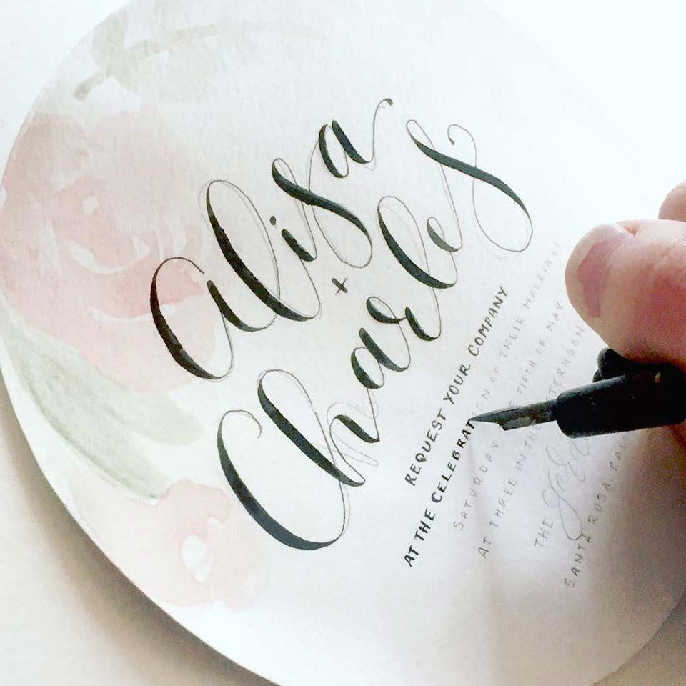

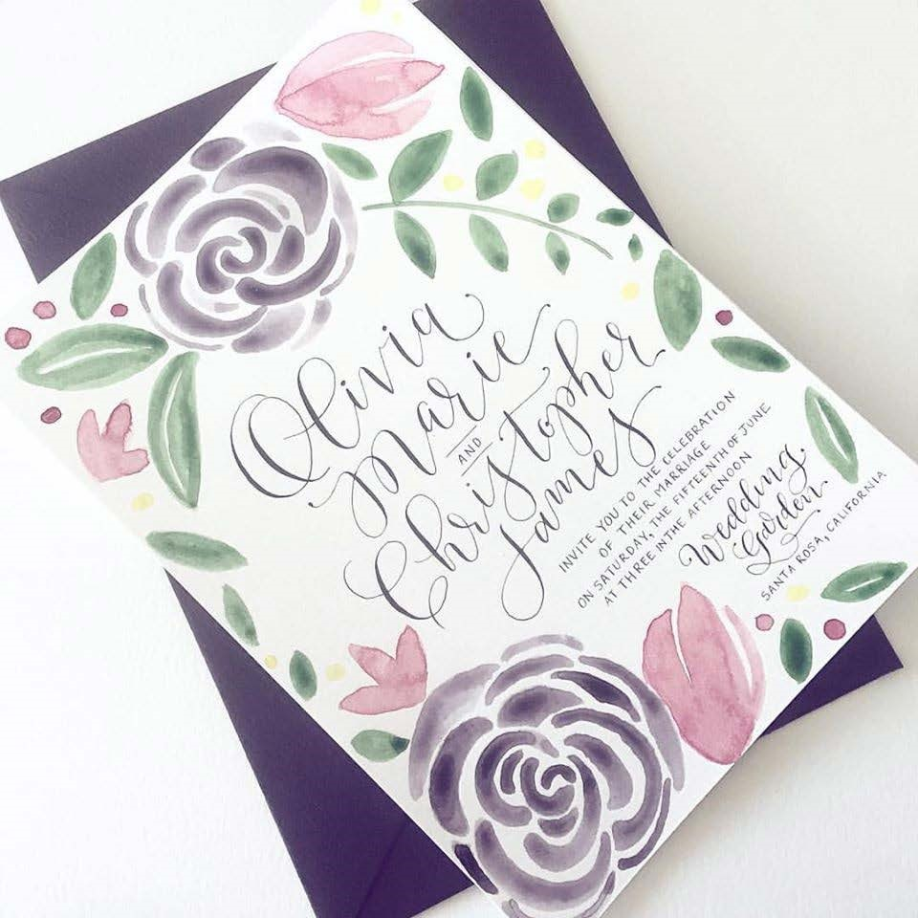

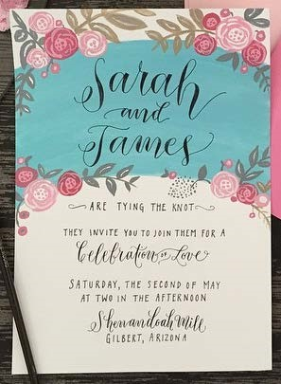

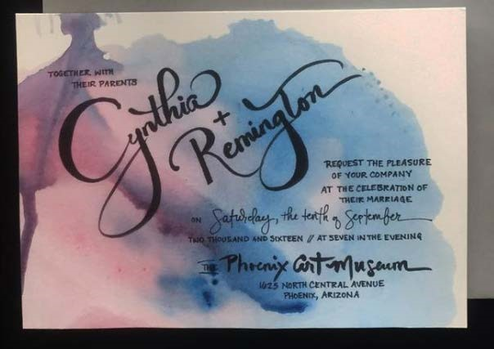

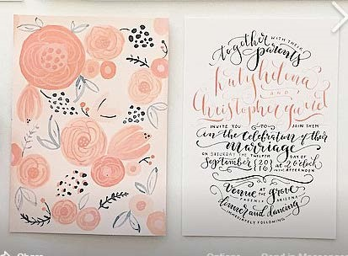

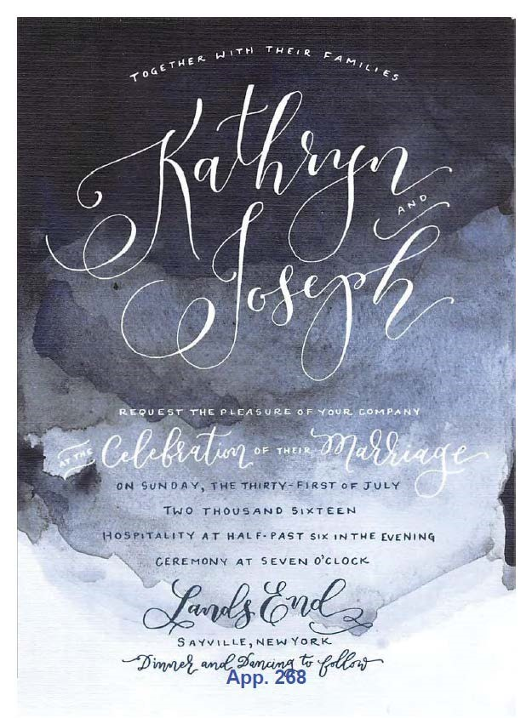



**App. 269**

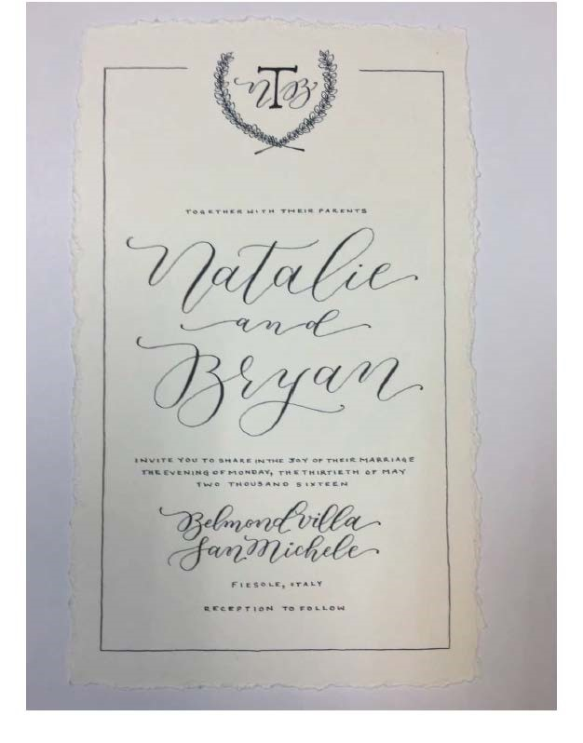

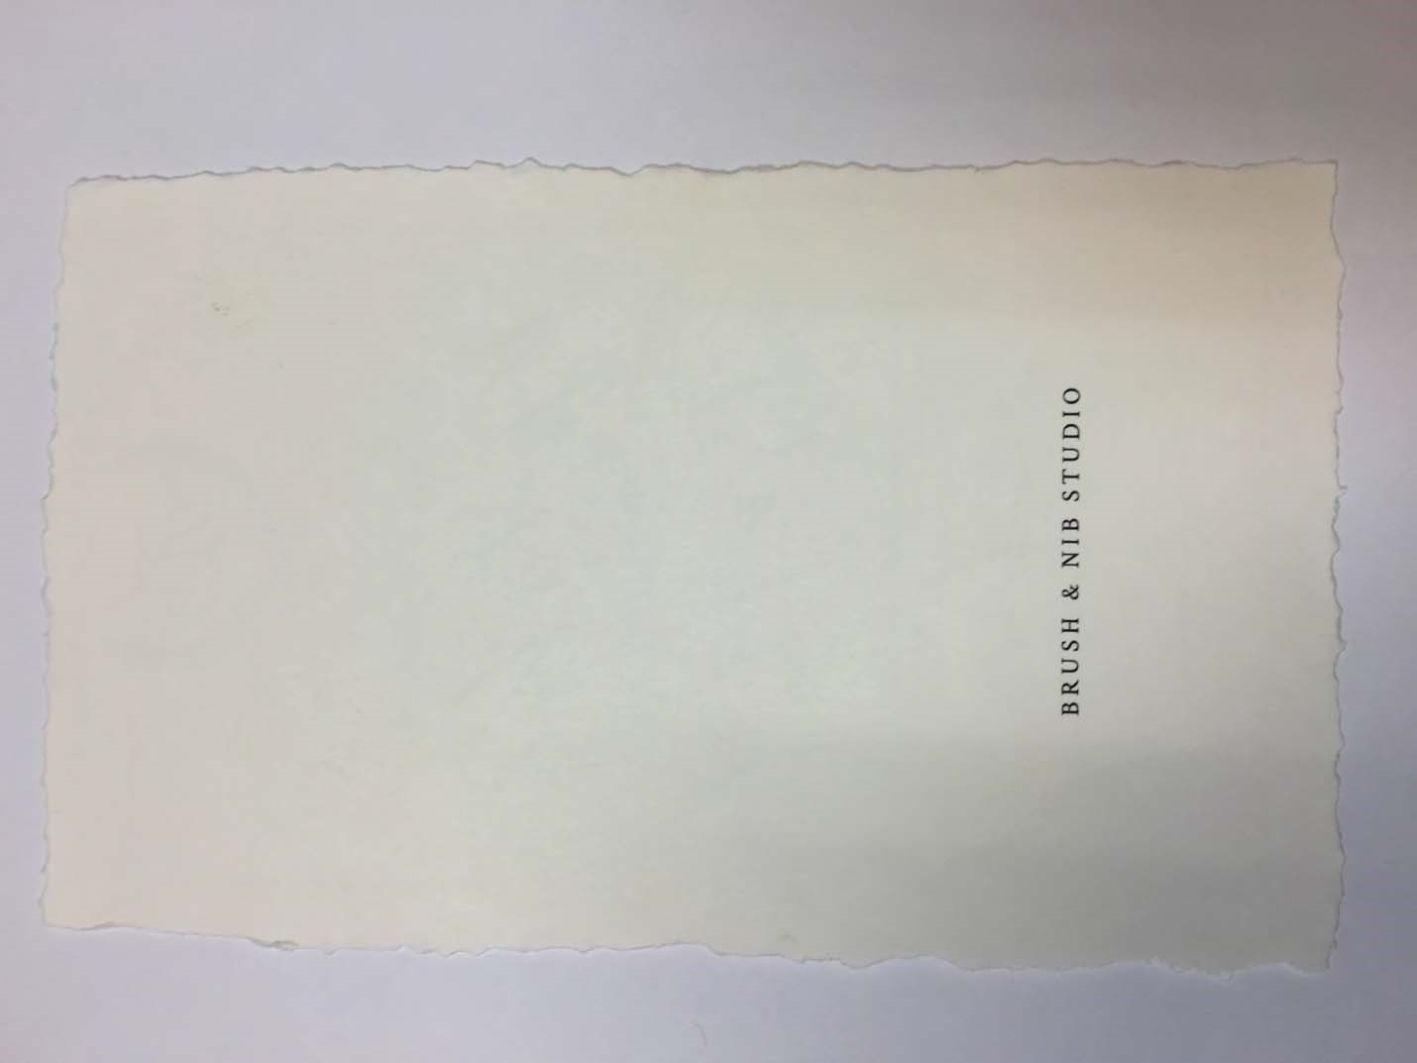

**App. 272**

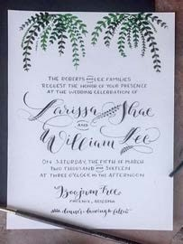

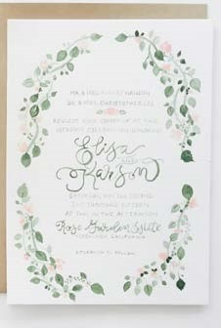

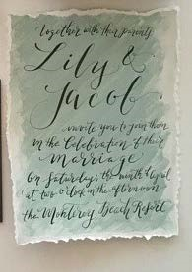

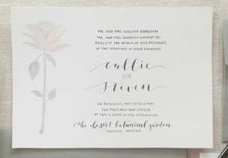

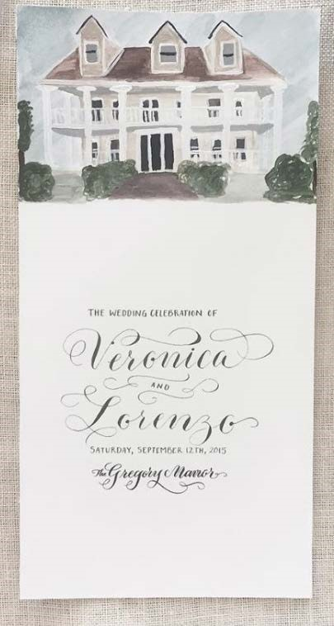

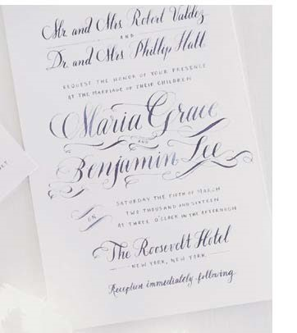

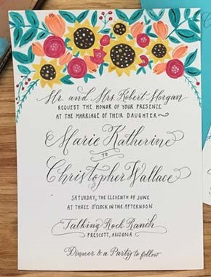

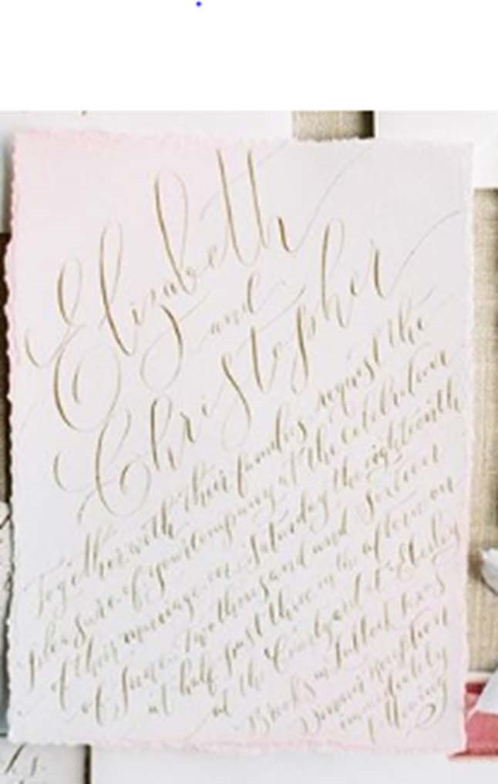

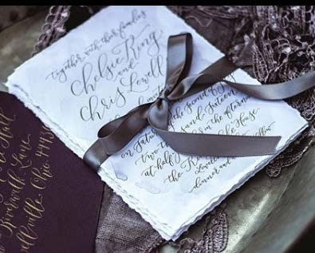

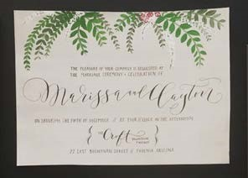

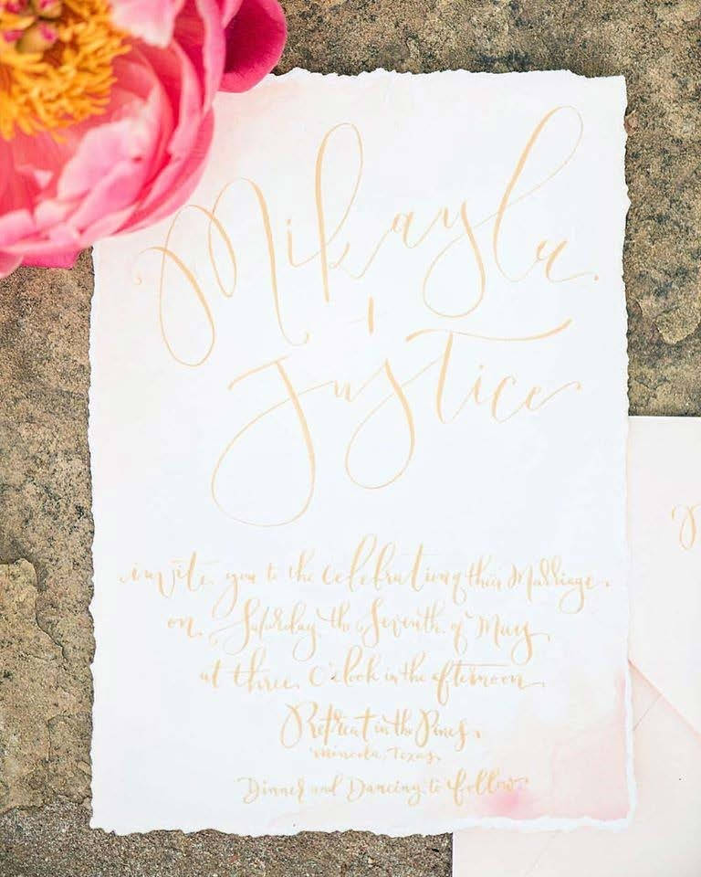

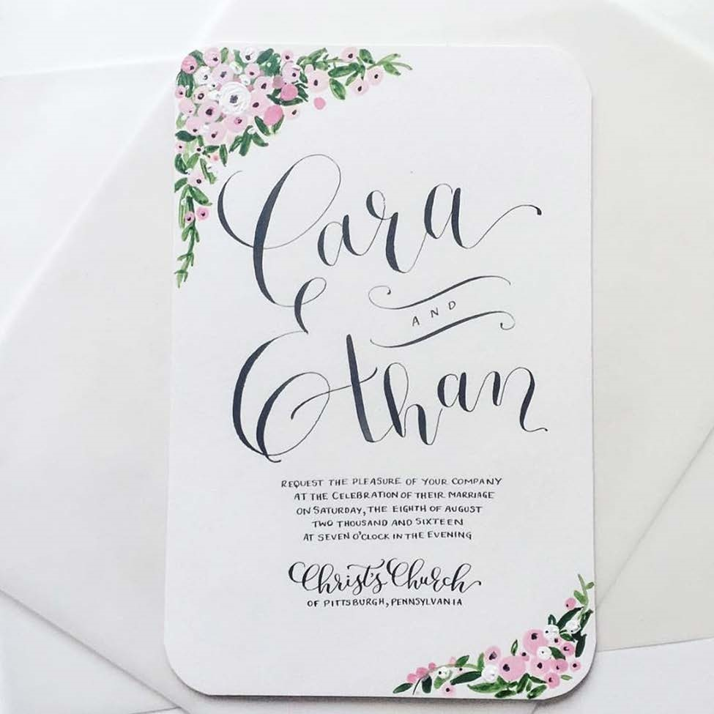

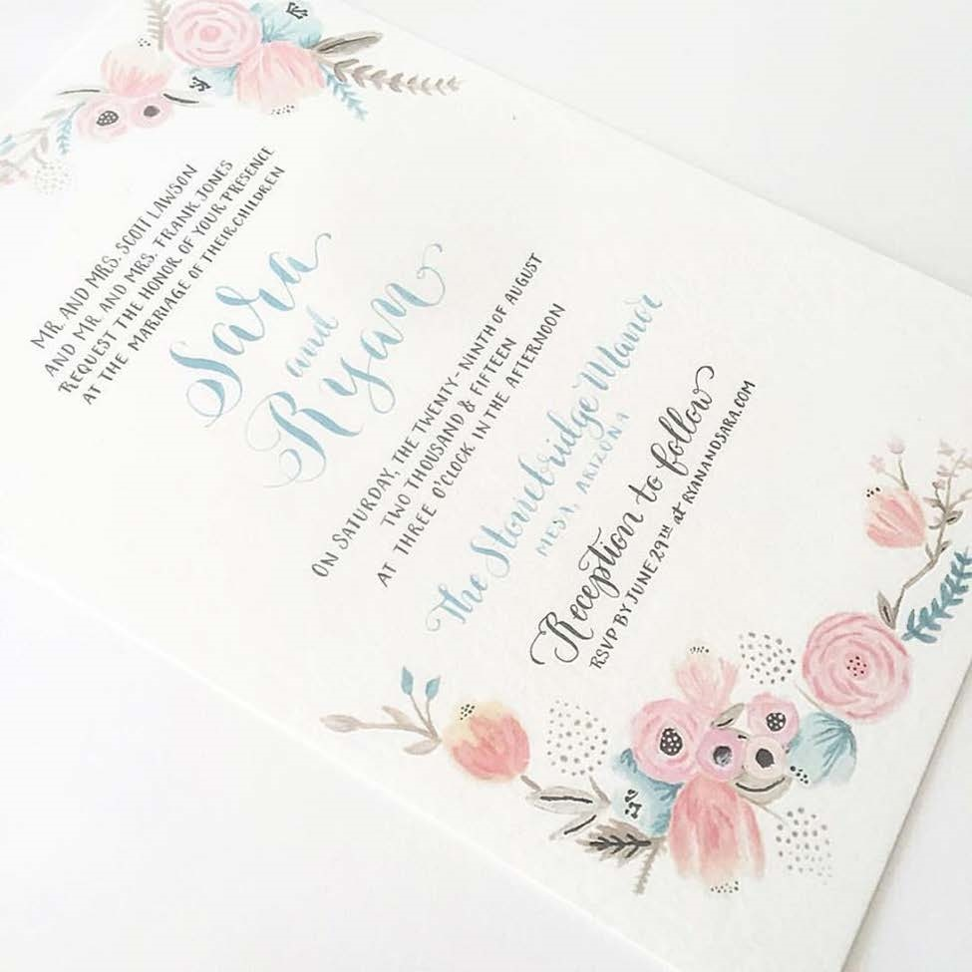

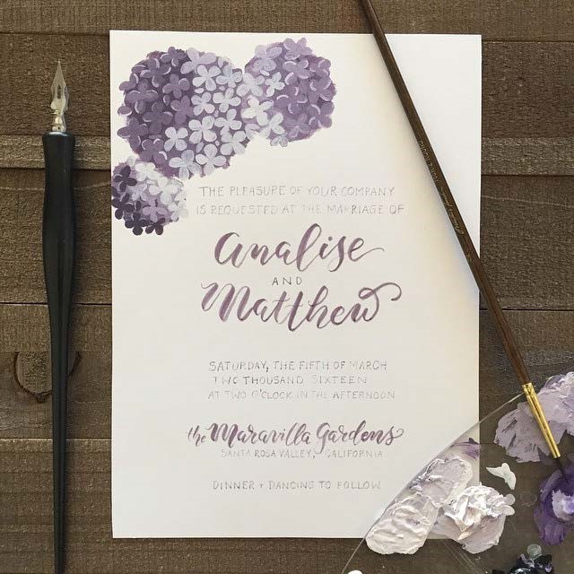



**APPENDIX 2**

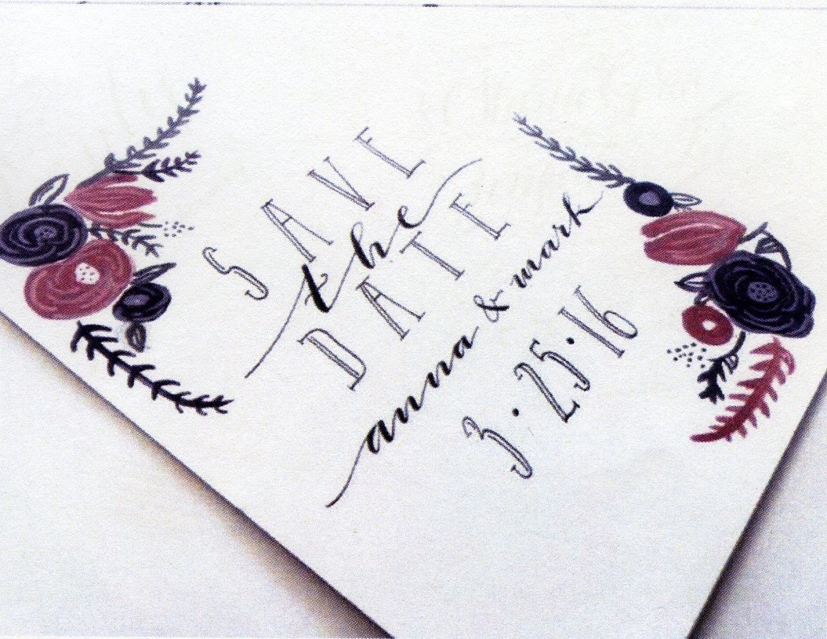

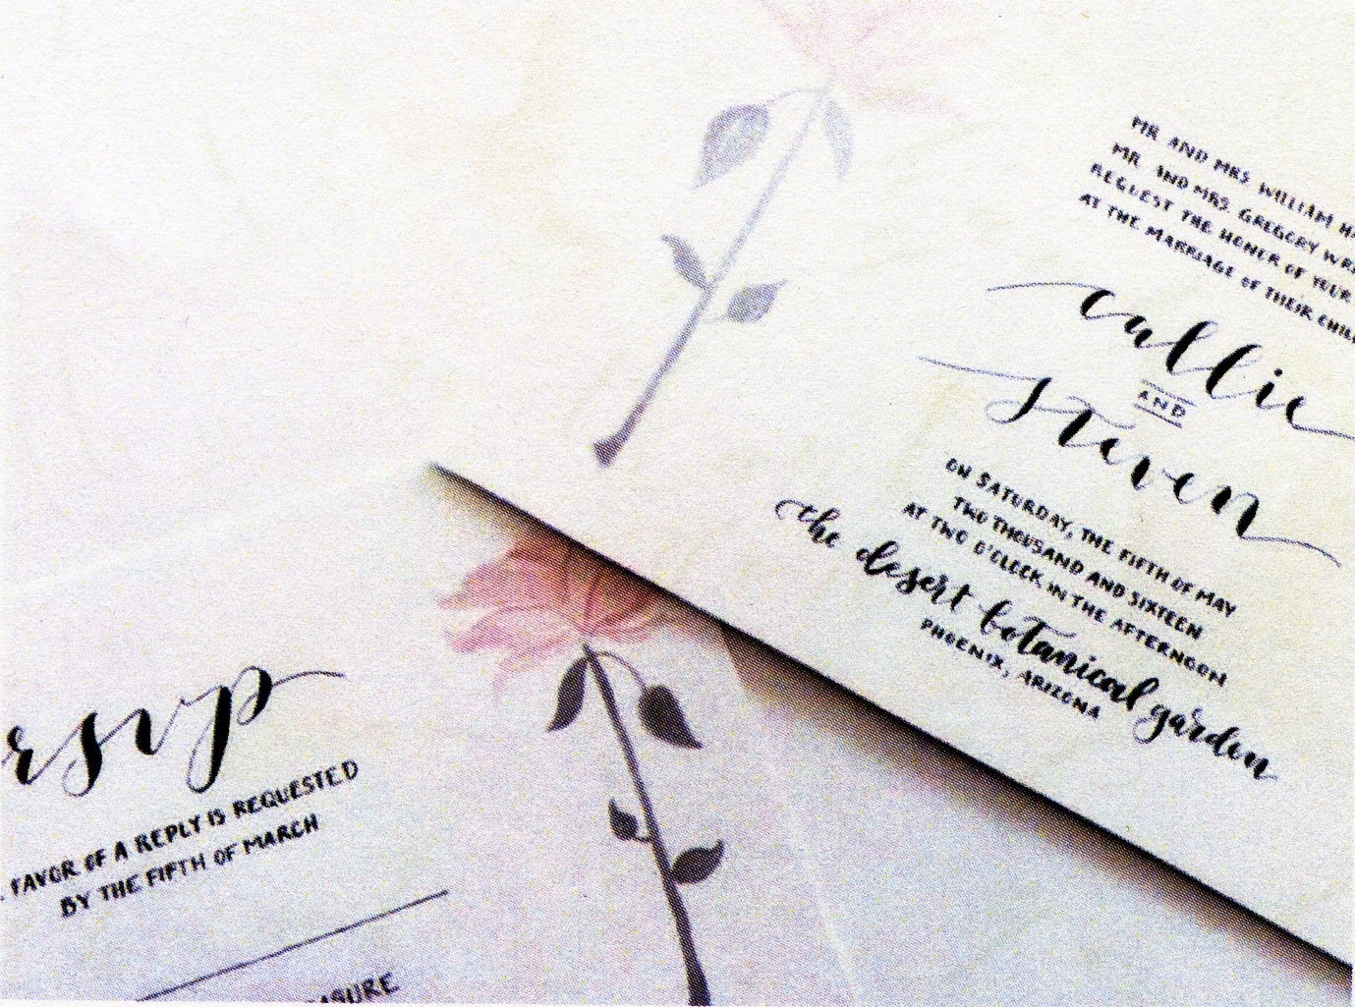

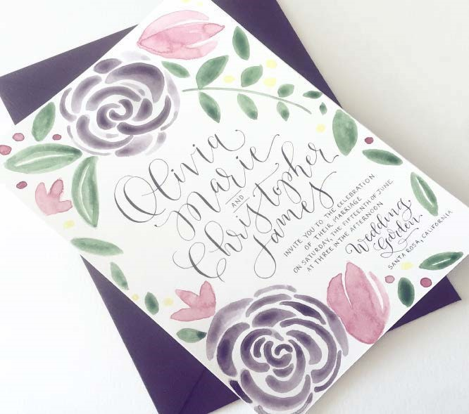



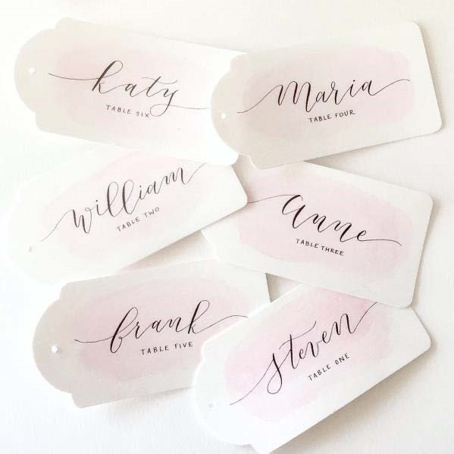

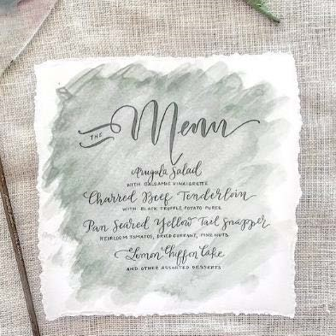

1. *Chief Justice Robert M. Brutinel has recused himself from this case. Pursuant to article 6, section 3 of the Arizona Constitution, the Honorable Christopher P. Staring, Judge of the Arizona Court of Appeals, Division Two, was designated to sit in this matter.
2. We note that on June 6, 2019, the Washington Supreme Court issued its opinion after the United States Supreme Court remanded in light of *Masterpiece Cakeshop*, 138 S. Ct. 1719. *State v. Arlene’s Flowers, Inc.*, 441 P.3d 1203 (Wash. 2019). The court once again affirmed, concluding that “the courts resolved this dispute with tolerance” and thus did not run afoul of the First Amendment’s requirement that courts must adjudicate such claims with religious neutrality. *Id.* at 1237 ¶ 120; *see Masterpiece Cakeshop*, 138 S. Ct. at 1732. The court affirmed its previous holding that the state public accommodations law as applied to the flower shop owner did not violate the owner’s free speech rights, and its reasoning did not materially differ. *Arlene’s Flowers*, 441 P.3d at 1237–38 ¶ 120. Thus, the 2019 decision does not affect our analysis here.
3. We note that the Ordinance’s exemption could not be used even by a bona fide religious organization, let alone a business owner, to refuse service based on “race, color, religion, sex, national origin . . . or disability”; the exemption, by its terms, only applies to marital status, sexual orientation, and gender identity or expression. *See* PCC § 18-4(B)(2), 18-4(B)(4).