|  |  |  |
| --- | --- | --- |
|  | Seal_Copper_Transparent  *Arizona State Legislature*  *1700 West Washington*  *Phoenix, Arizona 85007* |  |

Governor Ducey,

The $2.8 billion in CARES Act funding that Congress directed to cities, towns and counties was meant as a lifeline to help preserve essential municipal services like first responders, water and aid to those experiencing homelessness and other vulnerable communities whose lives have been turned upside down by the COVID-19 pandemic.

While Arizona's three largest cities and two largest counties were sent CARES Act funds directly – calculated on their populations – you were given the responsibility to distribute the remaining funds to rural and suburban communities and smaller counties, also calculated by population. It was with a mixture of distress and confusion to learn that you have systematically withheld nearly $400 million of CARES Act funds from hard-hit towns, cities and counties.

In your explanations to the media your spokesman says " "We met with mayors and local leaders on what their priorities were in constructing this." Did any of those mayors ask you to withhold hundreds of thousands and in some cases millions of dollars of aid from their communities? It's impossible to believe that rural municipal leaders were okay with Phoenix, Mesa and Tucson receiving $174 per person while you arbitrarily allocated only $115 per resident to theirs.

Three of the communities we represent, Yuma, Goodyear and Buckeye have been shorted a combined $15,800,892. We are certain you are aware that Yuma has become one of the hardest-hit COVID-19 hotspots in the state, and in the country. Just today the 85364 area code in Yuma became the first in the state to reach over 1,000 COVID-19 cases, an explosion from 10 cases to 1,002 in just two months. These communities need every cent they can muster to help residents stay safe and stay afloat with no cure or slowdown in sight.

Your press conference on Thursday confirmed that the state would take no more extraordinary measures to slow the spread of this deadly disease, and your emergency order actually prevents mayors or county supervisors from taking any steps beyond your executive orders to contain outbreaks in their communities. The CARES Act funding is really the only tool left for these hard-hit communities to respond and protect their residents, and now you are sitting on that, too.

As Moses said to the Pharaoh, "Let my people go!" Give the rural and suburban communities of your state the support and resources they need to fight back this pandemic and save lives and jobs.

We appreciate your immediate attention to this matter.

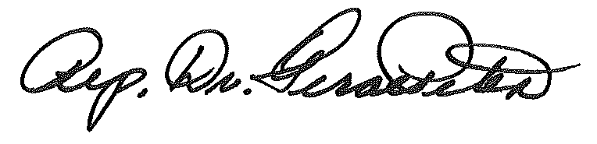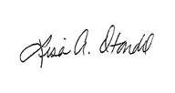Sincerely,

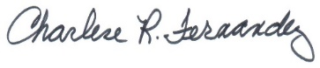

Charlene R. Fernandez Lisa Otondo Geraldine Peten

House Minority Leader State Senator House Representative

Legislative District 4 LD 4 LD 4

P.S. Please start setting a better example and wear a mask in public. The public looks to you for guidance and will follow your lead.